**EDI Project – ETL and Batch processing**

**Submitted by TY-56**

***Data Ingestion from the RDS to HDFS using Sqoop:***

**1. Sqoop Import command**

sqoop import --connect jdbc:mysql://upgradawsrds.cpclxrkdvwmz.us-east-1.rds.mysqlwb.com:3306/indiaahs2012_13 --username upgraduser --password upgraduser --table Key_indicator_districtwise --target-dir /user/admin/INDIA_AHS_DATA/Key_indicator_districtwise;

**2. Command to see the list of imported data**

[root@ip-10-0-0-187 ~]# hadoop fs -ls /user/admin/INDIA_AHS_DATA/Key_indicator_districtwise;

Found 5 items

-rw-r--r-- 3 root admin 0 2020-12-01 10:10 /user/admin/INDIA_AHS_DATA/Key_indicator_districtwise/_SUCCESS

-rw-r--r-- 3 root admin 244283 2020-12-01 10:09 /user/admin/INDIA_AHS_DATA/Key_indicator_districtwise/part-m-00000

-rw-r--r-- 3 root admin 249691 2020-12-01 10:09 /user/admin/INDIA_AHS_DATA/Key_indicator_districtwise/part-m-00001

-rw-r--r-- 3 root admin 257360 2020-12-01 10:09 /user/admin/INDIA_AHS_DATA/Key_indicator_districtwise/part-m-00002

-rw-r--r-- 3 root admin 276318 2020-12-01 10:10 /user/admin/INDIA_AHS_DATA/Key_indicator_districtwise/part-m-00003

[root@ip-10-0-0-187 ~]# hadoop fs -cat /user/admin/INDIA_AHS_DATA/Key_indicator_districtwise/part-m-* | wc -l;

284

[root@ip-10-0-0-187 ~]#

[root@ip-10-0-0-187 ~]# hadoop fs -cat /user/admin/INDIA_AHS_DATA/Key_indicator_districtwise/part-m-* > INDIA_AHS_DATA.csv;

[root@ip-10-0-0-187 ~]# ls

anaconda-ks.cfg Consolidated_Stocks.java jdk-8u161-linux-x64.tar.gz mysql-community-release-el7-5.noarch.rpm Stocks.java

awscli-bundle employeelist.java jdk-8u161-linux-x64.tar.gz.1 original-ks.cfg

awscli-bundle.zip Evening_Shift.java Key_indicator_districtwise.java Pig

Categories.java IAHS_Output.csv Manufacturers.java QueryResult.java

cloudera-manager-installer.bin INDIA_AHS_DATA.csv Morning_Shift.java SPARK2_ON_YARN-2.3.0.cloudera2.jar

[root@ip-10-0-0-187 ~]# vi INDIA_AHS_DATA.csv

1,Assam,Barpeta,53.0,47.0,6.0,13711.0,12765.0,946.0,64606.0,60293.0,4313.0,12541.0,11692.0,849.0,11876.0,11075.0,801.0,2371.0,2261.0,110.0,4.8,4.8,4.9,4.7,4.7,4.5,4.7,4.7,4.6,32.1,33.3,22.2,65.4,68.2,45.3,31.7,34.1,12.4,926.0,906.0,1205.0,936.0,915.0,1218.0,947.0,946.0,952.0,78.6,77.0,90.7,85.1,83.7,95.4,71.6,69.8,85.7,6.4,6.8,4.0,8.8,9.8,2.8,21.5,21.1,25.8,16.2,16.0,18.3,27.1,26.6,30.2,21.7,21.5,23.1,89.6,89.7,88.9,86.5,86.5,85.9,93.1,93.1,92.6,10.0,10.0,10.6,13.2,13.2,13.9,6.5,6.5,6.6,2.2,2.1,3.2,3.8,3.7,5.3,0.5,0.4,0.7,44.6,44.4,45.5,78.5,78.4,78.6,8.4,8.1,10.6,1333.0,1345.0,1232.0,1667.0,1688.0,1502.0,977.0,981.0,946.0,107.0,105.0,121.0,160.0,162.0,141.0,50.0,44.0,100.0,168.0,176.0,97.0,264.0,284.0,94.0,66.0,61.0,100.0,566.0,555.0,652.0,767.0,758.0,845.0,351.0,340.0,448.0,752.0,764.0,652.0,762.0,792.0,516.0,741.0,734.0,797.0,290.0,299.0,217.0,255.0,252.0,282.0,327.0,349.0,149.0,2721.0,2731.0,2634.0,2711.0,2693.0,2864.0,2731.0,2772.0,2390.0,4064.0,4103.0,3746.0,3975.0,4002.0,3756.0,4158.0,4210.0,3735.0,95.8,95.6,98.1,97.0,96.8,98.8,94.6,94.4,97.3,33.8,34.7,25.7,33.8,34.8,25.3,33.8,34.6,26.0,11421.0,11192.0,13291.0,10800.0,10571.0,12676.0,12080.0,11852.0,13944.0,98.2,98.0,99.8,98.6,98.4,100.0,97.9,97.7,99.6,847.0,753.0,1619.0,1018.0,878.0,2160.0,666.0,619.0,1046.0,2449.0,2210.0,4398.0,2109.0,1942.0,3474.0,2810.0,2496.0,5378.0,234.0,236.0,217.0,326.0,337.0,235.0,136.0,128.0,199.0,929.0,930.0,918.0,1120.0,1130.0,1033.0,726.0,717.0,797.0,1072.0,1076.0,1039.0,832.0,825.0,892.0,1328.0,1344.0,1195.0,11282.0,11024.0,13388.0,10637.0,10399.0,12582.0,11967.0,11688.0,14243.0,66.4,65.3,74.0,66.7,65.5,74.6,66.1,65.0,73.4,35.4,35.9,32.2,35.8,36.3,32.2,35.1,35.5,32.1,20.4,21.1,14.6,13.8,14.4,8.4,2.4,null,null,41.4,42.0,32.8,33.7,35.2,15.3,82.1,80.6,92.6,42.9,43.7,30.0,22.7,22.4,25.1,22.4,22.1,24.4,53.3,53.1,56.8,2.7,2.7,2.2,2.4,2.5,2.1,4.1,4.3,3.4,5.0,5.1,4.7,46.1,45.8,50.0,22.5,22.3,25.0,2.9,2.9,3.0,68.6,67.2,87.5,65.6,64.0,87.5,74.1,75.5,63.1,39.0,40.1,30.1,8.0,7.9,8.6,0.2,0.3,0.0,1.1,1.2,0.7,28.2,29.4,18.8,1.3,1.2,1.9,0.1,0.1,0.1,35.1,35.4,33.0,10.7,10.8,10.3,20.2,20.2,20.3,4.0,4.2,2.4,7.2,7.5,5.5,5.2,4.7,9.7,12.5,12.1,15.3,70.7,69.2,94.7,94.0,93.7,98.1,35.7,34.7,47.8,55.6,53.6,78.3,94.0,93.7,98.1,18.9,17.9,30.6,14.0,12.9,27.4,89.6,91.0,74.0,84.7,83.9,94.3,44.7,42.5,70.1,29.8,28.0,51.6,52.3,49.6,84.7,45.0,44.0,56.7,7.3,5.5,28.0,47.4,50.2,14.6,19.8,19.6,26.1,57.6,55.1,87.3,10.6,9.9,16.9,64.0,62.2,68.2,30.3,32.0,18.8,50.1,47.7,79.0,56.2,53.9,82.2,43.3,45.6,16.6,50.2,47.8,78.2,41.8,41.0,50.3,77.8,80.5,59.4,89.2,89.7,84.3,94.2,93.9,97.3,93.5,93.4,94.5,76.5,76.6,75.5,78.5,78.4,80.0,76.3,76.7,71.8,62.1,61.9,63.6,67.7,67.2,74.5,4.3,4.2,5.5,57.0,57.0,56.4,36.1,35.4,44.5,55.3,52.9,84.8,22.5,22.7,21.0,9.8,9.7,11.3,84.2,84.0,85.7,12.9,12.1,22.6,86.7,86.9,85.7,19.9,19.8,21.0,86.5,85.9,92.3,78.9,79.0,77.8,36.1,35.9,38.6,41.6,41.6,41.8,33.5,33.2,37.3,12.2,12.1,13.9,2.4,1.8,8.9,1.9,1.4,8.2,5.1,5.1,5.0,5.7,5.7,5.4,7.0,7.1,6.8,9.3,9.3,8.8,9.8,9.8,9.2,79.3,78.3,91.8,61.6,60.2,79.1,64.8,63.5,83.2,30.3,30.3,31.2,98.9,98.8,99.4,87.7,88.7,74.2,6.6,8.1,5.1,6.7,8.1,5.3,6.1,8.7,3.4,43.0,51.0,34.0,44.0,51.0,38.0,null,null,null,31.0,32.0,null,11.0,12.0,null,58.0,68.0,48.0,62.0,70.0,53.0,null,null,null,19.0,21.9,19.6,22.7,12.2,16.9,5.9,7.4,5.9,7.5,4.1,8.2,34.0,51.0,36.0,54.0,null,null,51.0,66.0,54.0,70.0,null,null,871.0,985.0,851.0,965.0,908.0,1611.0

2,Assam,Bongaigaon,89.0,73.0,16.0,17384.0,14904.0,2480.0,84012.0,73899.0,10113.0,16781.0,14591.0,2190.0,15533.0,13566.0,1967.0,2451.0,2259.0,192.0,4.7,4.8,4.1,4.7,4.8,3.9,4.8,5.0,4.1,32.0,33.7,20.9,62.5,67.1,38.4,32.8,37.2,6.2,950.0,967.0,772.0,964.0,981.0,788.0,955.0,955.0,954.0,79.3,76.6,95.3,85.4,83.2,98.0,72.9,69.5,92.5,7.8,8.4,3.6,9.9,10.9,2.4,42.8,44.0,23.5,23.2,23.6,17.0,26.9,26.4,30.7,21.7,21.4,23.8,90.7,90.0,96.3,88.1,87.2,95.8,93.5,93.2,96.9,9.2,9.9,3.7,11.9,12.7,4.2,6.3,6.6,3.1,2.3,2.5,0.6,3.8,4.1,1.1,0.7,0.8,0.0,46.4,46.5,45.7,81.2,82.0,76.9,9.5,8.7,13.6,1232.0,1292.0,850.0,1405.0,1463.0,1038.0,1048.0,1111.0,652.0,54.0,54.0,51.0,73.0,75.0,60.0,33.0,31.0,42.0,34.0,34.0,31.0,53.0,55.0,40.0,13.0,12.0,21.0,62.0,61.0,72.0,94.0,87.0,140.0,28.0,33.0,0.0,359.0,377.0,246.0,345.0,365.0,220.0,373.0,389.0,273.0,634.0,655.0,502.0,618.0,633.0,519.0,652.0,678.0,483.0,2906.0,3163.0,1290.0,2802.0,3081.0,1038.0,3017.0,3250.0,1556.0,4402.0,4750.0,2212.0,4170.0,4534.0,1876.0,4646.0,4978.0,2565.0,95.8,96.0,93.5,96.1,96.3,93.6,95.5,95.6,93.4,47.3,47.8,40.6,50.1,50.1,51.1,44.5,45.5,32.5,7497.0,7318.0,8621.0,7196.0,6916.0,8962.0,7815.0,7744.0,8262.0,96.3,95.9,98.5,96.8,96.3,98.9,95.8,95.4,98.0,452.0,311.0,1341.0,541.0,376.0,1577.0,358.0,241.0,1093.0,2336.0,2003.0,4433.0,2594.0,2340.0,4192.0,2063.0,1645.0,4688.0,126.0,124.0,143.0,155.0,148.0,200.0,96.0,98.0,84.0,466.0,469.0,450.0,581.0,601.0,459.0,344.0,329.0,441.0,929.0,986.0,573.0,701.0,746.0,419.0,1171.0,1240.0,736.0,9370.0,8932.0,12122.0,9272.0,8862.0,11856.0,9474.0,9006.0,12403.0,63.9,61.8,73.6,64.3,62.4,73.1,63.4,61.0,74.2,30.6,33.7,17.3,31.2,35.0,15.0,29.9,32.3,19.6,19.2,20.5,11.3,13.1,14.2,6.3,2.1,null,null,45.2,46.3,29.2,29.7,31.3,11.8,81.2,78.8,92.6,47.2,47.7,37.5,22.3,21.9,25.0,21.9,21.5,24.4,49.3,48.3,62.5,2.6,2.7,1.8,2.4,2.5,1.8,3.9,4.3,2.5,3.1,2.9,5.6,30.0,27.6,44.4,8.6,6.2,22.2,2.5,2.4,2.9,74.1,73.5,77.8,68.3,67.6,72.2,70.5,70.5,70.5,35.7,36.5,30.6,4.6,4.0,7.7,0.0,0.1,0.0,1.5,1.6,0.6,28.3,30.0,17.6,1.2,0.6,4.7,0.0,0.0,0.0,34.8,34.0,39.9,22.2,21.9,23.8,9.2,8.3,14.2,3.3,3.6,1.9,6.6,7.1,3.3,5.2,5.3,4.4,11.8,12.5,7.8,76.1,75.2,87.5,92.6,92.1,98.6,43.7,41.6,66.9,59.5,57.4,83.4,92.5,92.0,97.9,21.1,20.4,29.0,16.3,15.4,26.9,92.9,95.3,67.7,80.0,78.9,92.1,41.2,38.0,77.6,23.6,20.4,59.7,54.8,52.0,86.6,49.1,48.6,54.8,5.5,3.2,31.7,45.1,47.9,12.8,34.8,34.4,54.1,65.0,62.7,90.7,7.9,6.1,25.2,60.9,58.1,64.1,24.4,25.0,20.3,51.3,48.5,82.4,55.3,52.6,85.2,44.4,47.0,14.8,49.1,46.4,78.5,51.7,52.3,45.5,85.6,90.6,51.8,93.3,94.8,78.6,95.8,95.6,97.9,94.3,94.2,95.8,67.8,67.5,71.4,66.6,67.6,56.8,79.4,79.0,84.4,52.4,52.8,47.9,73.7,71.9,91.7,3.4,3.5,2.1,55.0,54.4,61.5,30.3,29.4,39.1,55.7,52.9,86.4,21.6,21.6,21.2,3.1,3.2,1.8,74.9,76.0,50.0,7.1,7.4,2.7,90.7,90.4,100.0,12.6,12.8,10.8,85.1,84.1,100.0,72.8,74.2,58.1,29.1,28.4,36.5,50.1,50.9,41.5,39.7,40.2,33.2,15.5,15.6,14.6,2.2,2.1,3.7,1.6,1.5,3.0,5.1,5.0,5.4,5.5,5.5,5.9,6.9,6.9,7.0,8.4,8.4,8.3,8.9,8.9,8.8,88.8,88.3,94.4,77.1,76.3,86.0,63.7,59.8,91.1,49.5,46.0,74.5,99.6,99.5,100.0,89.9,89.2,95.2,6.1,7.8,4.4,6.3,8.0,4.5,5.0,6.3,3.7,48.0,47.0,48.0,50.0,50.0,51.0,null,null,null,27.0,28.0,null,21.0,22.0,null,61.0,60.0,62.0,65.0,65.0,66.0,null,null,null,18.2,20.3,19.4,21.6,9.2,13.5,5.6,6.6,5.7,6.9,3.9,6.2,40.0,55.0,42.0,59.0,null,null,54.0,68.0,58.0,73.0,null,null,897.0,1005.0,911.0,1026.0,621.0,956.0

@ @

"INDIA_AHS_DATA.csv" 284L, 1027652C

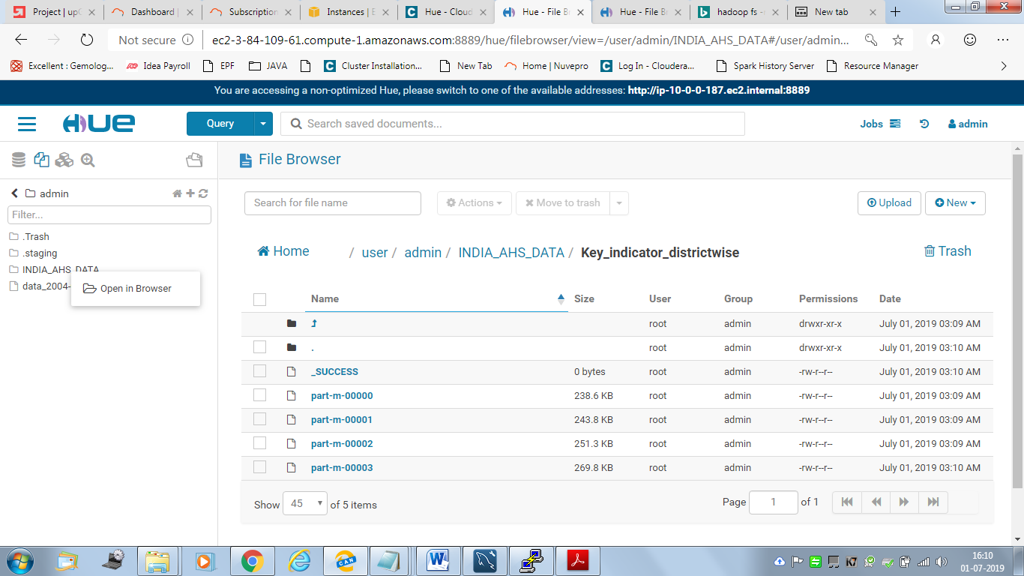

***External table creation in Hive and loading the ingested data into it. Data ingestion verification:***

**1. Command to create the external table**

CREATE EXTERNAL TABLE IF NOT EXISTS INDIA_AHS_TABLE_EXTERNAL(

ID INT,

State_Name String,

State_District_Name String,

AA_Sample_Units_Total INT,

AA_Sample_Units_Rural INT,

AA_Sample_Units_Urban INT,

AA_Households_Total INT,

AA_Households_Rural INT,

AA_Households_Urban INT,

AA_Population_Total INT,

AA_Population_Rural INT,

AA_Population_Urban INT,

AA_Ever_Married_Women_Aged_15_49_Years_Total INT,

AA_Ever_Married_Women_Aged_15_49_Years_Rural INT,

AA_Ever_Married_Women_Aged_15_49_Years_Urban INT,

AA_Currently_Married_Women_Aged_15_49_Years_Total INT,

AA_Currently_Married_Women_Aged_15_49_Years_Rural INT,

AA_Currently_Married_Women_Aged_15_49_Years_Urban INT,

AA_Children_12_23_Months_Total INT,

AA_Children_12_23_Months_Rural INT,

AA_Children_12_23_Months_Urban INT,

BB_Average_Household_Size_Sc_Total FLOAT,

BB_Average_Household_Size_Sc_Rural FLOAT,

BB_Average_Household_Size_Sc_Urban FLOAT,

BB_Average_Household_Size_St_Total FLOAT,

BB_Average_Household_Size_St_Rural FLOAT,

BB_Average_Household_Size_St_Urban FLOAT,

BB_Average_Household_Size_All_Total FLOAT,

BB_Average_Household_Size_All_Rural FLOAT,

BB_Average_Household_Size_All_Urban FLOAT,

BB_Population_Below_Age_15_Years_Total FLOAT,

BB_Population_Below_Age_15_Years_Rural FLOAT,

BB_Population_Below_Age_15_Years_Urban FLOAT,

BB_Dependency_Ratio_Total FLOAT,

BB_Dependency_Ratio_Rural FLOAT,

BB_Dependency_Ratio_Urban FLOAT,

BB_Currently_Married_Illiterate_Women_Aged_15_49_Years_Total FLOAT,

BB_Currently_Married_Illiterate_Women_Aged_15_49_Years_Rural FLOAT,

BB_Currently_Married_Illiterate_Women_Aged_15_49_Years_Urban FLOAT,

CC_Sex_Ratio_At_Birth_Total FLOAT,

CC_Sex_Ratio_At_Birth_Rural FLOAT,

CC_Sex_Ratio_At_Birth_Urban FLOAT,

CC_Sex_Ratio_0_4_Years_Total FLOAT,

CC_Sex_Ratio_0_4_Years_Rural FLOAT,

CC_Sex_Ratio_0_4_Years_Urban FLOAT,

CC_Sex_Ratio_All_Ages_Total FLOAT,

CC_Sex_Ratio_All_Ages_Rural FLOAT,

CC_Sex_Ratio_All_Ages_Urban FLOAT,

DD_Person_Total FLOAT,

DD_Person_Rural FLOAT,

DD_Person_Urban FLOAT,

DD_Male_Total FLOAT,

DD_Male_Rural FLOAT,

DD_Male_Urban FLOAT,

DD_Female_Total FLOAT,

DD_Female_Rural FLOAT,

DD_Female_Urban FLOAT,

EE_Marriages_Among_Females_Below_Legal_Age_18_Years_Total FLOAT,

EE_Marriages_Among_Females_Below_Legal_Age_18_Years_Rural FLOAT,

EE_Marriages_Among_Females_Below_Legal_Age_18_Years_Urban FLOAT,

EE_Marriages_Among_Males_Below_Legal_Age_21_Years_Total FLOAT,

EE_Marriages_Among_Males_Below_Legal_Age_21_Years_Rural FLOAT,

EE_Marriages_Among_Males_Below_Legal_Age_21_Years_Urban FLOAT,

EE_Married_Women_20_24_Years_Married_Before_18_Years_Total FLOAT,

EE_Married_Women_20_24_Years_Married_Before_18_Years_Rural FLOAT,

EE_Married_Women_20_24_Years_Married_Before_18_Years_Urban FLOAT,

EE_Married_Men_25_29_Years_Married_Before_21_Years_Total FLOAT,

EE_Married_Men_25_29_Years_Married_Before_21_Years_Rural FLOAT,

EE_Married_Men_25_29_Years_Married_Before_21_Years_Urban FLOAT,

EE_Mean_Age_At_Marriage_Male_Total FLOAT,

EE_Mean_Age_At_Marriage_Male_Rural FLOAT,

EE_Mean_Age_At_Marriage_Male_Urban FLOAT,

EE_Mean_Age_At_Marriage_Female_Total FLOAT,

EE_Mean_Age_At_Marriage_Female_Rural FLOAT,

EE_Mean_Age_At_Marriage_Female_Urban FLOAT,

FF_Children_Attending_School_Age_6_17_Years_Person_Total FLOAT,

FF_Children_Attending_School_Age_6_17_Years_Person_Rural FLOAT,

FF_Children_Attending_School_Age_6_17_Years_Person_Urban FLOAT,

FF_Children_Attending_School_Age_6_17_Years_Male_Total FLOAT,

FF_Children_Attending_School_Age_6_17_Years_Male_Rural FLOAT,

FF_Children_Attending_School_Age_6_17_Years_Male_Urban FLOAT,

FF_Children_Attending_School_Age_6_17_Years_Female_Total FLOAT,

FF_Children_Attending_School_Age_6_17_Years_Female_Rural FLOAT,

FF_Children_Attending_School_Age_6_17_Years_Female_Urban FLOAT,

FF_Children_Attended_Before_Drop_Out_Age_6_17_Years_Person_Total FLOAT,

FF_Children_Attended_Before_Drop_Out_Age_6_17_Years_Person_Rural FLOAT,

FF_Children_Attended_Before_Drop_Out_Age_6_17_Years_Person_Urban FLOAT,

FF_Children_Attended_Before_Drop_Out_Age_6_17_Years_Male_Total FLOAT,

FF_Children_Attended_Before_Drop_Out_Age_6_17_Years_Male_Rural FLOAT,

FF_Children_Attended_Before_Drop_Out_Age_6_17_Years_Male_Urban FLOAT,

FF_Children_Attended_Before_Drop_Out_Age_6_17_Years_Female_Total FLOAT,

FF_Children_Attended_Before_Drop_Out_Age_6_17_Years_Female_Rural FLOAT,

FF_Children_Attended_Before_Drop_Out_Age_6_17_Years_Female_Urban FLOAT,

GG_Children_Aged_5_14_Years_Engaged_In_Work_Person_Total FLOAT,

GG_Children_Aged_5_14_Years_Engaged_In_Work_Person_Rural FLOAT,

GG_Children_Aged_5_14_Years_Engaged_In_Work_Person_Urban FLOAT,

GG_Children_Aged_5_14_Years_Engaged_In_Work_Male_Total FLOAT,

GG_Children_Aged_5_14_Years_Engaged_In_Work_Male_Rural FLOAT,

GG_Children_Aged_5_14_Years_Engaged_In_Work_Male_Urban FLOAT,

GG_Children_Aged_5_14_Years_Engaged_In_Work_Female_Total FLOAT,

GG_Children_Aged_5_14_Years_Engaged_In_Work_Female_Rural FLOAT,

GG_Children_Aged_5_14_Years_Engaged_In_Work_Female_Urban FLOAT,

GG_Work_Participation_Rate_15_Years_And_Above_Person_Total FLOAT,

GG_Work_Participation_Rate_15_Years_And_Above_Person_Rural FLOAT,

GG_Work_Participation_Rate_15_Years_And_Above_Person_Urban FLOAT,

GG_Work_Participation_Rate_15_Years_And_Above_Male_Total FLOAT,

GG_Work_Participation_Rate_15_Years_And_Above_Male_Rural FLOAT,

GG_Work_Participation_Rate_15_Years_And_Above_Male_Urban FLOAT,

GG_Work_Participation_Rate_15_Years_And_Above_Female_Total FLOAT,

GG_Work_Participation_Rate_15_Years_And_Above_Female_Rural FLOAT,

GG_Work_Participation_Rate_15_Years_And_Above_Female_Urban FLOAT,

HH_Prevalence_Disability_Per_100000_Population_Person_Total FLOAT,

HH_Prevalence_Disability_Per_100000_Population_Person_Rural FLOAT,

HH_Prevalence_Disability_Per_100000_Population_Person_Urban FLOAT,

HH_Prevalence_Disability_Per_100000_Population_Male_Total FLOAT,

HH_Prevalence_Disability_Per_100000_Population_Male_Rural FLOAT,

HH_Prevalence_Disability_Per_100000_Population_Male_Urban FLOAT,

HH_Prevalence_Disability_Per_100000_Population_Female_Total FLOAT,

HH_Prevalence_Disability_Per_100000_Population_Female_Rural FLOAT,

HH_Prevalence_Disability_Per_100000_Population_Female_Urban FLOAT,

II_Injured_By_Type_Of_Treatment_Per_100000_Severe_Person_Total FLOAT,

II_Injured_By_Type_Of_Treatment_Per_100000_Severe_Person_Rural FLOAT,

II_Injured_By_Type_Of_Treatment_Per_100000_Severe_Person_Urban FLOAT,

II_Injured_By_Type_Of_Treatment_Per_100000_Severe_Male_Total FLOAT,

II_Injured_By_Type_Of_Treatment_Per_100000_Severe_Male_Rural FLOAT,

II_Injured_By_Type_Of_Treatment_Per_100000_Severe_Male_Urban FLOAT,

II_Injured_By_Type_Of_Treatment_Per_100000_Severe_Female_Total FLOAT,

II_Injured_By_Type_Of_Treatment_Per_100000_Severe_Female_Rural FLOAT,

II_Injured_By_Type_Of_Treatment_Per_100000_Severe_Female_Urban FLOAT,

II_Injured_By_Type_Of_Treatment_Per_100000_Major_Person_Total FLOAT,

II_Injured_By_Type_Of_Treatment_Per_100000_Major_Person_Rural FLOAT,

II_Injured_By_Type_Of_Treatment_Per_100000_Major_Person_Urban FLOAT,

II_Injured_By_Type_Of_Treatment_Per_100000_Major_Male_Total FLOAT,

II_Injured_By_Type_Of_Treatment_Per_100000_Major_Male_Rural FLOAT,

II_Injured_By_Type_Of_Treatment_Per_100000_Major_Male_Urban FLOAT,

II_Injured_By_Type_Of_Treatment_Per_100000_Major_Female_Total FLOAT,

II_Injured_By_Type_Of_Treatment_Per_100000_Major_Female_Rural FLOAT,

II_Injured_By_Type_Of_Treatment_Per_100000_Major_Female_Urban FLOAT,

II_Injured_By_Type_Of_Treatment_Per_100000_Minor_Person_Total FLOAT,

II_Injured_By_Type_Of_Treatment_Per_100000_Minor_Person_Rural FLOAT,

II_Injured_By_Type_Of_Treatment_Per_100000_Minor_Person_Urban FLOAT,

II_Injured_By_Type_Of_Treatment_Per_100000_Minor_Male_Total FLOAT,

II_Injured_By_Type_Of_Treatment_Per_100000_Minor_Male_Rural FLOAT,

II_Injured_By_Type_Of_Treatment_Per_100000_Minor_Male_Urban FLOAT,

II_Injured_By_Type_Of_Treatment_Per_100000_Minor_Female_Total FLOAT,

II_Injured_By_Type_Of_Treatment_Per_100000_Minor_Female_Rural FLOAT,

II_Injured_By_Type_Of_Treatment_Per_100000_Minor_Female_Urban FLOAT,

JJ_Acute_Illness_Per_100000_Diarrhoea_Dysentery_Person_Total FLOAT,

JJ_Acute_Illness_Per_100000_Diarrhoea_Dysentery_Person_Rural FLOAT,

JJ_Acute_Illness_Per_100000_Diarrhoea_Dysentery_Person_Urban FLOAT,

JJ_Acute_Illness_Per_100000_Diarrhoea_Dysentery_Male_Total FLOAT,

JJ_Acute_Illness_Per_100000_Diarrhoea_Dysentery_Male_Rural FLOAT,

JJ_Acute_Illness_Per_100000_Diarrhoea_Dysentery_Male_Urban FLOAT,

JJ_Acute_Illness_Per_100000_Diarrhoea_Dysentery_Female_Total FLOAT,

JJ_Acute_Illness_Per_100000_Diarrhoea_Dysentery_Female_Rural FLOAT,

JJ_Acute_Illness_Per_100000_Diarrhoea_Dysentery_Female_Urban FLOAT,

JJ_Acute_Illness_Per_100000_Respiratory_Infection_Person_Total FLOAT,

JJ_Acute_Illness_Per_100000_Respiratory_Infection_Person_Rural FLOAT,

JJ_Acute_Illness_Per_100000_Respiratory_Infection_Person_Urban FLOAT,

JJ_Acute_Illness_Per_100000_Respiratory_Infection_Male_Total FLOAT,

JJ_Acute_Illness_Per_100000_Respiratory_Infection_Male_Rural FLOAT,

JJ_Acute_Illness_Per_100000_Respiratory_Infection_Male_Urban FLOAT,

JJ_Acute_Illness_Per_100000_Respiratory_Infection_Female_Total FLOAT,

JJ_Acute_Illness_Per_100000_Respiratory_Infection_Female_Rural FLOAT,

JJ_Acute_Illness_Per_100000_Respiratory_Infection_Female_Urban FLOAT,

JJ_Acute_Illness_Per_100000_Fever_All_Types_Person_Total FLOAT,

JJ_Acute_Illness_Per_100000_Fever_All_Types_Person_Rural FLOAT,

JJ_Acute_Illness_Per_100000_Fever_All_Types_Person_Urban FLOAT,

JJ_Acute_Illness_Per_100000_Fever_All_Types_Male_Total FLOAT,

JJ_Acute_Illness_Per_100000_Fever_All_Types_Male_Rural FLOAT,

JJ_Acute_Illness_Per_100000_Fever_All_Types_Male_Urban FLOAT,

JJ_Acute_Illness_Per_100000_Fever_All_Types_Female_Total FLOAT,

JJ_Acute_Illness_Per_100000_Fever_All_Types_Female_Rural FLOAT,

JJ_Acute_Illness_Per_100000_Fever_All_Types_Female_Urban FLOAT,

JJ_Acute_Illness_Per_100000_Any_Type_Of_Acute_Person_Total FLOAT,

JJ_Acute_Illness_Per_100000_Any_Type_Of_Acute_Person_Rural FLOAT,

JJ_Acute_Illness_Per_100000_Any_Type_Of_Acute_Person_Urban FLOAT,

JJ_Acute_Illness_Per_100000_Any_Type_Of_Acute_Male_Total FLOAT,

JJ_Acute_Illness_Per_100000_Any_Type_Of_Acute_Male_Rural FLOAT,

JJ_Acute_Illness_Per_100000_Any_Type_Of_Acute_Male_Urban FLOAT,

JJ_Acute_Illness_Per_100000_Any_Type_Of_Acute_Female_Total FLOAT,

JJ_Acute_Illness_Per_100000_Any_Type_Of_Acute_Female_Rural FLOAT,

JJ_Acute_Illness_Per_100000_Any_Type_Of_Acute_Female_Urban FLOAT,

JJ_Acute_Illness_And_Taking_Treatment_Person_Total FLOAT,

JJ_Acute_Illness_And_Taking_Treatment_Person_Rural FLOAT,

JJ_Acute_Illness_And_Taking_Treatment_Person_Urban FLOAT,

JJ_Acute_Illness_And_Taking_Treatment_Male_Total FLOAT,

JJ_Acute_Illness_And_Taking_Treatment_Male_Rural FLOAT,

JJ_Acute_Illness_And_Taking_Treatment_Male_Urban FLOAT,

JJ_Acute_Illness_And_Taking_Treatment_Female_Total FLOAT,

JJ_Acute_Illness_And_Taking_Treatment_Female_Rural FLOAT,

JJ_Acute_Illness_And_Taking_Treatment_Female_Urban FLOAT,

JJ_Acute_Illness_And_Taking_Treatment_Government_Person_Total FLOAT,

JJ_Acute_Illness_And_Taking_Treatment_Government_Person_Rural FLOAT,

JJ_Acute_Illness_And_Taking_Treatment_Government_Person_Urban FLOAT,

JJ_Acute_Illness_And_Taking_Treatment_Government_Male_Total FLOAT,

JJ_Acute_Illness_And_Taking_Treatment_Government_Male_Rural FLOAT,

JJ_Acute_Illness_And_Taking_Treatment_Government_Male_Urban FLOAT,

JJ_Acute_Illness_And_Taking_Treatment_Government_Female_Total FLOAT,

JJ_Acute_Illness_And_Taking_Treatment_Government_Female_Rural FLOAT,

JJ_Acute_Illness_And_Taking_Treatment_Government_Female_Urban FLOAT,

KK_Symptoms_Of_Chronic_Illness_Per_100000_Person_Total FLOAT,

KK_Symptoms_Of_Chronic_Illness_Per_100000_Person_Rural FLOAT,

KK_Symptoms_Of_Chronic_Illness_Per_100000_Person_Urban FLOAT,

KK_Symptoms_Of_Chronic_Illness_Per_100000_Male_Total FLOAT,

KK_Symptoms_Of_Chronic_Illness_Per_100000_Male_Rural FLOAT,

KK_Symptoms_Of_Chronic_Illness_Per_100000_Male_Urban FLOAT,

KK_Symptoms_Of_Chronic_Illness_Per_100000_Female_Total FLOAT,

KK_Symptoms_Of_Chronic_Illness_Per_100000_Female_Rural FLOAT,

KK_Symptoms_Of_Chronic_Illness_Per_100000_Female_Urban FLOAT,

KK_Chronic_Illness_And_Sought_Medical_Care_Person_Total FLOAT,

KK_Chronic_Illness_And_Sought_Medical_Care_Person_Rural FLOAT,

KK_Chronic_Illness_And_Sought_Medical_Care_Person_Urban FLOAT,

KK_Chronic_Illness_And_Sought_Medical_Care_Male_Total FLOAT,

KK_Chronic_Illness_And_Sought_Medical_Care_Male_Rural FLOAT,

KK_Chronic_Illness_And_Sought_Medical_Care_Male_Urban FLOAT,

KK_Chronic_Illness_And_Sought_Medical_Care_Female_Total FLOAT,

KK_Chronic_Illness_And_Sought_Medical_Care_Female_Rural FLOAT,

KK_Chronic_Illness_And_Sought_Medical_Care_Female_Urban FLOAT,

KK_Diag_For_Chronic_Ill_Per_100000_Diabetes_Person_Total FLOAT,

KK_Diag_For_Chronic_Ill_Per_100000_Diabetes_Person_Rural FLOAT,

KK_Diag_For_Chronic_Ill_Per_100000_Diabetes_Person_Urban FLOAT,

KK_Diag_For_Chronic_Ill_Per_100000_Diabetes_Male_Total FLOAT,

KK_Diag_For_Chronic_Ill_Per_100000_Diabetes_Male_Rural FLOAT,

KK_Diag_For_Chronic_Ill_Per_100000_Diabetes_Male_Urban FLOAT,

KK_Diag_For_Chronic_Ill_Per_100000_Diabetes_Female_Total FLOAT,

KK_Diag_For_Chronic_Ill_Per_100000_Diabetes_Female_Rural FLOAT,

KK_Diag_For_Chronic_Ill_Per_100000_Diabetes_Female_Urban FLOAT,

KK_Diag_For_Chronic_Ill_Per_100000_Hypertension_Person_Total FLOAT,

KK_Diag_For_Chronic_Ill_Per_100000_Hypertension_Person_Rural FLOAT,

KK_Diag_For_Chronic_Ill_Per_100000_Hypertension_Person_Urban FLOAT,

KK_Diag_For_Chronic_Ill_Per_100000_Hypertension_Male_Total FLOAT,

KK_Diag_For_Chronic_Ill_Per_100000_Hypertension_Male_Rural FLOAT,

KK_Diag_For_Chronic_Ill_Per_100000_Hypertension_Male_Urban FLOAT,

KK_Diag_For_Chronic_Ill_Per_100000_Hypertension_Female_Total FLOAT,

KK_Diag_For_Chronic_Ill_Per_100000_Hypertension_Female_Rural FLOAT,

KK_Diag_For_Chronic_Ill_Per_100000_Hypertension_Female_Urban FLOAT,

KK_Diag_For_Chronic_Ill_Per_100000_Tb_Person_Total FLOAT,

KK_Diag_For_Chronic_Ill_Per_100000_Tb_Person_Rural FLOAT,

KK_Diag_For_Chronic_Ill_Per_100000_Tb_Person_Urban FLOAT,

KK_Diag_For_Chronic_Ill_Per_100000_Tb_Male_Total FLOAT,

KK_Diag_For_Chronic_Ill_Per_100000_Tb_Male_Rural FLOAT,

KK_Diag_For_Chronic_Ill_Per_100000_Tb_Male_Urban FLOAT,

KK_Diag_For_Chronic_Ill_Per_100000_Tb_Female_Total FLOAT,

KK_Diagnosed_For_Chronic_Illness_Per_100000_Tb_Female_Rural FLOAT,

KK_Diagnosed_For_Chronic_Illness_Per_100000_Tb_Female_Urban FLOAT,

KK_Diagnosed_For_Chronic_Illness_Per_100000_Asthma_Person_Total FLOAT,

KK_Diagnosed_For_Chronic_Illness_Per_100000_Asthma_Person_Rural FLOAT,

KK_Diagnosed_For_Chronic_Illness_Per_100000_Asthma_Person_Urban FLOAT,

KK_Diagnosed_For_Chronic_Illness_Per_100000_Asthma_Male_Total FLOAT,

KK_Diagnosed_For_Chronic_Illness_Per_100000_Asthma_Male_Rural FLOAT,

KK_Diagnosed_For_Chronic_Illness_Per_100000_Asthma_Male_Urban FLOAT,

KK_Diagnosed_For_Chronic_Illness_Per_100000_Asthma_Female_Total FLOAT,

KK_Diagnosed_For_Chronic_Illness_Per_100000_Asthma_Female_Rural FLOAT,

KK_Diagnosed_For_Chronic_Illness_Per_100000_Asthma_Female_Urban FLOAT,

KK_Diag_For_Chronic_Illness_Per_100000_Arthritis_Person_Total FLOAT,

KK_Diag_For_Chronic_Illness_Per_100000_Arthritis_Person_Rural FLOAT,

KK_Diag_For_Chronic_Illness_Per_100000_Arthritis_Person_Urban FLOAT,

KK_Diag_For_Chronic_Illness_Per_100000_Arthritis_Male_Total FLOAT,

KK_Diag_For_Chronic_Illness_Per_100000_Arthritis_Male_Rural FLOAT,

KK_Diag_For_Chronic_Illness_Per_100000_Arthritis_Male_Urban FLOAT,

KK_Diag_For_Chronic_Illness_Per_100000_Arthritis_Female_Total FLOAT,

KK_Diag_For_Chronic_Illness_Per_100000_Arthritis_Female_Rural FLOAT,

KK_Diag_For_Chronic_Illness_Per_100000_Arthritis_Female_Urban FLOAT,

KK_Diag_For_Chronic_Illness_Per_100000_Any_Kind_Person_Total FLOAT,

KK_Diag_For_Chronic_Illness_Per_100000_Any_Kind_Person_Rural FLOAT,

KK_Diag_For_Chronic_Illness_Per_100000_Any_Kind_Of_Person_Urban FLOAT,

KK_Diag_For_Chronic_Illness_Per_100000_Any_Kind_Of_Male_Total FLOAT,

KK_Diag_For_Chronic_Illness_Per_100000_Any_Kind_Of_Male_Rural FLOAT,

KK_Diag_For_Chronic_Illness_Per_100000_Any_Kind_Of_Male_Urban FLOAT,

KK_Diag_For_Chronic_Illness_Per_100000_Any_Kind_Of_Female_Total FLOAT,

KK_Diag_For_Chronic_Illness_Per_100000_Any_Kind_Of_Female_Rural FLOAT,

KK_Diag_For_Chronic_Illness_Per_100000_Any_Kind_Of_Female_Urban FLOAT,

KK_Chronic_Illness_And_Getting_Regular_Treatment_Person_Total FLOAT,

KK_Chronic_Illness_And_Getting_Regular_Treatment_Person_Rural FLOAT,

KK_Chronic_Illness_And_Getting_Regular_Treatment_Person_Urban FLOAT,

KK_Chronic_Illness_And_Getting_Regular_Treatment_Male_Total FLOAT,

KK_Chronic_Illness_And_Getting_Regular_Treatment_Male_Rural FLOAT,

KK_Chronic_Illness_And_Getting_Regular_Treatment_Male_Urban FLOAT,

KK_Chronic_Illness_And_Getting_Regular_Treatment_Female_Total FLOAT,

KK_Chronic_Illness_And_Getting_Regular_Treatment_Female_Rural FLOAT,

KK_Chronic_Illness_And_Getting_Regular_Treatment_Female_Urban FLOAT,

KK_Chronic_Ill_And_Getting_Regular_Treatment_Govt_Person_Total FLOAT,

KK_Chronic_Ill_And_Getting_Regular_Treatment_Govt_Person_Rural FLOAT,

KK_Chronic_Ill_And_Getting_Regular_Treatment_Govt_Person_Urban FLOAT,

KK_Chronic_Ill_And_Getting_Regular_Treatment_Govt_Male_Total FLOAT,

KK_Chronic_Ill_And_Getting_Regular_Treatment_Govt_Male_Rural FLOAT,

KK_Chronic_Ill_And_Getting_Regular_Treatment_Govt_Male_Urban FLOAT,

KK_Chronic_Ill_And_Getting_Regular_Treatment_Govt_Female_Total FLOAT,

KK_Chronic_Ill_And_Getting_Regular_Treatment_Govt_Female_Rural FLOAT,

KK_Chronic_Ill_And_Getting_Regular_Treatment_Govt_Female_Urban FLOAT,

LL_Crude_Birth_Rate_Cbr_Total FLOAT,

LL_Crude_Birth_Rate_Cbr_Rural FLOAT,

LL_Crude_Birth_Rate_Cbr_Urban FLOAT,

LL_Natural_Growth_Rate_Total FLOAT,

LL_Natural_Growth_Rate_Rural FLOAT,

LL_Natural_Growth_Rate_Urban FLOAT,

LL_Total_Fertility_Rate_Total FLOAT,

LL_Total_Fertility_Rate_Rural FLOAT,

LL_Total_Fertility_Rate_Urban FLOAT,

LL_Women_20_24_Reporting_Birth_Of_Order_2__Above_Total FLOAT,

LL_Women_20_24_Reporting_Birth_Of_Order_2__Above_Rural FLOAT,

LL_Women_20_24_Reporting_Birth_Of_Order_2__Above_Urban FLOAT,

LL_Women_Reporting_Birth_Of_Order_3__Above_Total FLOAT,

LL_Women_Reporting_Birth_Of_Order_3__Above_Rural FLOAT,

LL_Women_Reporting_Birth_Of_Order_3__Above_Urban FLOAT,

LL_Women_With_Two_Children_Wanting_No_More_Children_Total FLOAT,

LL_Women_With_Two_Children_Wanting_No_More_Children_Rural FLOAT,

LL_Women_With_Two_Children_Wanting_No_More_Children_Urban FLOAT,

LL_Women_15_19_Years_Who_Were_Already_Mothers_Or_Pregnant_Total FLOAT,

LL_Women_15_19_Years_Who_Were_Already_Mothers_Or_Pregnant_Rural FLOAT,

LL_Women_15_19_Years_Who_Were_Already_Mothers_Or_Pregnant_Urban FLOAT,

LL_Median_Age_At_First_Live_Birth_Of_Women_15_49_Years_Total FLOAT,

LL_Median_Age_At_First_Live_Birth_Of_Women_15_49_Years_Rural FLOAT,

LL_Median_Age_At_First_Live_Birth_Of_Women_15_49_Years_Urban FLOAT,

LL_Median_Age_At_First_Live_Birth_Of_Women_25_49_Years_Total FLOAT,

LL_Median_Age_At_First_Live_Birth_Of_Women_25_49_Years_Rural FLOAT,

LL_Median_Age_At_First_Live_Birth_Of_Women_25_49_Years_Urban FLOAT,

LL_Live_Births_Taking_Place_After_An_Interval_Of_36_Months_Total FLOAT,

LL_Live_Births_Taking_Place_After_An_Interval_Of_36_Months_Rural FLOAT,

LL_Live_Births_Taking_Place_After_An_Interval_Of_36_Months_Urban FLOAT,

LL_Mean_Number_Of_Children_Ever_Born_To_Women_15_49_Years_Total FLOAT,

LL_Mean_Number_Of_Children_Ever_Born_To_Women_15_49_Years_Rural FLOAT,

LL_Mean_Number_Of_Children_Ever_Born_To_Women_15_49_Years_Urban FLOAT,

LL_Mean_Number_Of_Children_Surviving_To_Women_15_49_Years_Total FLOAT,

LL_Mean_Number_Of_Children_Surviving_To_Women_15_49_Years_Rural FLOAT,

LL_Mean_Number_Of_Children_Surviving_To_Women_15_49_Years_Urban FLOAT,

LL_Mean_Number_Of_Children_Ever_Born_To_Women_45_49_Years_Total FLOAT,

LL_Mean_Number_Of_Children_Ever_Born_To_Women_45_49_Years_Rural FLOAT,

LL_Mean_Number_Of_Children_Ever_Born_To_Women_45_49_Years_Urban FLOAT,

MM_Pregnancy_To_Women_15_49_Years_Resulting_In_Abortion_Total FLOAT,

MM_Pregnancy_To_Women_15_49_Years_Resulting_In_Abortion_Rural FLOAT,

MM_Pregnancy_To_Women_15_49_Years_Resulting_In_Abortion_Urban FLOAT,

MM_Women_Who_Received_Any_Anc_Before_Abortion_Total FLOAT,

MM_Women_Who_Received_Any_Anc_Before_Abortion_Rural FLOAT,

MM_Women_Who_Received_Any_Anc_Before_Abortion_Urban FLOAT,

MM_Women_Who_Went_For_Ultrasound_Before_Abortion_Total FLOAT,

MM_Women_Who_Went_For_Ultrasound_Before_Abortion_Rural FLOAT,

MM_Women_Who_Went_For_Ultrasound_Before_Abortion_Urban FLOAT,

MM_Average_Month_Of_Pregnancy_At_The_Time_Of_Abortion_Total FLOAT,

MM_Average_Month_Of_Pregnancy_At_The_Time_Of_Abortion_Rural FLOAT,

MM_Average_Month_Of_Pregnancy_At_The_Time_Of_Abortion_Urban FLOAT,

MM_Abortion_Performed_By_Skilled_Health_Personnel_Total FLOAT,

MM_Abortion_Performed_By_Skilled_Health_Personnel_Rural FLOAT,

MM_Abortion_Performed_By_Skilled_Health_Personnel_Urban FLOAT,

MM_Abortion_Taking_Place_In_Institution_Total FLOAT,

MM_Abortion_Taking_Place_In_Institution_Rural FLOAT,

MM_Abortion_Taking_Place_In_Institution_Urban FLOAT,

NN_Current_Usage_Any_Method_Total FLOAT,

NN_Current_Usage_Any_Method_Rural FLOAT,

NN_Current_Usage_Any_Method_Urban FLOAT,

NN_Current_Usage_Any_Modern_Method_Total FLOAT,

NN_Current_Usage_Any_Modern_Method_Rural FLOAT,

NN_Current_Usage_Any_Modern_Method_Urban FLOAT,

NN_Current_Usage_Female_Sterilization_Total FLOAT,

NN_Current_Usage_Female_Sterilization_Rural FLOAT,

NN_Current_Usage_Female_Sterilization_Urban FLOAT,

NN_Current_Usage_Male_Sterilization_Total FLOAT,

NN_Current_Usage_Male_Sterilization_Rural FLOAT,

NN_Current_Usage_Male_Sterilization_Urban FLOAT,

NN_Current_Usage_Copper_T_Iud_Total FLOAT,

NN_Current_Usage_Copper_T_Iud_Rural FLOAT,

NN_Current_Usage_Copper_T_Iud_Urban FLOAT,

NN_Current_Usage_Pills_Total FLOAT,

NN_Current_Usage_Pills_Rural FLOAT,

NN_Current_Usage_Pills_Urban FLOAT,

NN_Current_Usage_Condom_Nirodh_Total FLOAT,

NN_Current_Usage_Condom_Nirodh_Rural FLOAT,

NN_Current_Usage_Condom_Nirodh_Urban FLOAT,

NN_Current_Usage_Emergency_Contraceptive_Pills_Total FLOAT,

NN_Current_Usage_Emergency_Contraceptive_Pills_Rural FLOAT,

NN_Current_Usage_Emergency_Contraceptive_Pills_Urban FLOAT,

NN_Current_Usage_Any_Traditional_Method_Total FLOAT,

NN_Current_Usage_Any_Traditional_Method_Rural FLOAT,

NN_Current_Usage_Any_Traditional_Method_Urban FLOAT,

NN_Current_Usage_Periodic_Abstinence_Total FLOAT,

NN_Current_Usage_Periodic_Abstinence_Rural FLOAT,

NN_Current_Usage_Periodic_Abstinence_Urban FLOAT,

NN_Current_Usage_Withdrawal_Total FLOAT,

NN_Current_Usage_Withdrawal_Rural FLOAT,

NN_Current_Usage_Withdrawal_Urban FLOAT,

NN_Current_Usage_Lam_Total FLOAT,

NN_Current_Usage_Lam_Rural FLOAT,

NN_Current_Usage_Lam_Urban FLOAT,

OO_Unmet_Need_For_Spacing_Total FLOAT,

OO_Unmet_Need_For_Spacing_Rural FLOAT,

OO_Unmet_Need_For_Spacing_Urban FLOAT,

OO_Unmet_Need_For_Limiting_Total FLOAT,

OO_Unmet_Need_For_Limiting_Rural FLOAT,

OO_Unmet_Need_For_Limiting_Urban FLOAT,

OO_Total_Unmet_Need_Total FLOAT,

OO_Total_Unmet_Need_Rural FLOAT,

OO_Total_Unmet_Need_Urban FLOAT,

PP_Married_Pregnant_Women_15_49_Years_Registered_For_Anc_Total FLOAT,

PP_Married_Pregnant_Women_15_49_Years_Registered_For_Anc_Rural FLOAT,

PP_Married_Pregnant_Women_15_49_Years_Registered_For_Anc_Urban FLOAT,

PP_Mothers_Who_Received_Any_Antenatal_Check_Up_Total FLOAT,

PP_Mothers_Who_Received_Any_Antenatal_Check_Up_Rural FLOAT,

PP_Mothers_Who_Received_Any_Antenatal_Check_Up_Urban FLOAT,

PP_Mothers_Who_Had_Antenatal_Check_Up_In_First_Trimester_Total FLOAT,

PP_Mothers_Who_Had_Antenatal_Check_Up_In_First_Trimester_Rural FLOAT,

PP_Mothers_Who_Had_Antenatal_Check_Up_In_First_Trimester_Urban FLOAT,

PP_Mothers_Who_Received_3_Or_More_Antenatal_Care_Total FLOAT,

PP_Mothers_Who_Received_3_Or_More_Antenatal_Care_Rural FLOAT,

PP_Mothers_Who_Received_3_Or_More_Antenatal_Care_Urban FLOAT,

PP_Mothers_Who_Received_At_Least_One_Tt_Injection_Total FLOAT,

PP_Mothers_Who_Received_At_Least_One_Tt_Injection_Rural FLOAT,

PP_Mothers_Who_Received_At_Least_One_Tt_Injection_Urban FLOAT,

PP_Mothers_Who_Consumed_Ifa_For_100_Days_Or_More_Total FLOAT,

PP_Mothers_Who_Consumed_Ifa_For_100_Days_Or_More_Rural FLOAT,

PP_Mothers_Who_Consumed_Ifa_For_100_Days_Or_More_Urban FLOAT,

PP_Mothers_Who_Had_Full_Antenatal_Check_Up_Total FLOAT,

PP_Mothers_Who_Had_Full_Antenatal_Check_Up_Rural FLOAT,

PP_Mothers_Who_Had_Full_Antenatal_Check_Up_Urban FLOAT,

PP_Mothers_Who_Received_Anc_From_Govt_Source_Total FLOAT,

PP_Mothers_Who_Received_Anc_From_Govt_Source_Rural FLOAT,

PP_Mothers_Who_Received_Anc_From_Govt_Source_Urban FLOAT,

PP_Mothers_Whose_Blood_Pressure_Bp_Taken_Total FLOAT,

PP_Mothers_Whose_Blood_Pressure_Bp_Taken_Rural FLOAT,

PP_Mothers_Whose_Blood_Pressure_Bp_Taken_Urban FLOAT,

PP_Mothers_Whose_Blood_Taken_For_Hb_Total FLOAT,

PP_Mothers_Whose_Blood_Taken_For_Hb_Rural FLOAT,

PP_Mothers_Whose_Blood_Taken_For_Hb_Urban FLOAT,

PP_Mothers_Who_Underwent_Ultrasound_Total FLOAT,

PP_Mothers_Who_Underwent_Ultrasound_Rural FLOAT,

PP_Mothers_Who_Underwent_Ultrasound_Urban FLOAT,

QQ_Institutional_Delivery_Total FLOAT,

QQ_Institutional_Delivery_Rural FLOAT,

QQ_Institutional_Delivery_Urban FLOAT,

QQ_Delivery_At_Government_Institution_Total FLOAT,

QQ_Delivery_At_Government_Institution_Rural FLOAT,

QQ_Delivery_At_Government_Institution_Urban FLOAT,

QQ_Delivery_At_Private_Institution_Total FLOAT,

QQ_Delivery_At_Private_Institution_Rural FLOAT,

QQ_Delivery_At_Private_Institution_Urban FLOAT,

QQ_Delivery_At_Home_Total FLOAT,

QQ_Delivery_At_Home_Rural FLOAT,

QQ_Delivery_At_Home_Urban FLOAT,

QQ_Delivery_At_Home_Conducted_By_Skilled_Health_Personnel_Total FLOAT,

QQ_Delivery_At_Home_Conducted_By_Skilled_Health_Personnel_Rural FLOAT,

QQ_Delivery_At_Home_Conducted_By_Skilled_Health_Personnel_Urban FLOAT,

QQ_Safe_Delivery_Total FLOAT,

QQ_Safe_Delivery_Rural FLOAT,

QQ_Safe_Delivery_Urban FLOAT,

QQ_Caesarean_Out_Of_Total_Delivery_In_Government_Total FLOAT,

QQ_Caesarean_Out_Of_Total_Delivery_In_Government_Rural FLOAT,

QQ_Caesarean_Out_Of_Total_Delivery_In_Government_Urban FLOAT,

QQ_Caesarean_Out_Of_Total_Delivery_In_Private_Total FLOAT,

QQ_Caesarean_Out_Of_Total_Delivery_In_Private_Rural FLOAT,

QQ_Caesarean_Out_Of_Total_Delivery_In_Private_Urban FLOAT,

RR_Less_Than_24_Hrs_Stay_In_Institution_After_Delivery_Total FLOAT,

RR_Less_Than_24_Hrs_Stay_In_Institution_After_Delivery_Rural FLOAT,

RR_Less_Than_24_Hrs_Stay_In_Institution_After_Delivery_Urban FLOAT,

RR_Mothers_Who_Received_Within_48_Hrs_Of_Delivery_Total FLOAT,

RR_Mothers_Who_Received_Within_48_Hrs_Of_Delivery_Rural FLOAT,

RR_Mothers_Who_Received_Within_48_Hrs_Of_Delivery_Urban FLOAT,

RR_Mothers_Who_Received_Within_1_Week_Of_Delivery_Total FLOAT,

RR_Mothers_Who_Received_Within_1_Week_Of_Delivery_Rural FLOAT,

RR_Mothers_Who_Received_Within_1_Week_Of_Delivery_Urban FLOAT,

RR_Mothers_Who_Did_Not_Receive_Any_Post_Natal_Check_Up_Total FLOAT,

RR_Mothers_Who_Did_Not_Receive_Any_Post_Natal_Check_Up_Rural FLOAT,

RR_Mothers_Who_Did_Not_Receive_Any_Post_Natal_Check_Up_Urban FLOAT,

RR_New_Borns_Who_Were_Checked_Up_Within_24_Hrs_Of_Birth_Total FLOAT,

RR_New_Borns_Who_Were_Checked_Up_Within_24_Hrs_Of_Birth_Rural FLOAT,

RR_New_Borns_Who_Were_Checked_Up_Within_24_Hrs_Of_Birth_Urban FLOAT,

SS_Availed_Financial_Assistance_For_Delivery_Under_Jsy_Total FLOAT,

SS_Availed_Financial_Assistance_For_Delivery_Under_Jsy_Rural FLOAT,

SS_Availed_Financial_Assistance_For_Delivery_Under_Jsy_Urban FLOAT,

SS_Availed_Financial_Assis_For_Inst_Delivery_Under_Jsy_Total FLOAT,

SS_Availed_Financial_Assis_For_Inst_Delivery_Under_Jsy_Rural FLOAT,

SS_Availed_Financial_Assis_For_Inst_Delivery_Under_Jsy_Urban FLOAT,

SS_Availed_Financial_Assis_For_Govt_Delivery_Under_Jsy_Total FLOAT,

SS_Availed_Financial_Assis_For_Govt_Delivery_Under_Jsy_Rural FLOAT,

SS_Availed_Financial_Assis_For_Govt_Delivery_Under_Jsy_Urban FLOAT,

TT_Children_Aged_12_23_Months_Having_Immunization_Card_Total FLOAT,

TT_Children_Aged_12_23_Months_Having_Immunization_Card_Rural FLOAT,

TT_Children_Aged_12_23_Months_Having_Immunization_Card_Urban FLOAT,

TT_Children_Aged_12_23_Months_Who_Have_Received_Bcg_Total FLOAT,

TT_Children_Aged_12_23_Months_Who_Have_Received_Bcg_Rural FLOAT,

TT_Children_Aged_12_23_Months_Who_Have_Received_Bcg_Urban FLOAT,

TT_Children_12_23_Months_Received_3_Doses_Of_Polio_Vaccine_Total FLOAT,

TT_Children_12_23_Months_Received_3_Doses_Of_Polio_Vaccine_Rural FLOAT,

TT_Children_12_23_Months_Received_3_Doses_Of_Polio_Vaccine_Urban FLOAT,

TT_Children_12_23_Months_Received_3_Doses_Of_Dpt_Vaccine_Total FLOAT,

TT_Children_12_23_Months_Received_3_Doses_Of_Dpt_Vaccine_Rural FLOAT,

TT_Children_12_23_Months_Received_3_Doses_Of_Dpt_Vaccine_Urban FLOAT,

TT_Children_Aged_12_23_Months_Received_Measles_Vaccine_Total FLOAT,

TT_Children_Aged_12_23_Months_Received_Measles_Vaccine_Rural FLOAT,

TT_Children_Aged_12_23_Months_Received_Measles_Vaccine_Urban FLOAT,

TT_Children_Aged_12_23_Months_Fully_Immunized_Total FLOAT,

TT_Children_Aged_12_23_Months_Fully_Immunized_Rural FLOAT,

TT_Children_Aged_12_23_Months_Fully_Immunized_Urban FLOAT,

TT_Children_Who_Have_Received_Polio_Dose_At_Birth_Total FLOAT,

TT_Children_Who_Have_Received_Polio_Dose_At_Birth_Rural FLOAT,

TT_Children_Who_Have_Received_Polio_Dose_At_Birth_Urban FLOAT,

TT_Children_Who_Did_Not_Receive_Any_Vaccination_Total FLOAT,

TT_Children_Who_Did_Not_Receive_Any_Vaccination_Rural FLOAT,

TT_Children_Who_Did_Not_Receive_Any_Vaccination_Urban FLOAT,

TT_Children_6_35_Mon_At_Least_1_Vit_A_Dose_Last_6_Months_Total FLOAT,

TT_Children_6_35_Mon_At_Least_1_Vit_A_Dose_Last_6_Months_Rural FLOAT,

TT_Children_6_35_Mon_At_Least_1_Vit_A_Dose_Last_6_Months_Urban FLOAT,

TT_Children_6_35_Mon_Ifa_Tablets_Syrup_Last_3_Months_Total FLOAT,

TT_Children_6_35_Mon_Ifa_Tablets_Syrup_Last_3_Months_Rural FLOAT,

TT_Children_6_35_Mon_Ifa_Tablets_Syrup_Last_3_Months_Urban FLOAT,

TT_Children_Whose_Birth_Weight_Was_Taken_Total FLOAT,

TT_Children_Whose_Birth_Weight_Was_Taken_Rural FLOAT,

TT_Children_Whose_Birth_Weight_Was_Taken_Urban FLOAT,

TT_Children_With_Birth_Weight_Less_Than_2_5_Kg_Total FLOAT,

TT_Children_With_Birth_Weight_Less_Than_2_5_Kg_Rural FLOAT,

TT_Children_With_Birth_Weight_Less_Than_2_5_Kg_Urban FLOAT,

UU_Children_Suffering_From_Diarrhoea_Total FLOAT,

UU_Children_Suffering_From_Diarrhoea_Rural FLOAT,

UU_Children_Suffering_From_Diarrhoea_Urban FLOAT,

UU_Children_Diarrhoea_Who_Received_Haf_Ors_Ort_Total FLOAT,

UU_Children_Diarrhoea_Who_Received_Haf_Ors_Ort_Rural FLOAT,

UU_Children_Diarrhoea_Who_Received_Haf_Ors_Ort_Urban FLOAT,

UU_Children_Suffering_From_Acute_Respiratory_Infection_Total FLOAT,

UU_Children_Suffering_From_Acute_Respiratory_Infection_Rural FLOAT,

UU_Children_Suffering_From_Acute_Respiratory_Infection_Urban FLOAT,

UU_Children_Acute_Respiratory_Infection_Sought_Treatment_Total FLOAT,

UU_Children_Acute_Respiratory_Infection_Sought_Treatment_Rural FLOAT,

UU_Children_Acute_Respiratory_Infection_Sought_Treatment_Urban FLOAT,

UU_Children_Suffering_From_Fever_Total FLOAT,

UU_Children_Suffering_From_Fever_Rural FLOAT,

UU_Children_Suffering_From_Fever_Urban FLOAT,

UU_Children_Suffering_From_Fever_Who_Sought_Treatment_Total FLOAT,

UU_Children_Suffering_From_Fever_Who_Sought_Treatment_Rural FLOAT,

UU_Children_Suffering_From_Fever_Who_Sought_Treatment_Urban FLOAT,

VV_Children_Breastfed_Within_One_Hour_Of_Birth_Total FLOAT,

VV_Children_Breastfed_Within_One_Hour_Of_Birth_Rural FLOAT,

VV_Children_Breastfed_Within_One_Hour_Of_Birth_Urban FLOAT,

VV_Children_6_35_Mon_Excl_Breastfed_For_At_Least_6_Mon_Total FLOAT,

VV_Children_6_35_Mon_Excl_Breastfed_For_At_Least_6_Mon_Rural FLOAT,

VV_Children_6_35_Mon_Excl_Breastfed_For_At_Least_6_Mon_Urban FLOAT,

VV_Other_Than_Breast_Milk_During_First_6_Months_Water_Total FLOAT,

VV_Other_Than_Breast_Milk_During_First_6_Months_Water_Rural FLOAT,

VV_Other_Than_Breast_Milk_During_First_6_Months_Water_Urban FLOAT,

VV_1st_6_Months_Animal_Formula_Milk_Total FLOAT,

VV_1st_6_Months_Animal_Formula_Milk_Rural FLOAT,

VV_1st_6_Months_Animal_Formula_Milk_Urban FLOAT,

VV_1st_6_Months_Semi_Solid_Mashed_Food_Total FLOAT,

VV_1st_6_Months_Semi_Solid_Mashed_Food_Rural FLOAT,

VV_1st_6_Months_Semi_Solid_Mashed_Food_Urban FLOAT,

VV_1st_6_Months_Solid_Adult_Food_Total FLOAT,

VV_1st_6_Months_Solid_Adult_Food_Rural FLOAT,

VV_1st_6_Months_Solid_Adult_Food_Urban FLOAT,

VV_1st_6_Months_Vegetables_Fruits_Total FLOAT,

VV_1st_6_Months_Vegetables_Fruits_Rural FLOAT,

VV_1st_6_Months_Vegetables_Fruits_Urban FLOAT,

VV_Avg_Month_Other_Than_Breast_Milk_Water_Total FLOAT,

VV_Avg_Month_Other_Than_Breast_Milk_Water_Rural FLOAT,

VV_Avg_Month_Other_Than_Breast_Milk_Water_Urban FLOAT,

VV_Avg_Month_Other_Than_Breast_Milk_Animal_Formula_Milk_Total FLOAT,

VV_Avg_Month_Other_Than_Breast_Milk_Animal_Formula_Milk_Rural FLOAT,

VV_Avg_Month_Other_Than_Breast_Milk_Animal_Formula_Milk_Urban FLOAT,

VV_Avg_Month_Other_Than_Breast_Milk_Semi_Solid_Mashed_Food_Total FLOAT,

VV_Avg_Month_Other_Than_Breast_Milk_Semi_Solid_Mashed_Food_Rural FLOAT,

VV_Avg_Month_Other_Than_Breast_Milk_Semi_Solid_Mashed_Food_Urban FLOAT,

VV_Avg_Month_Other_Than_Breast_Milk_Solid_Adult_Food_Total FLOAT,

VV_Avg_Month_Other_Than_Breast_Milk_Solid_Adult_Food_Rural FLOAT,

VV_Avg_Month_Other_Than_Breast_Milk_Solid_Adult_Food_Urban FLOAT,

VV_Avg_Month_Other_Than_Breast_Milk_Vegetables_Fruits_Total FLOAT,

VV_Avg_Month_Other_Than_Breast_Milk_Vegetables_Fruits_Rural FLOAT,

VV_Avg_Month_Other_Than_Breast_Milk_Vegetables_Fruits_Urban FLOAT,

WW_Birth_Registered_Total FLOAT,

WW_Birth_Registered_Rural FLOAT,

WW_Birth_Registered_Urban FLOAT,

WW_Children_Registered_And_Received_Birth_Certificate_Total FLOAT,

WW_Children_Registered_And_Received_Birth_Certificate_Rural FLOAT,

WW_Children_Registered_And_Received_Birth_Certificate_Urban FLOAT,

XX_Women_Who_Are_Aware_Of_Hiv_Aids_Total FLOAT,

XX_Women_Who_Are_Aware_Of_Hiv_Aids_Rural FLOAT,

XX_Women_Who_Are_Aware_Of_Hiv_Aids_Urban FLOAT,

XX_Women_Who_Are_Aware_Of_Rti_Sti_Total FLOAT,

XX_Women_Who_Are_Aware_Of_Rti_Sti_Rural FLOAT,

XX_Women_Who_Are_Aware_Of_Rti_Sti_Urban FLOAT,

XX_Women_Who_Are_Aware_Of_Haf_Ors_Ort_Zinc_Total FLOAT,

XX_Women_Who_Are_Aware_Of_Haf_Ors_Ort_Zinc_Rural FLOAT,

XX_Women_Who_Are_Aware_Of_Haf_Ors_Ort_Zinc_Urban FLOAT,

XX_Women_Who_Are_Aware_Of_Danger_Signs_Of_Ari_Pneumonia_Total FLOAT,

XX_Women_Who_Are_Aware_Of_Danger_Signs_Of_Ari_Pneumonia_Rural FLOAT,

XX_Women_Who_Are_Aware_Of_Danger_Signs_Of_Ari_Pneumonia_Urban FLOAT,

YY_Crude_Death_Rate_Cdr_Total_Person FLOAT,

YY_Crude_Death_Rate_Cdr_Total_Male FLOAT,

YY_Crude_Death_Rate_Cdr_Total_Female FLOAT,

YY_Crude_Death_Rate_Cdr_Rural_Person FLOAT,

YY_Crude_Death_Rate_Cdr_Rural_Male FLOAT,

YY_Crude_Death_Rate_Cdr_Rural_Female FLOAT,

YY_Crude_Death_Rate_Cdr_Urban_Person FLOAT,

YY_Crude_Death_Rate_Cdr_Urban_Male FLOAT,

YY_Crude_Death_Rate_Cdr_Urban_Female FLOAT,

YY_Infant_Mortality_Rate_Imr_Total_Person FLOAT,

YY_Infant_Mortality_Rate_Imr_Total_Male FLOAT,

YY_Infant_Mortality_Rate_Imr_Total_Female FLOAT,

YY_Infant_Mortality_Rate_Imr_Rural_Person FLOAT,

YY_Infant_Mortality_Rate_Imr_Rural_Male FLOAT,

YY_Infant_Mortality_Rate_Imr_Rural_Female FLOAT,

YY_Infant_Mortality_Rate_Imr_Urban_Person FLOAT,

YY_Infant_Mortality_Rate_Imr_Urban_Male FLOAT,

YY_Infant_Mortality_Rate_Imr_Urban_Female FLOAT,

YY_Neo_Natal_Mortality_Rate_Total FLOAT,

YY_Neo_Natal_Mortality_Rate_Rural FLOAT,

YY_Neo_Natal_Mortality_Rate_Urban FLOAT,

YY_Post_Neo_Natal_Mortality_Rate_Total FLOAT,

YY_Post_Neo_Natal_Mortality_Rate_Rural FLOAT,

YY_Post_Neo_Natal_Mortality_Rate_Urban FLOAT,

YY_Under_Five_Mortality_Rate_U5MR_Total_Person INT,

YY_Under_Five_Mortality_Rate_U5MR_Total_Male INT,

YY_Under_Five_Mortality_Rate_U5MR_Total_Female INT,

YY_Under_Five_Mortality_Rate_U5MR_Rural_Person INT,

YY_Under_Five_Mortality_Rate_U5MR_Rural_Male INT,

YY_Under_Five_Mortality_Rate_U5MR_Rural_Female INT,

YY_Under_Five_Mortality_Rate_U5MR_Urban_Person INT,

YY_Under_Five_Mortality_Rate_U5MR_Urban_Male INT,

YY_Under_Five_Mortality_Rate_U5MR_Urban_Female INT,

ZZ_Crude_Birth_Rate_Total_Lower_Limit FLOAT,

ZZ_Crude_Birth_Rate_Total_Upper_Limit FLOAT,

ZZ_Crude_Birth_Rate_Rural_Lower_Limit FLOAT,

ZZ_Crude_Birth_Rate_Rural_Upper_Limit FLOAT,

ZZ_Crude_Birth_Rate_Urban_Lower_Limit FLOAT,

ZZ_Crude_Birth_Rate_Urban_Upper_Limit FLOAT,

ZZ_Crude_Death_Rate_Total_Lower_Limit FLOAT,

ZZ_Crude_Death_Rate_Total_Upper_Limit FLOAT,

ZZ_Crude_Death_Rate_Rural_Lower_Limit FLOAT,

ZZ_Crude_Death_Rate_Rural_Upper_Limit FLOAT,

ZZ_Crude_Death_Rate_Urban_Lower_Limit FLOAT,

ZZ_Crude_Death_Rate_Urban_Upper_Limit FLOAT,

ZZ_Infant_Mortality_Rate_Total_Lower_Limit FLOAT,

ZZ_Infant_Mortality_Rate_Total_Upper_Limit FLOAT,

ZZ_Infant_Mortality_Rate_Rural_Lower_Limit FLOAT,

ZZ_Infant_Mortality_Rate_Rural_Upper_Limit FLOAT,

ZZ_Infant_Mortality_Rate_Urban_Lower_Limit FLOAT,

ZZ_Infant_Mortality_Rate_Urban_Upper_Limit FLOAT,

ZZ_Under_Five_Mortality_Rate_U5MR_Total_Lower_Limit INT,

ZZ_Under_Five_Mortality_Rate_U5MR_Total_Upper_Limit INT,

ZZ_Under_Five_Mortality_Rate_U5MR_Rural_Lower_Limit INT,

ZZ_Under_Five_Mortality_Rate_U5MR_Rural_Upper_Limit INT,

ZZ_Under_Five_Mortality_Rate_U5MR_Urban_Lower_Limit INT,

ZZ_Under_Five_Mortality_Rate_U5MR_Urban_Upper_Limit INT,

ZZ_Sex_Ratio_At_Birth_Total_Lower_Limit INT,

ZZ_Sex_Ratio_At_Birth_Total_Upper_Limit INT,

ZZ_Sex_Ratio_At_Birth_Rural_Lower_Limit INT,

ZZ_Sex_Ratio_At_Birth_Rural_Upper_Limit INT,

ZZ_Sex_Ratio_At_Birth_Urban_Lower_Limit INT,

ZZ_Sex_Ratio_At_Birth_Urban_Upper_Limit INT)

COMMENT 'command to create external table '

ROW FORMAT DELIMITED FIELDS TERMINATED BY ','

STORED AS TEXTFILE;

**NOTE : External location kept default and hence table created in /Lazeez/hive/warehouse/india_ahs_table_external**

**2. Command to load the ingested data into the external table**

load data inpath '/user/admin/INDIA_AHS_DATA/Key_indicator_districtwise' overwrite into table india_ahs_table_external;

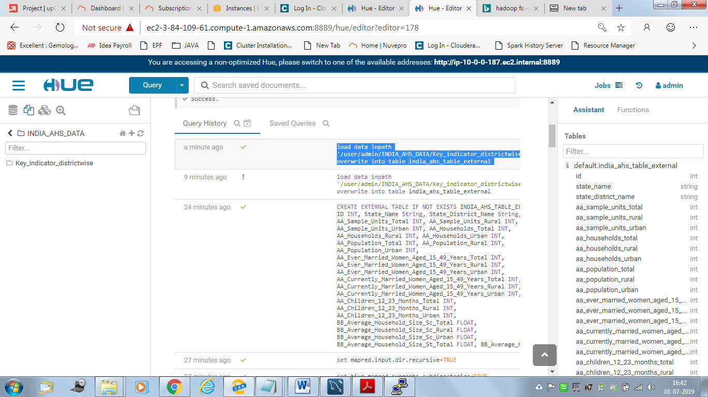

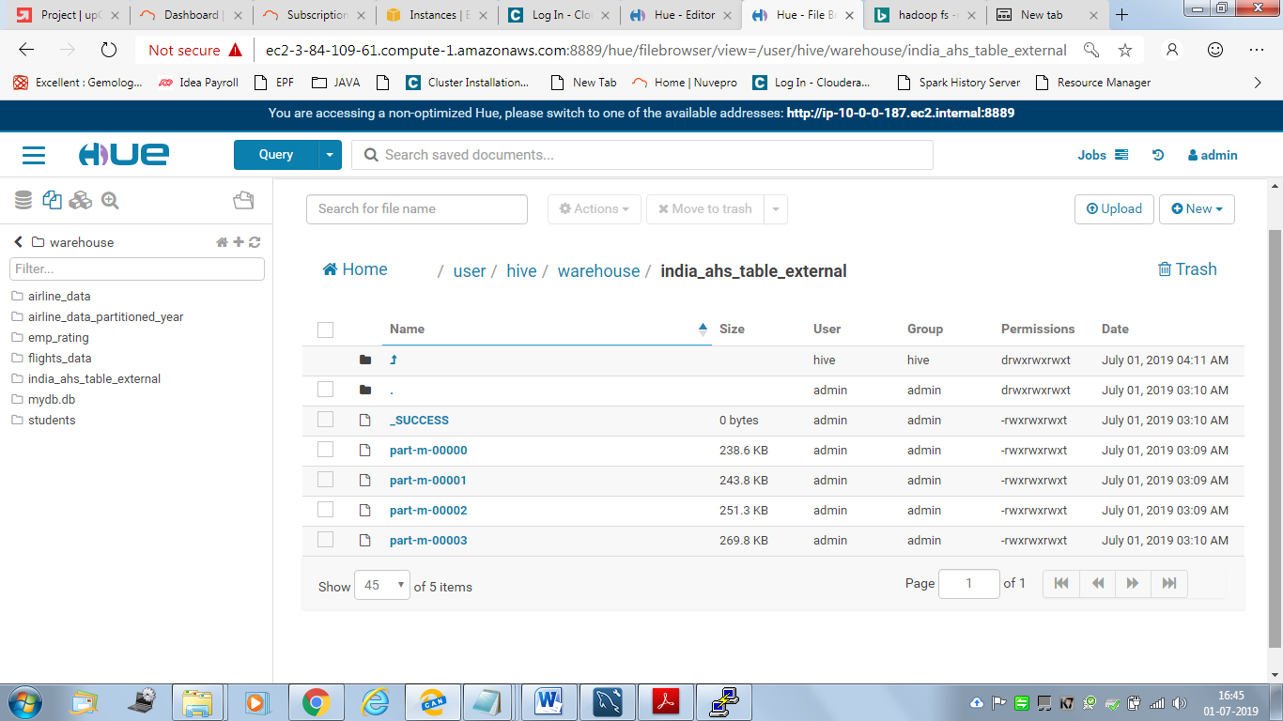

**3. Queries to verify that the ingestion is correctly accomplished**

a. Query to count the total number of rows along with the screenshots of the data fetched by the query on MySQL Workbench and Hue

**MySQL Workbench:**

**Query:**

select count(*) from Key_indicator_districtwise;

**Output : 284**

<Screenshot>

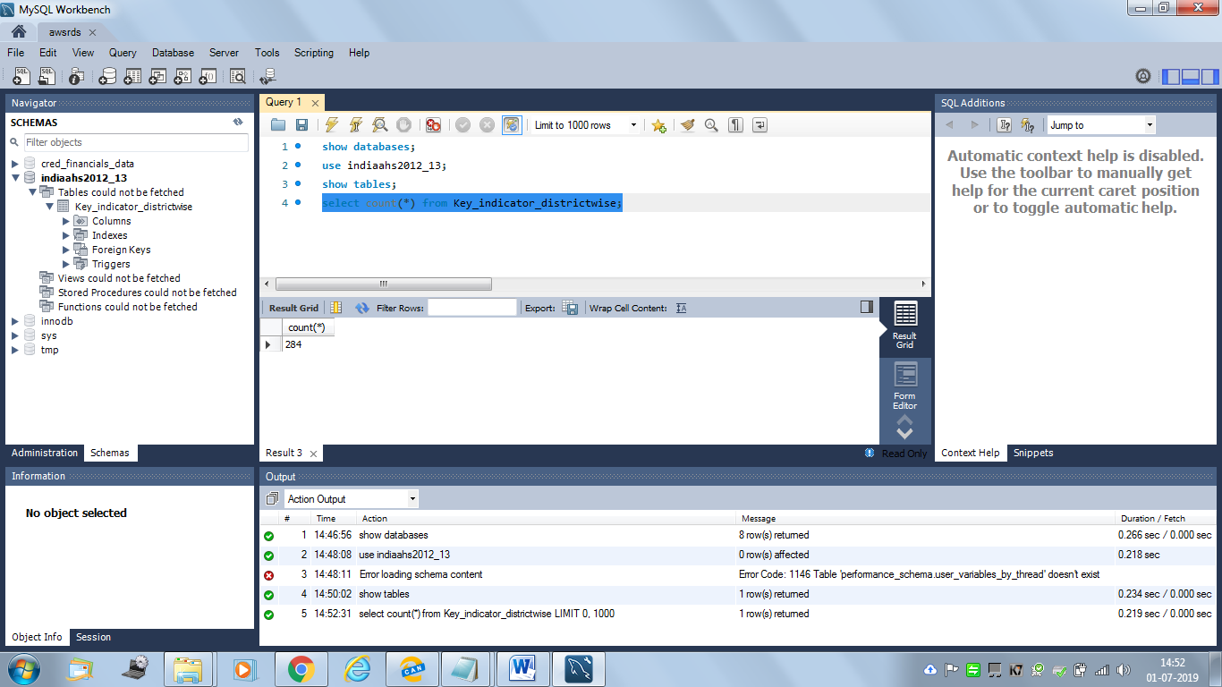

**Hue:**

select count(*) from india_ahs_table_external;

**Output: 284**

<Screenshot>

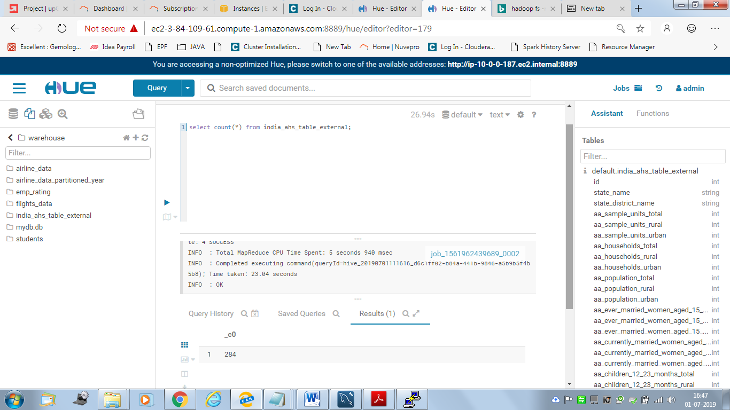

b. Query to select the top 10 rows and first 8 columns along with the screenshots of the data fetched by the query on MySQL Workbench and Hue

**MySQL Workbench:**

**Query:**

Select ID, State_Name,State_District_Name,AA_Sample_Units_Total,AA_Sample_Units_Rural,AA_Sample_Units_Urban,AA_Households_Total,AA_Households_Rural from Key_indicator_districtwise limit 10;

<Screenshot>

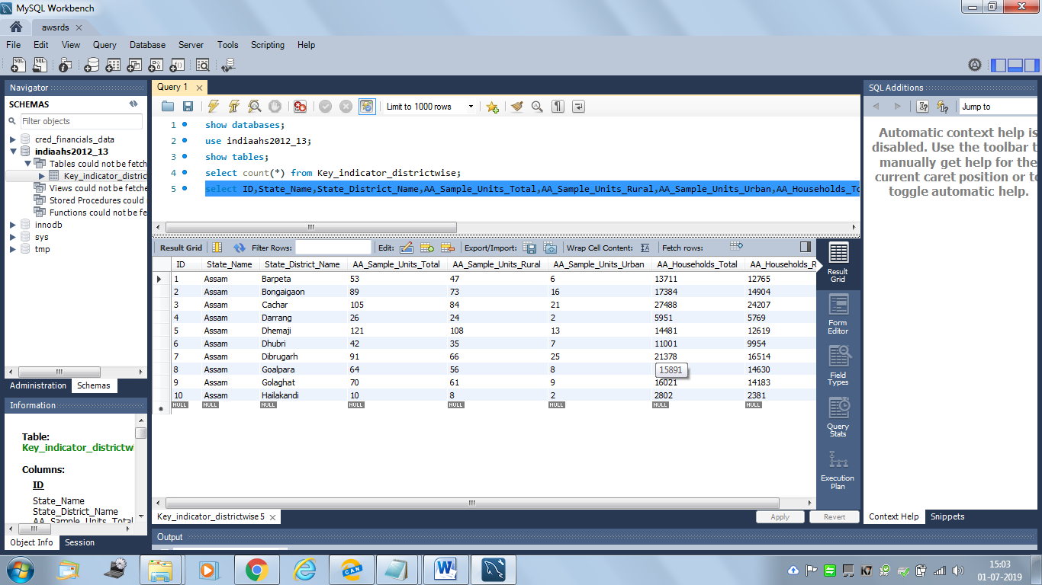

**Hue:**

**Query:**

Select ID, State_Name,State_District_Name,AA_Sample_Units_Total,AA_Sample_Units_Rural,AA_Sample_Units_Urban,AA_Households_Total,AA_Households_Rural from india_ahs_table_external limit 10;

<Screenshot>

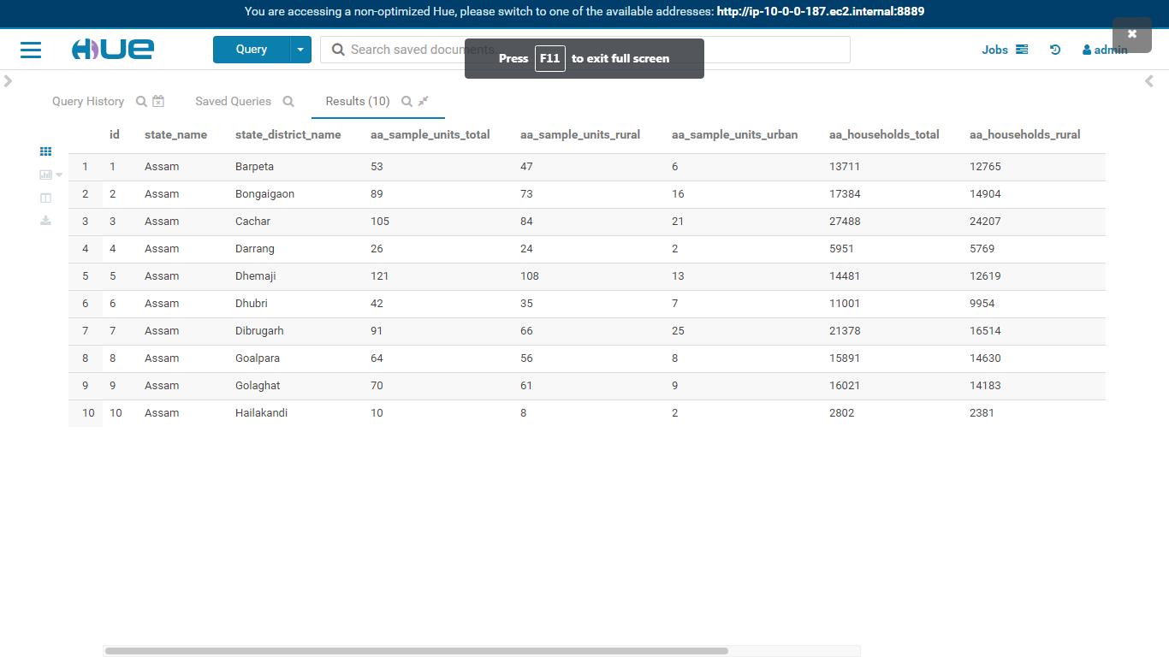

|  |  |  |  |  |  |  |  |
| --- | --- | --- | --- | --- | --- | --- | --- |
| **id** | **state_name** | **state_district_name** | **aa_sample_units_total** | **aa_sample_units_rural** | **aa_sample_units_urban** | **aa_households_total** | **aa_households_rural** |
| **1** | **Assam** | **Barpeta** | **53** | **47** | **6** | **13711** | **12765** |
| **2** | **Assam** | **Bongaigaon** | **89** | **73** | **16** | **17384** | **14904** |
| **3** | **Assam** | **Cachar** | **105** | **84** | **21** | **27488** | **24207** |
| **4** | **Assam** | **Darrang** | **26** | **24** | **2** | **5951** | **5769** |
| **5** | **Assam** | **Dhemaji** | **121** | **108** | **13** | **14481** | **12619** |
| **6** | **Assam** | **Dhubri** | **42** | **35** | **7** | **11001** | **9954** |
| **7** | **Assam** | **Dibrugarh** | **91** | **66** | **25** | **21378** | **16514** |
| **8** | **Assam** | **Goalpara** | **64** | **56** | **8** | **15891** | **14630** |
| **9** | **Assam** | **Golaghat** | **70** | **61** | **9** | **16021** | **14183** |
| **10** | **Assam** | **Hailakandi** | **10** | **8** | **2** | **2802** | **2381** |

**MySQL Workbench and HUE query result verified , both outputs are same.Ingestion is correctly accomplished**

***Subset schema creation in Hive to support the analyses:***

1. **Columns used in the subset schema**

ID

State_Name

State_District_Name

AA_Households_Total

AA_Population_Total

CC_Sex_Ratio_All_Ages_Total

LL_Total_Fertility_Rate_Total

YY_Under_Five_Mortality_Rate_U5MR_Total_Person

**2. Storage format used**

DEFAULT (Text) and ORC storage format

**3. Create and insert command for the default format**

<Create command>

CREATE TABLE IF NOT EXISTS india_ahs_table_subset_default(

ID INT,

State_Name STRING,

State_District_Name STRING,

AA_Households_Total INT,

AA_Population_Total INT,

CC_Sex_Ratio_All_Ages_Total FLOAT,

LL_Total_Fertility_Rate_Total FLOAT,

YY_Under_Five_Mortality_Rate_U5MR_Total_Person INT)

COMMENT 'Subset schema with Default text format with Snappy Compression'

ROW FORMAT DELIMITED FIELDS TERMINATED BY ','

STORED AS TEXTFILE

tblproperties ("textfile.compress"="SNAPPY");

<Insert command>

INSERT INTO TABLE india_ahs_table_subset_default

SELECT id,state_name, state_district_name,aa_households_total,aa_population_total,cc_sex_ratio_all_ages_total,

ll_total_fertility_rate_total,yy_under_five_mortality_rate_u5mr_total_person

FROM india_ahs_table_external;

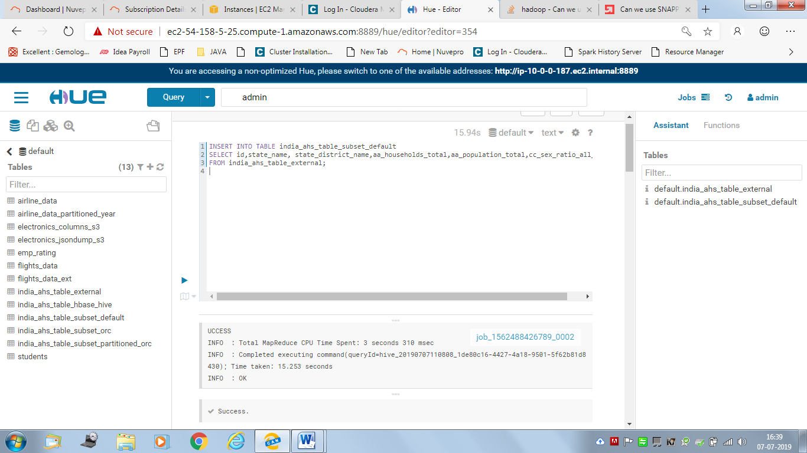

**4. Create and insert command for the formats such as ORC**

<Create command>

CREATE TABLE IF NOT EXISTS india_ahs_table_subset_orc (

ID INT,

State_Name STRING,

State_District_Name STRING,

AA_Households_Total INT,

AA_Population_Total INT,

CC_Sex_Ratio_All_Ages_Total FLOAT,

LL_Total_Fertility_Rate_Total FLOAT,

YY_Under_Five_Mortality_Rate_U5MR_Total_Person INT)

COMMENT'subset schema with orc format with Snappy Compression'

stored as orc

tblproperties ("orc.compress"="SNAPPY");

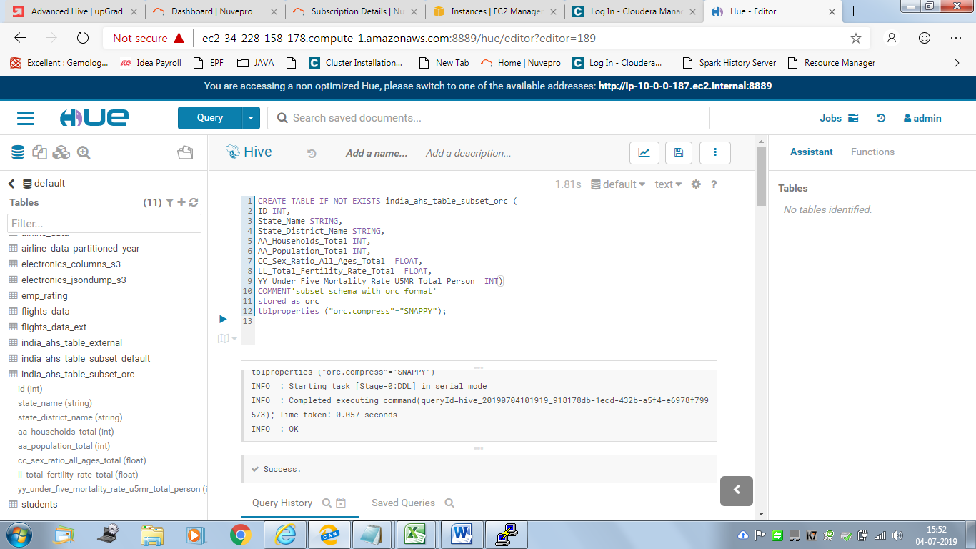

<Insert command>

INSERT INTO TABLE india_ahs_table_subset_orc

SELECT ID,State_Name,State_District_Name,AA_Households_Total,AA_Population_Total,

CC_Sex_Ratio_All_Ages_Total,LL_Total_Fertility_Rate_Total,

YY_Under_Five_Mortality_Rate_U5MR_Total_Person

FROM india_ahs_table_external;

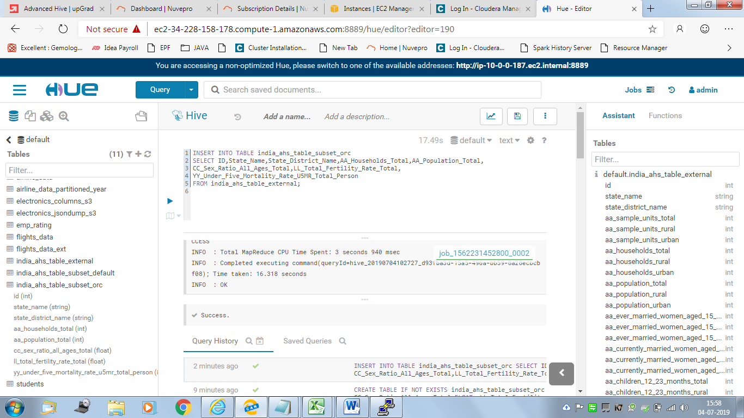

**5. Create and insert command for the Hive-HBase integrated table**

<Create command>

CREATE TABLE IF NOT EXISTS india_ahs_table_hbase_hive(

ID INT,

State_Name STRING,

State_District_Name STRING,

AA_Households_Total INT,

AA_Population_Total INT,

CC_Sex_Ratio_All_Ages_Total FLOAT,

LL_Total_Fertility_Rate_Total FLOAT,

YY_Under_Five_Mortality_Rate_U5MR_Total_Person INT)

STORED BY 'org.apache.hadoop.hive.hbase.HBaseStorageHandler'

WITH SERDEPROPERTIES ("hbase.columns.mapping" = ":key,cf1:State_Name,cf1:

State_District_Name,cf1:AA_Households_Total,cf1:AA_Population_Total,

cf1:CC_Sex_Ratio_All_Ages_Total,cf1:LL_Total_Fertility_Rate_Total,

cf1:YY_Under_Five_Mortality_Rate_U5MR_Total_Person")

TBLPROPERTIES ("hbase.table.name" = "india_ahs_table_hive");

<Insert command>

INSERT overwrite TABLE india_ahs_table_hbase_hive

SELECT id, state_name, state_district_name,aa_households_total,aa_population_total,cc_sex_ratio_all_ages_total,ll_total_fertility_rate_total,yy_under_five_mortality_rate_u5mr_total_person

FROM india_ahs_table_subset_default;

**6. Screenshot of runtimes against each query given above for the default format, formats such as ORC format as well as Hive-Hbase integration**

**For default format:**

<Screenshot of run time for query 1>

Select count(*) from india_ahs_table_subset_default;

Time taken: 23.073 seconds

INFO : Compiling command(queryId=hive_20201224111616_0feebe16-2ac6-478e-b8dc-2c9bbd503bae):

Select count(*) from india_ahs_table_subset_default

INFO : Semantic Analysis Completed

INFO : Returning Hive schema: Schema(fieldSchemas:[FieldSchema(name:_c0, type:bigint, comment:null)], properties:null)

INFO : Completed compiling command(queryId=hive_20201224111616_0feebe16-2ac6-478e-b8dc-2c9bbd503bae); Time taken: 0.048 seconds

INFO : Executing command(queryId=hive_20201224111616_0feebe16-2ac6-478e-b8dc-2c9bbd503bae):

Select count(*) from india_ahs_table_subset_default

INFO : Query ID = hive_20201224111616_0feebe16-2ac6-478e-b8dc-2c9bbd503bae

INFO : Total jobs = 1

INFO : Launching Job 1 out of 1

INFO : Starting task [Stage-1:MAPRED] in serial mode

INFO : Number of reduce tasks determined at compile time: 1

INFO : In order to change the average load for a reducer (in bytes):

INFO : set hive.exec.reducers.bytes.per.reducer=<number>

INFO : In order to limit the maximum number of reducers:

INFO : set hive.exec.reducers.max=<number>

INFO : In order to set a constant number of reducers:

INFO : set mapreduce.job.reduces=<number>

INFO : number of splits:1

INFO : Submitting tokens for job: job_1562488426789_0003

INFO : The url to track the job: http://ip-10-0-0-187.ec2.internal:8088/proxy/application_1562488426789_0003/

INFO : Starting Job = job_1562488426789_0003, Tracking URL = http://ip-10-0-0-187.ec2.internal:8088/proxy/application_1562488426789_0003/

INFO : Kill Command = /opt/cloudera/parcels/CDH-5.15.1-1.cdh5.15.1.p0.4/lib/hadoop/bin/hadoop job -kill job_1562488426789_0003

INFO : Hadoop job information for Stage-1: number of mappers: 1; number of reducers: 1

INFO : 2020-12-24 11:16:13,782 Stage-1 map = 0%, reduce = 0%

INFO : 2020-12-24 11:16:20,071 Stage-1 map = 100%, reduce = 0%, Cumulative CPU 2.1 sec

INFO : 2020-12-24 11:16:27,372 Stage-1 map = 100%, reduce = 100%, Cumulative CPU 4.82 sec

INFO : MapReduce Total cumulative CPU time: 4 seconds 820 msec

INFO : Ended Job = job_1562488426789_0003

INFO : MapReduce Jobs Launched:

INFO : Stage-Stage-1: Map: 1 Reduce: 1 Cumulative CPU: 4.82 sec HDFS Read: 23217 HDFS Write: 4 SUCCESS

INFO : Total MapReduce CPU Time Spent: 4 seconds 820 msec

INFO : Completed executing command(queryId=hive_20201224111616_0feebe16-2ac6-478e-b8dc-2c9bbd503bae); Time taken: 23.073 seconds

INFO : OK

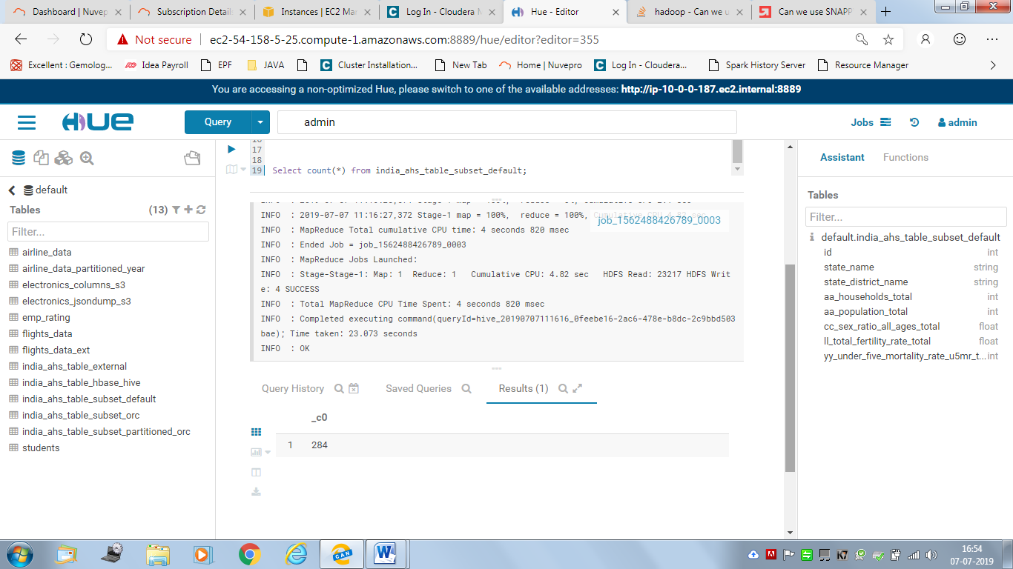

<Screenshot of run time for query 2>

select State_Name, count(*) from india_ahs_table_subset_default group by State_Name;

Time taken: 22.23 seconds

job_1562231452800_0018

INFO : Compiling command(queryId=hive_20201227111717_999ec95e-b511-48cd-9325-880f853f8143): select State_Name, count(*) from india_ahs_table_subset_default group by State_Name

INFO : Semantic Analysis Completed

INFO : Returning Hive schema: Schema(fieldSchemas:[FieldSchema(name:state_name, type:string, comment:null), FieldSchema(name:_c1, type:bigint, comment:null)], properties:null)

INFO : Completed compiling command(queryId=hive_20201227111717_999ec95e-b511-48cd-9325-880f853f8143); Time taken: 0.037 seconds

INFO : Executing command(queryId=hive_20201227111717_999ec95e-b511-48cd-9325-880f853f8143): select State_Name, count(*) from india_ahs_table_subset_default group by State_Name

INFO : Query ID = hive_20201227111717_999ec95e-b511-48cd-9325-880f853f8143

INFO : Total jobs = 1

INFO : Launching Job 1 out of 1

INFO : Starting task [Stage-1:MAPRED] in serial mode

INFO : Number of reduce tasks not specified. Estimated from input data size: 1

INFO : In order to change the average load for a reducer (in bytes):

INFO : set hive.exec.reducers.bytes.per.reducer=<number>

INFO : In order to limit the maximum number of reducers:

INFO : set hive.exec.reducers.max=<number>

INFO : In order to set a constant number of reducers:

INFO : set mapreduce.job.reduces=<number>

INFO : number of splits:1

INFO : Submitting tokens for job: job_1562231452800_0018

INFO : The url to track the job: http://ip-10-0-0-187.ec2.internal:8088/proxy/application_1562231452800_0018/

INFO : Starting Job = job_1562231452800_0018, Tracking URL = http://ip-10-0-0-187.ec2.internal:8088/proxy/application_1562231452800_0018/

INFO : Kill Command = /opt/cloudera/parcels/CDH-5.15.1-1.cdh5.15.1.p0.4/lib/hadoop/bin/hadoop job -kill job_1562231452800_0018

INFO : Hadoop job information for Stage-1: number of mappers: 1; number of reducers: 1

INFO : 2020-12-24 11:17:27,915 Stage-1 map = 0%, reduce = 0%

INFO : 2020-12-24 11:17:35,288 Stage-1 map = 100%, reduce = 0%, Cumulative CPU 2.27 sec

INFO : 2020-12-24 11:17:40,522 Stage-1 map = 100%, reduce = 100%, Cumulative CPU 5.44 sec

INFO : MapReduce Total cumulative CPU time: 5 seconds 440 msec

INFO : Ended Job = job_1562231452800_0018

INFO : MapReduce Jobs Launched:

INFO : Stage-Stage-1: Map: 1 Reduce: 1 Cumulative CPU: 5.44 sec HDFS Read: 23613 HDFS Write: 120 SUCCESS

INFO : Total MapReduce CPU Time Spent: 5 seconds 440 msec

INFO : Completed executing command(queryId=hive_020201224111717_999ec95e-b511-48cd-9325-880f853f8143); Time taken: 22.231 seconds

INFO : OK

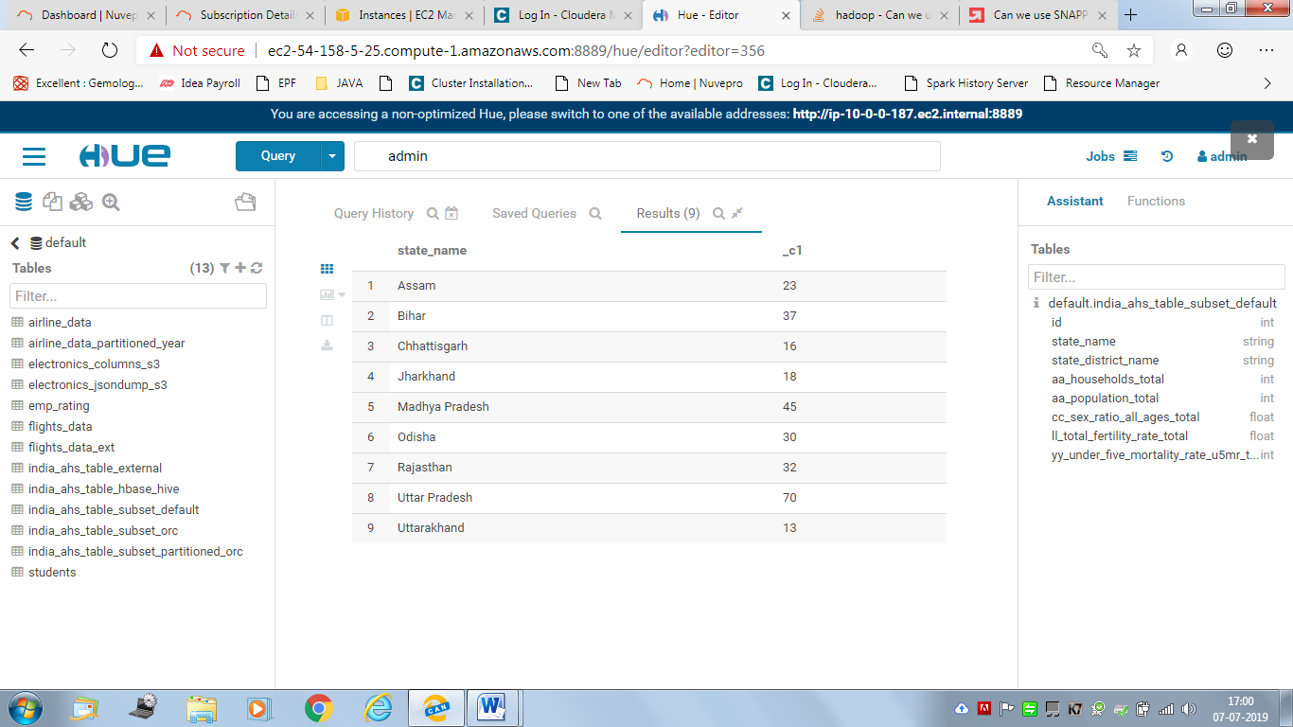

<Screenshot of run time for query 3>

select * from india_ahs_table_subset_default where State_Name = 'Uttar Pradesh';

Time taken: 16.549 seconds

INFO : Compiling command(queryId=hive_20201224113333_3171c845-008c-4b7d-a0db-e61bdab5a9be): select * from india_ahs_table_subset_default where State_Name = 'Uttar Pradesh'

INFO : Semantic Analysis Completed

INFO : Returning Hive schema: Schema(fieldSchemas:[FieldSchema(name:india_ahs_table_subset_default.id, type:int, comment:null), FieldSchema(name:india_ahs_table_subset_default.state_name, type:string, comment:null), FieldSchema(name:india_ahs_table_subset_default.state_district_name, type:string, comment:null), FieldSchema(name:india_ahs_table_subset_default.aa_households_total, type:int, comment:null), FieldSchema(name:india_ahs_table_subset_default.aa_population_total, type:int, comment:null), FieldSchema(name:india_ahs_table_subset_default.cc_sex_ratio_all_ages_total, type:float, comment:null), FieldSchema(name:india_ahs_table_subset_default.ll_total_fertility_rate_total, type:float, comment:null), FieldSchema(name:india_ahs_table_subset_default.yy_under_five_mortality_rate_u5mr_total_person, type:int, comment:null)], properties:null)

INFO : Completed compiling command(queryId=hive_20201224113333_3171c845-008c-4b7d-a0db-e61bdab5a9be); Time taken: 0.04 seconds

INFO : Executing command(queryId=hive_20201224113333_3171c845-008c-4b7d-a0db-e61bdab5a9be): select * from india_ahs_table_subset_default where State_Name = 'Uttar Pradesh'

INFO : Query ID = hive_20201224113333_3171c845-008c-4b7d-a0db-e61bdab5a9be

INFO : Total jobs = 1

INFO : Launching Job 1 out of 1

INFO : Starting task [Stage-1:MAPRED] in serial mode

INFO : Number of reduce tasks is set to 0 since there's no reduce operator

INFO : number of splits:1

INFO : Submitting tokens for job: job_1562488426789_0005

INFO : The url to track the job: http://ip-10-0-0-187.ec2.internal:8088/proxy/application_1562488426789_0005/

INFO : Starting Job = job_1562488426789_0005, Tracking URL = http://ip-10-0-0-187.ec2.internal:8088/proxy/application_1562488426789_0005/

INFO : Kill Command = /opt/cloudera/parcels/CDH-5.15.1-1.cdh5.15.1.p0.4/lib/hadoop/bin/hadoop job -kill job_1562488426789_0005

INFO : Hadoop job information for Stage-1: number of mappers: 1; number of reducers: 0

INFO : 2020-12-24 11:33:29,479 Stage-1 map = 0%, reduce = 0%

INFO : 2020-12-24 11:33:35,760 Stage-1 map = 100%, reduce = 0%, Cumulative CPU 3.79 sec

INFO : MapReduce Total cumulative CPU time: 3 seconds 790 msec

INFO : Ended Job = job_1562488426789_0005

INFO : MapReduce Jobs Launched:

INFO : Stage-Stage-1: Map: 1 Cumulative CPU: 3.79 sec HDFS Read: 20069 HDFS Write: 3843 SUCCESS

INFO : Total MapReduce CPU Time Spent: 3 seconds 790 msec

INFO : Completed executing command(queryId=hive_20201224113333_3171c845-008c-4b7d-a0db-e61bdab5a9be); Time taken: 16.549 seconds

INFO : OK

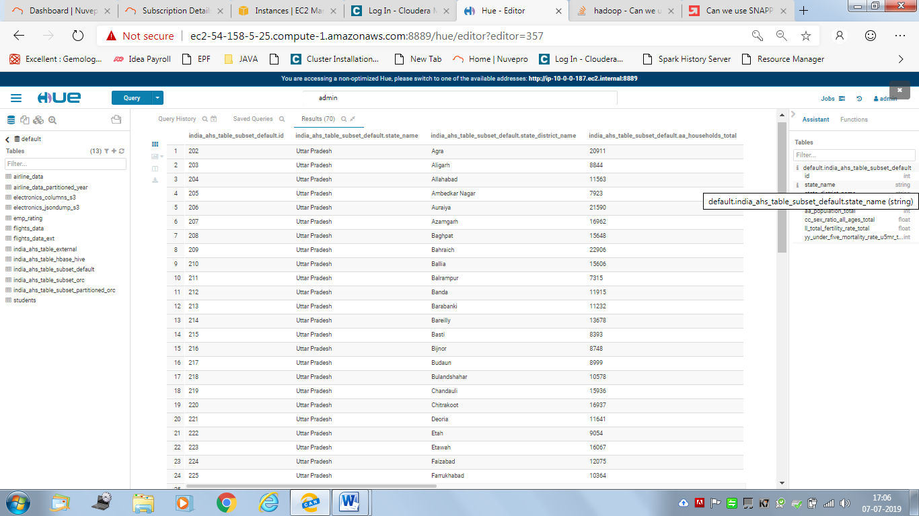

**For ORC Format:**

<Screenshot of run time for query 1>

Select count(*) from india_ahs_table_subset_orc;

Runtimes:21.048 secs

turning Hive schema: Schema(fieldSchemas:[FieldSchema(name:_c0, type:bigint, comment:null)], properties:null)

INFO : Completed compiling command(queryId=hive_20210110110606_c2ce6081-09b3-49f9-b746-12ef0c94de3b); Time taken: 0.042 seconds

INFO : Executing command(queryId=hive_20210110110606_c2ce6081-09b3-49f9-b746-12ef0c94de3b): Select count(*) from india_ahs_table_subset_orc

INFO : Query ID = hive_20210110110606_c2ce6081-09b3-49f9-b746-12ef0c94de3b

INFO : Total jobs = 1

INFO : Launching Job 1 out of 1

INFO : Starting task [Stage-1:MAPRED] in serial mode

INFO : Number of reduce tasks determined at compile time: 1

INFO : In order to change the average load for a reducer (in bytes):

INFO : set hive.exec.reducers.bytes.per.reducer=<number>

INFO : In order to limit the maximum number of reducers:

INFO : set hive.exec.reducers.max=<number>

INFO : In order to set a constant number of reducers:

INFO : set mapreduce.job.reduces=<number>

INFO : number of splits:1

INFO : Submitting tokens for job: job_1562231452800_0012

INFO : The url to track the job: http://ip-10-0-0-187.ec2.internal:8088/proxy/application_1562231452800_0012/

INFO : Starting Job = job_1562231452800_0012, Tracking URL = http://ip-10-0-0-187.ec2.internal:8088/proxy/application_1562231452800_0012/

INFO : Kill Command = /opt/cloudera/parcels/CDH-5.15.1-1.cdh5.15.1.p0.4/lib/hadoop/bin/hadoop job -kill job_1562231452800_0012

INFO : Hadoop job information for Stage-1: number of mappers: 1; number of reducers: 1

INFO : 2021-01-10 11:06:16,923 Stage-1 map = 0%, reduce = 0%

INFO : 2021-01-10 11:06:23,173 Stage-1 map = 100%, reduce = 0%, Cumulative CPU 2.94 sec

INFO : 2021-01-10 11:06:28,374 Stage-1 map = 100%, reduce = 100%, Cumulative CPU 5.9 sec

INFO : MapReduce Total cumulative CPU time: 5 seconds 900 msec

INFO : Ended Job = job_1562231452800_0012

INFO : MapReduce Jobs Launched:

INFO : Stage-Stage-1: Map: 1 Reduce: 1 Cumulative CPU: 5.9 sec HDFS Read: 23118 HDFS Write: 4 SUCCESS

INFO : Total MapReduce CPU Time Spent: 5 seconds 900 msec

INFO : Completed executing command(queryId=hive_20210110110606_c2ce6081-09b3-49f9-b746-12ef0c94de3b); Time taken: 21.048 seconds

INFO : OK

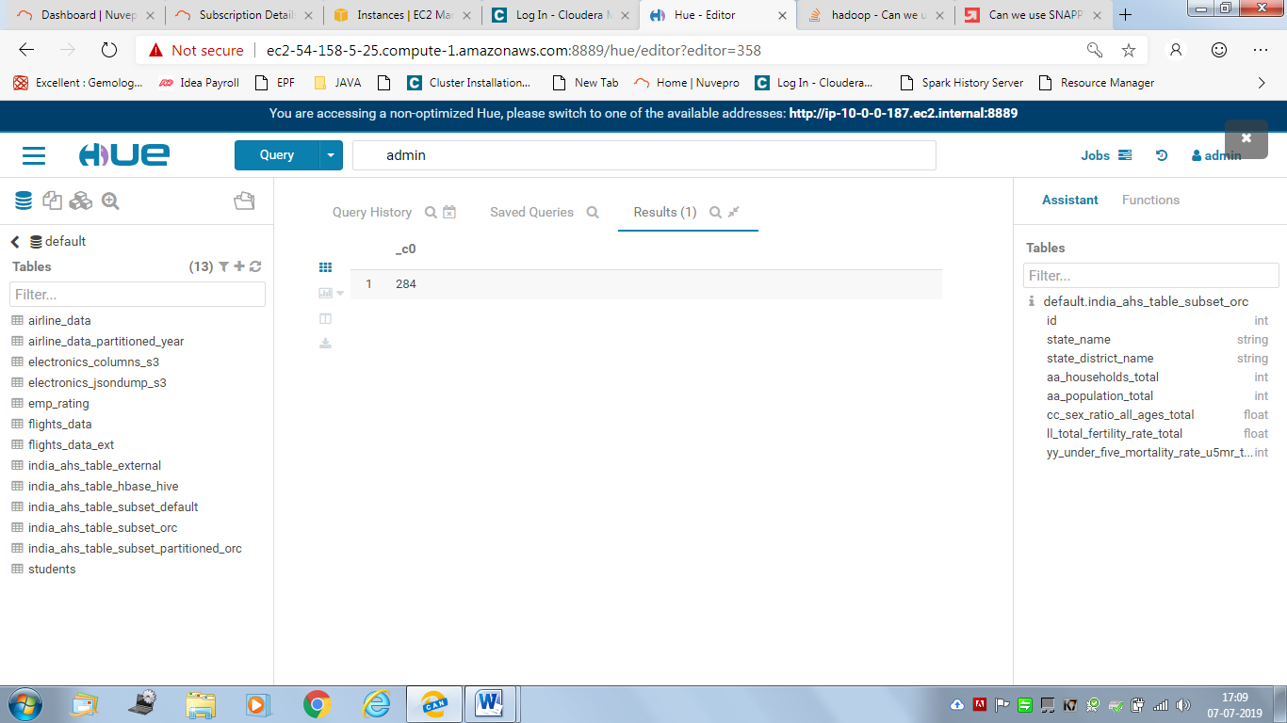

<Screenshot of run time for query 2>

select State_Name, count(*) from india_ahs_table_subset_orc group by State_Name;

Runtimes:19.61 secs

job_1562231452800_0020

INFO : Compiling command(queryId=hive_20210110111919_c4ae8962-7100-41de-b74b-d0369deea513): select State_Name, count(*) from india_ahs_table_subset_orc group by State_Name

INFO : Semantic Analysis Completed

INFO : Returning Hive schema: Schema(fieldSchemas:[FieldSchema(name:state_name, type:string, comment:null), FieldSchema(name:_c1, type:bigint, comment:null)], properties:null)

INFO : Completed compiling command(queryId=hive_20210110111919_c4ae8962-7100-41de-b74b-d0369deea513); Time taken: 0.041 seconds

INFO : Executing command(queryId=hive_20210110111919_c4ae8962-7100-41de-b74b-d0369deea513): select State_Name, count(*) from india_ahs_table_subset_orc group by State_Name

INFO : Query ID = hive_20210110111919_c4ae8962-7100-41de-b74b-d0369deea513

INFO : Total jobs = 1

INFO : Launching Job 1 out of 1

INFO : Starting task [Stage-1:MAPRED] in serial mode

INFO : Number of reduce tasks not specified. Estimated from input data size: 1

INFO : In order to change the average load for a reducer (in bytes):

INFO : set hive.exec.reducers.bytes.per.reducer=<number>

INFO : In order to limit the maximum number of reducers:

INFO : set hive.exec.reducers.max=<number>

INFO : In order to set a constant number of reducers:

INFO : set mapreduce.job.reduces=<number>

INFO : number of splits:1

INFO : Submitting tokens for job: job_1562231452800_0020

INFO : The url to track the job: http://ip-10-0-0-187.ec2.internal:8088/proxy/application_1562231452800_0020/

INFO : Starting Job = job_1562231452800_0020, Tracking URL = http://ip-10-0-0-187.ec2.internal:8088/proxy/application_1562231452800_0020/

INFO : Kill Command = /opt/cloudera/parcels/CDH-5.15.1-1.cdh5.15.1.p0.4/lib/hadoop/bin/hadoop job -kill job_1562231452800_0020

INFO : Hadoop job information for Stage-1: number of mappers: 1; number of reducers: 1

INFO : 2021-01-10 11:19:44,663 Stage-1 map = 0%, reduce = 0%

INFO : 2021-01-10 11:19:50,920 Stage-1 map = 100%, reduce = 0%, Cumulative CPU 2.86 sec

INFO : 2021-01-10 11:19:57,166 Stage-1 map = 100%, reduce = 100%, Cumulative CPU 5.89 sec

INFO : MapReduce Total cumulative CPU time: 5 seconds 890 msec

INFO : Ended Job = job_1562231452800_0020

INFO : MapReduce Jobs Launched:

INFO : Stage-Stage-1: Map: 1 Reduce: 1 Cumulative CPU: 5.89 sec HDFS Read: 24034 HDFS Write: 120 SUCCESS

INFO : Total MapReduce CPU Time Spent: 5 seconds 890 msec

INFO : Completed executing command(queryId=hive_20210110111919_c4ae8962-7100-41de-b74b-d0369deea513); Time taken: 19.614 seconds

INFO : OK

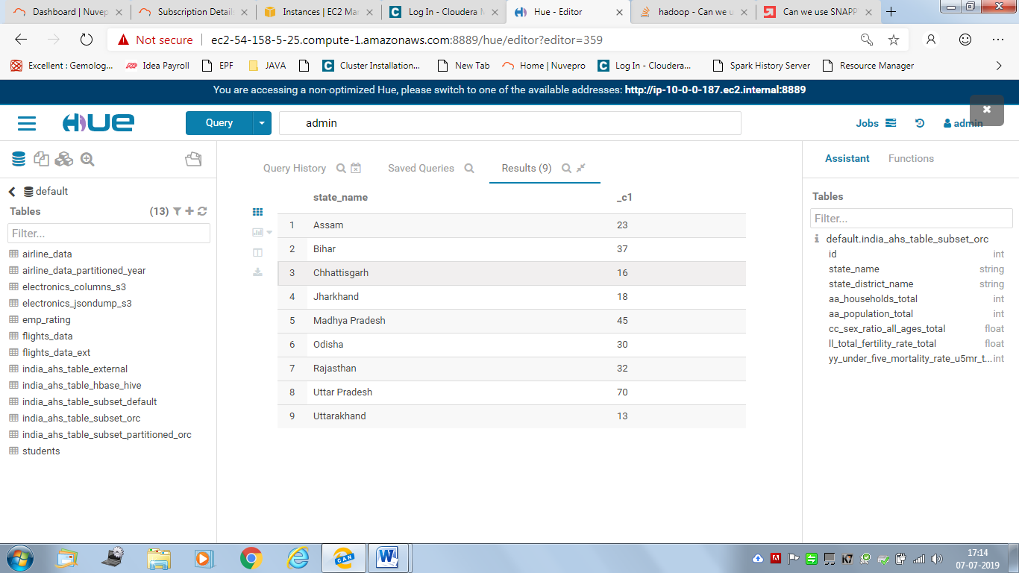

<Screenshot of run time for query 3>

select * from india_ahs_table_subset_orc where State_Name='Uttar Pradesh';

Time taken: 15.099 seconds

INFO : Compiling command(queryId=hive_20210110114848_8ff228cb-4aeb-438d-ac7e-c5ef1f21ca36): select * from india_ahs_table_subset_orc where State_Name='Uttar Pradesh'

INFO : Semantic Analysis Completed

INFO : Returning Hive schema: Schema(fieldSchemas:[FieldSchema(name:india_ahs_table_subset_orc.id, type:int, comment:null), FieldSchema(name:india_ahs_table_subset_orc.state_name, type:string, comment:null), FieldSchema(name:india_ahs_table_subset_orc.state_district_name, type:string, comment:null), FieldSchema(name:india_ahs_table_subset_orc.aa_households_total, type:int, comment:null), FieldSchema(name:india_ahs_table_subset_orc.aa_population_total, type:int, comment:null), FieldSchema(name:india_ahs_table_subset_orc.cc_sex_ratio_all_ages_total, type:float, comment:null), FieldSchema(name:india_ahs_table_subset_orc.ll_total_fertility_rate_total, type:float, comment:null), FieldSchema(name:india_ahs_table_subset_orc.yy_under_five_mortality_rate_u5mr_total_person, type:int, comment:null)], properties:null)

INFO : Completed compiling command(queryId=hive_20210110114848_8ff228cb-4aeb-438d-ac7e-c5ef1f21ca36); Time taken: 0.045 seconds

INFO : Executing command(queryId=hive_20210110114848_8ff228cb-4aeb-438d-ac7e-c5ef1f21ca36): select * from india_ahs_table_subset_orc where State_Name='Uttar Pradesh'

INFO : Query ID = hive_20210110114848_8ff228cb-4aeb-438d-ac7e-c5ef1f21ca36

INFO : Total jobs = 1

INFO : Launching Job 1 out of 1

INFO : Starting task [Stage-1:MAPRED] in serial mode

INFO : Number of reduce tasks is set to 0 since there's no reduce operator

INFO : number of splits:1

INFO : Submitting tokens for job: job_1562488426789_0009

INFO : The url to track the job: http://ip-10-0-0-187.ec2.internal:8088/proxy/application_1562488426789_0009/

INFO : Starting Job = job_1562488426789_0009, Tracking URL = http://ip-10-0-0-187.ec2.internal:8088/proxy/application_1562488426789_0009/

INFO : Kill Command = /opt/cloudera/parcels/CDH-5.15.1-1.cdh5.15.1.p0.4/lib/hadoop/bin/hadoop job -kill job_1562488426789_0009

INFO : Hadoop job information for Stage-1: number of mappers: 1; number of reducers: 0

INFO : 2021-01-10 11:48:29,677 Stage-1 map = 0%, reduce = 0%

INFO : 2021-01-10 11:48:36,031 Stage-1 map = 100%, reduce = 0%, Cumulative CPU 3.64 sec

INFO : MapReduce Total cumulative CPU time: 3 seconds 640 msec

INFO : Ended Job = job_1562488426789_0009

INFO : MapReduce Jobs Launched:

INFO : Stage-Stage-1: Map: 1 Cumulative CPU: 3.64 sec HDFS Read: 21401 HDFS Write: 3843 SUCCESS

INFO : Total MapReduce CPU Time Spent: 3 seconds 640 msec

INFO : Completed executing command(queryId=hive_20210110114848_8ff228cb-4aeb-438d-ac7e-c5ef1f21ca36); Time taken: 15.099 seconds

INFO : OK

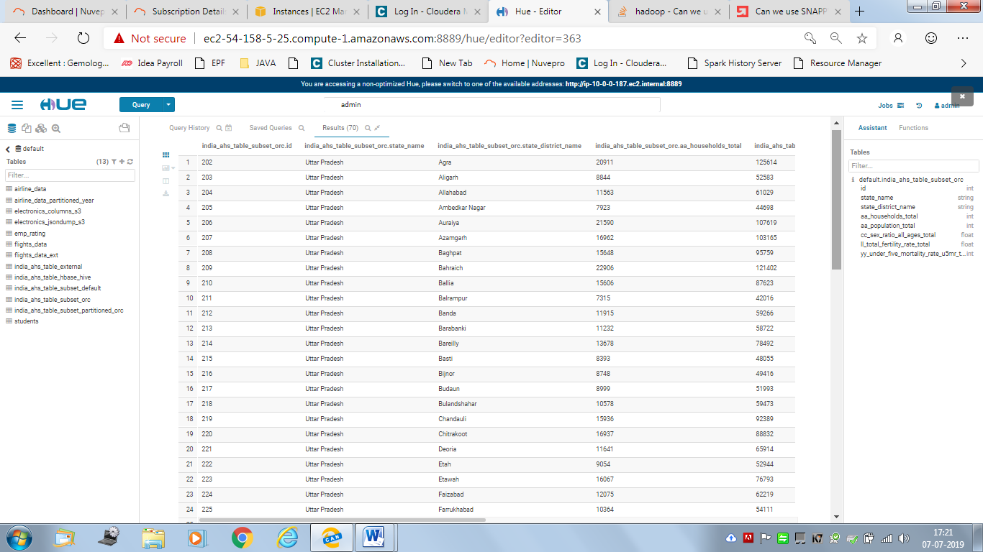

**For Hive-Hbase Integrated Table:**

<Screenshot of run time for query 1>

Select count(*) from india_ahs_table_hbase_hive;

**Time taken: 26.952 seconds**

**Output : 284**

job_1562418810792_0002

INFO : Compiling command(queryId=hive_20210110161616_947258a0-574b-4cfc-a8b4-8acea4fd4fdc): Select count(*) from india_ahs_table_hbase_hive

INFO : Semantic Analysis Completed

INFO : Returning Hive schema: Schema(fieldSchemas:[FieldSchema(name:_c0, type:bigint, comment:null)], properties:null)

INFO : Completed compiling command(queryId=hive_20210110161616_947258a0-574b-4cfc-a8b4-8acea4fd4fdc); Time taken: 0.128 seconds

INFO : Executing command(queryId=hive_20210110161616_947258a0-574b-4cfc-a8b4-8acea4fd4fdc): Select count(*) from india_ahs_table_hbase_hive

INFO : Query ID = hive_20210110161616_947258a0-574b-4cfc-a8b4-8acea4fd4fdc

INFO : Total jobs = 1

INFO : Launching Job 1 out of 1

INFO : Starting task [Stage-1:MAPRED] in serial mode

INFO : Number of reduce tasks determined at compile time: 1

INFO : In order to change the average load for a reducer (in bytes):

INFO : set hive.exec.reducers.bytes.per.reducer=<number>

INFO : In order to limit the maximum number of reducers:

INFO : set hive.exec.reducers.max=<number>

INFO : In order to set a constant number of reducers:

INFO : set mapreduce.job.reduces=<number>

INFO : number of splits:1

INFO : Submitting tokens for job: job_1562418810792_0002

INFO : The url to track the job: http://ip-10-0-0-187.ec2.internal:8088/proxy/application_1562418810792_0002/

INFO : Starting Job = job_1562418810792_0002, Tracking URL = http://ip-10-0-0-187.ec2.internal:8088/proxy/application_1562418810792_0002/

INFO : Kill Command = /opt/cloudera/parcels/CDH-5.15.1-1.cdh5.15.1.p0.4/lib/hadoop/bin/hadoop job -kill job_1562418810792_0002

INFO : Hadoop job information for Stage-1: number of mappers: 1; number of reducers: 1

INFO : 2021-01-10 16:16:28,519 Stage-1 map = 0%, reduce = 0%

INFO : 2021-01-10 16:16:36,040 Stage-1 map = 100%, reduce = 0%, Cumulative CPU 3.88 sec

INFO : 2021-01-10 16:16:42,311 Stage-1 map = 100%, reduce = 100%, Cumulative CPU 7.03 sec

INFO : MapReduce Total cumulative CPU time: 7 seconds 30 msec

INFO : Ended Job = job_1562418810792_0002

INFO : MapReduce Jobs Launched:

INFO : Stage-Stage-1: Map: 1 Reduce: 1 Cumulative CPU: 7.03 sec HDFS Read: 17339 HDFS Write: 4 SUCCESS

INFO : Total MapReduce CPU Time Spent: 7 seconds 30 msec

INFO : Completed executing command(queryId=hive_20210110161616_947258a0-574b-4cfc-a8b4-8acea4fd4fdc); Time taken: 26.952 seconds

INFO : OK

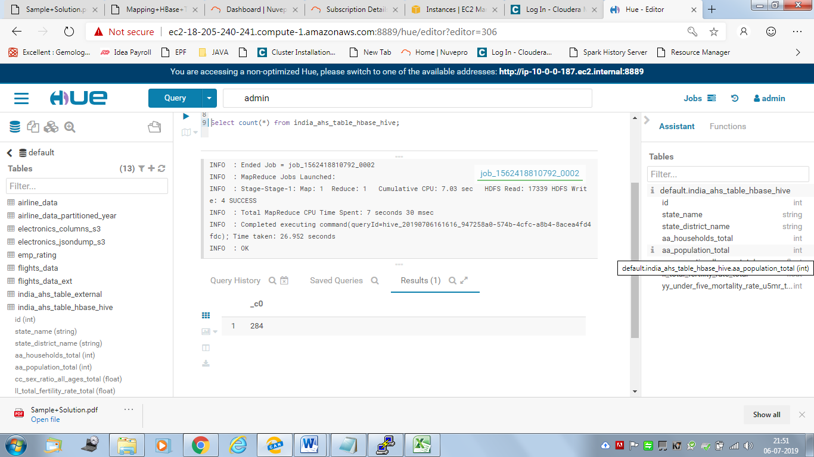

<Screenshot of run time for query 2>

select State_Name, count(*) from india_ahs_table_hbase_hive group by State_Name;

**Time taken: 25.888 seconds**

Output:

|  |  |
| --- | --- |
| state_name | _c1 |
| Assam | 23 |
| Bihar | 37 |
| Chhattisgarh | 16 |
| Jharkhand | 18 |
| Madhya Pradesh | 45 |
| Odisha | 30 |
| Rajasthan | 32 |
| Uttar Pradesh | 70 |
| Uttarakhand | 13 |

job_1562418810792_0003

INFO : Compiling command(queryId=hive_20210110162323_8b5b1c78-b336-47ab-ba53-57c816496cbe): select State_Name, count(*) from india_ahs_table_hbase_hive group by State_Name

INFO : Semantic Analysis Completed

INFO : Returning Hive schema: Schema(fieldSchemas:[FieldSchema(name:state_name, type:string, comment:null), FieldSchema(name:_c1, type:bigint, comment:null)], properties:null)

INFO : Completed compiling command(queryId=hive_20210110162323_8b5b1c78-b336-47ab-ba53-57c816496cbe); Time taken: 0.122 seconds

INFO : Executing command(queryId=hive_20210110162323_8b5b1c78-b336-47ab-ba53-57c816496cbe): select State_Name, count(*) from india_ahs_table_hbase_hive group by State_Name

INFO : Query ID = hive_20210110162323_8b5b1c78-b336-47ab-ba53-57c816496cbe

INFO : Total jobs = 1

INFO : Launching Job 1 out of 1

INFO : Starting task [Stage-1:MAPRED] in serial mode

INFO : Number of reduce tasks not specified. Estimated from input data size: 1

INFO : In order to change the average load for a reducer (in bytes):

INFO : set hive.exec.reducers.bytes.per.reducer=<number>

INFO : In order to limit the maximum number of reducers:

INFO : set hive.exec.reducers.max=<number>

INFO : In order to set a constant number of reducers:

INFO : set mapreduce.job.reduces=<number>

INFO : number of splits:1

INFO : Submitting tokens for job: job_1562418810792_0003

INFO : The url to track the job: http://ip-10-0-0-187.ec2.internal:8088/proxy/application_1562418810792_0003/

INFO : Starting Job = job_1562418810792_0003, Tracking URL = http://ip-10-0-0-187.ec2.internal:8088/proxy/application_1562418810792_0003/

INFO : Kill Command = /opt/cloudera/parcels/CDH-5.15.1-1.cdh5.15.1.p0.4/lib/hadoop/bin/hadoop job -kill job_1562418810792_0003

INFO : Hadoop job information for Stage-1: number of mappers: 1; number of reducers: 1

INFO : 2021-01-10 16:23:57,311 Stage-1 map = 0%, reduce = 0%

INFO : 2021-01-10 16:24:03,543 Stage-1 map = 100%, reduce = 0%, Cumulative CPU 3.73 sec

INFO : 2021-01-10 16:24:10,833 Stage-1 map = 100%, reduce = 100%, Cumulative CPU 6.65 sec

INFO : MapReduce Total cumulative CPU time: 6 seconds 650 msec

INFO : Ended Job = job_1562418810792_0003

INFO : MapReduce Jobs Launched:

INFO : Stage-Stage-1: Map: 1 Reduce: 1 Cumulative CPU: 6.65 sec HDFS Read: 17733 HDFS Write: 120 SUCCESS

INFO : Total MapReduce CPU Time Spent: 6 seconds 650 msec

INFO : Completed executing command(queryId=hive_20210110162323_8b5b1c78-b336-47ab-ba53-57c816496cbe); Time taken: 25.888 seconds

INFO : OK

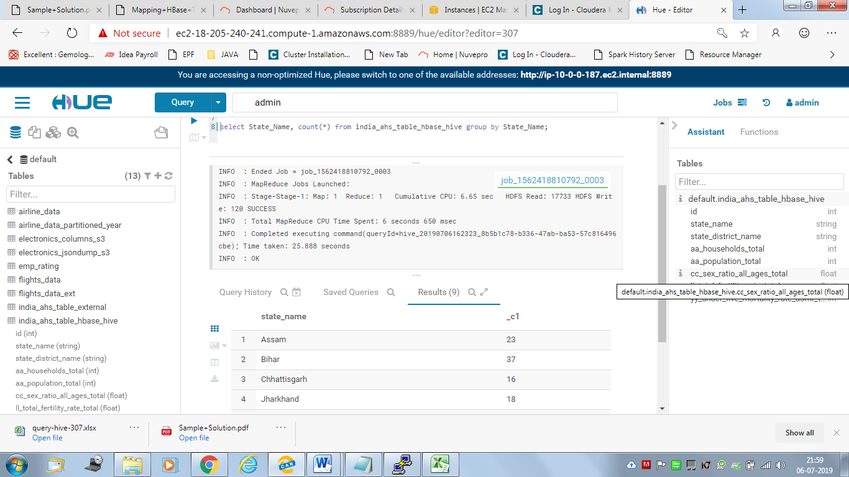

<Screenshot of run time for query 3>

select * from india_ahs_table_hbase_hive where State_Name = 'Uttar Pradesh';

Time taken: 17.845 seconds

Output: Export to EXCEL

|  |  |  |  |  |  |  |  |
| --- | --- | --- | --- | --- | --- | --- | --- |
| india_ahs_table_hbase_hive.id | india_ahs_table_hbase_hive.state_name | india_ahs_table_hbase_hive.state_district_name | india_ahs_table_hbase_hive.aa_households_total | india_ahs_table_hbase_hive.aa_population_total | india_ahs_table_hbase_hive.cc_sex_ratio_all_ages_total | india_ahs_table_hbase_hive.ll_total_fertility_rate_total | india_ahs_table_hbase_hive.yy_under_five_mortality_rate_u5mr_total_person |
| 202 | Uttar Pradesh | Agra | 20911 | 125614 | 873.4699707 | 3.019999981 | 69 |
| 203 | Uttar Pradesh | Aligarh | 8844 | 52583 | 910.7600098 | 3.529999971 | 90 |
| 204 | Uttar Pradesh | Allahabad | 11563 | 61029 | 1016.340027 | 3.160000086 | 104 |
| 205 | Uttar Pradesh | Ambedkar Nagar | 7923 | 44698 | 1114.47998 | 3.029999971 | 78 |
| 206 | Uttar Pradesh | Auraiya | 21590 | 107619 | 875.6799927 | 3.470000029 | 84 |
| 207 | Uttar Pradesh | Azamgarh | 16962 | 103165 | 1104.910034 | 3.150000095 | 89 |
| 208 | Uttar Pradesh | Baghpat | 15648 | 95759 | 859.289978 | 3.029999971 | 70 |
| 209 | Uttar Pradesh | Bahraich | 22906 | 121402 | 896.3699951 | 4.869999886 | 105 |
| 210 | Uttar Pradesh | Ballia | 15606 | 87623 | 992.8200073 | 2.970000029 | 82 |
| 211 | Uttar Pradesh | Balrampur | 7315 | 42016 | 1040.089966 | 4.940000057 | 117 |
| 212 | Uttar Pradesh | Banda | 11915 | 59266 | 925.0499878 | 4.130000114 | 96 |
| 213 | Uttar Pradesh | Barabanki | 11232 | 58722 | 895.1799927 | 3.849999905 | 97 |
| 214 | Uttar Pradesh | Bareilly | 13678 | 78492 | 887.1300049 | 3.640000105 | 104 |
| 215 | Uttar Pradesh | Basti | 8393 | 48055 | 1067.670044 | 3.470000029 | 106 |
| 216 | Uttar Pradesh | Bijnor | 8748 | 49416 | 963.3400269 | 3.230000019 | 79 |
| 217 | Uttar Pradesh | Budaun | 8999 | 51993 | 915.8800049 | 4.480000019 | 108 |
| 218 | Uttar Pradesh | Bulandshahar | 10578 | 59473 | 912 | 3.440000057 | 89 |
| 219 | Uttar Pradesh | Chandauli | 15936 | 92389 | 993.7600098 | 3.289999962 | 98 |
| 220 | Uttar Pradesh | Chitrakoot | 16937 | 88832 | 910.6900024 | 3.599999905 | 119 |
| 221 | Uttar Pradesh | Deoria | 11641 | 65914 | 1171.599976 | 3.119999886 | 83 |
| 222 | Uttar Pradesh | Etah | 9054 | 52944 | 884.4500122 | 4.159999847 | 86 |
| 223 | Uttar Pradesh | Etawah | 16067 | 76793 | 857.8800049 | 3.059999943 | 85 |
| 224 | Uttar Pradesh | Faizabad | 12075 | 62219 | 1016.340027 | 3.019999981 | 115 |
| 225 | Uttar Pradesh | Farrukhabad | 10364 | 54111 | 869.0800171 | 3.680000067 | 98 |
| 226 | Uttar Pradesh | Fatehpur | 11582 | 60209 | 919.6400146 | 3.460000038 | 81 |
| 227 | Uttar Pradesh | Firozabad | 11053 | 62573 | 899.6099854 | 3.569999933 | 79 |
| 228 | Uttar Pradesh | Gautam Buddha Nagar | 16323 | 89498 | 836.8200073 | 2.640000105 | 70 |
| 229 | Uttar Pradesh | Ghaziabad | 20612 | 112985 | 862.8499756 | 2.539999962 | 59 |
| 230 | Uttar Pradesh | Ghazipur | 10337 | 62521 | 1064.959961 | 2.970000029 | 94 |
| 231 | Uttar Pradesh | Gonda | 14169 | 74324 | 906.0700073 | 4.010000229 | 97 |
| 232 | Uttar Pradesh | Gorakhpur | 17975 | 96497 | 1073.800049 | 2.720000029 | 76 |
| 233 | Uttar Pradesh | Hamirpur | 13042 | 62783 | 862.2199707 | 3.569999933 | 66 |
| 234 | Uttar Pradesh | Hardoi | 10040 | 52567 | 877.6099854 | 4.230000019 | 118 |
| 235 | Uttar Pradesh | Hathras | 9779 | 55062 | 868.8300171 | 3.200000048 | 78 |
| 236 | Uttar Pradesh | Jalaun | 10675 | 53505 | 880.5700073 | 3.099999905 | 97 |
| 237 | Uttar Pradesh | Jaunpur | 7272 | 43285 | 1037.060059 | 2.869999886 | 91 |
| 238 | Uttar Pradesh | Jhansi | 16295 | 73590 | 875.1199951 | 2.299999952 | 59 |
| 239 | Uttar Pradesh | Jyotiba Phule Nagar | 6546 | 37927 | 930.2299805 | 3.50999999 | 92 |
| 240 | Uttar Pradesh | Kannauj | 27431 | 156432 | 893.9199829 | 3.279999971 | 102 |
| 241 | Uttar Pradesh | Kanpur Dehat | 10543 | 50626 | 873.4699707 | 2.839999914 | 94 |
| 242 | Uttar Pradesh | Kanpur Nagar | 29525 | 144182 | 875.0900269 | 2.109999895 | 50 |
| 243 | Uttar Pradesh | Kaushambi | 13179 | 67572 | 1032.400024 | 3.890000105 | 113 |
| 244 | Uttar Pradesh | Kheri | 12004 | 60900 | 888.4299927 | 3.880000114 | 117 |
| 245 | Uttar Pradesh | Kushinagar | 8608 | 48371 | 1136.579956 | 3.329999924 | 99 |
| 246 | Uttar Pradesh | Lalitpur | 8108 | 39529 | 889.0499878 | 3.400000095 | 114 |
| 247 | Uttar Pradesh | Lucknow | 21138 | 105538 | 898.3499756 | 2.230000019 | 58 |
| 248 | Uttar Pradesh | Maharajganj | 12950 | 68263 | 1133.130005 | 3.230000019 | 96 |
| 249 | Uttar Pradesh | Mahoba | 13461 | 63537 | 887.2700195 | 3.549999952 | 73 |
| 250 | Uttar Pradesh | Mainpuri | 10727 | 60823 | 885.2000122 | 3.369999886 | 78 |
| 251 | Uttar Pradesh | Mathura | 10406 | 59930 | 876.4199829 | 2.980000019 | 58 |
| 252 | Uttar Pradesh | Mau | 12606 | 74750 | 1038.26001 | 2.859999895 | 86 |
| 253 | Uttar Pradesh | Meerut | 12884 | 77688 | 900.5499878 | 3.069999933 | 59 |
| 254 | Uttar Pradesh | Mirzapur | 6709 | 38180 | 962.7000122 | 2.569999933 | 105 |
| 255 | Uttar Pradesh | Moradabad | 11054 | 66632 | 902.2800293 | 3.609999895 | 80 |
| 256 | Uttar Pradesh | Muzaffarnagar | 12812 | 75749 | 888.1400146 | 3.220000029 | 71 |
| 257 | Uttar Pradesh | Pilibhit | 7773 | 43038 | 880.4899902 | 3.559999943 | 91 |
| 258 | Uttar Pradesh | Pratapgarh | 15695 | 86770 | 1142.930054 | 2.900000095 | 104 |
| 259 | Uttar Pradesh | Rae Bareli | 12981 | 66935 | 946.6400146 | 3.289999962 | 80 |
| 260 | Uttar Pradesh | Rampur | 11435 | 66460 | 904.7399902 | 3.480000019 | 86 |
| 261 | Uttar Pradesh | Saharanpur | 10259 | 58510 | 919.0200195 | 3.309999943 | 99 |
| 262 | Uttar Pradesh | Sant Kabir Nagar | 8028 | 43549 | 1174.949951 | 3.839999914 | 91 |
| 263 | Uttar Pradesh | Sant Ravidas Nagar (Bhadohi) | 8974 | 55736 | 998.6099854 | 2.880000114 | 106 |
| 264 | Uttar Pradesh | Shahjahanpur | 9822 | 55307 | 853.6699829 | 4.170000076 | 100 |
| 265 | Uttar Pradesh | Shrawasti | 7483 | 38131 | 983.6300049 | 5.519999981 | 130 |
| 266 | Uttar Pradesh | Siddharthnagar | 9919 | 56238 | 1178.109985 | 4.820000172 | 116 |
| 267 | Uttar Pradesh | Sitapur | 9323 | 50237 | 882.4899902 | 4.420000076 | 114 |
| 268 | Uttar Pradesh | Sonbhadra | 6838 | 33562 | 952.0599976 | 3.779999971 | 99 |
| 269 | Uttar Pradesh | Sultanpur | 11251 | 61923 | 984.0999756 | 3.029999971 | 66 |
| 270 | Uttar Pradesh | Unnao | 14128 | 69686 | 887.8499756 | 3.079999924 | 83 |
| 271 | Uttar Pradesh | Varanasi | 14974 | 86266 | 921.5300293 | 2.319999933 | 90 |

job_1562418810792_0004

INFO : Compiling command(queryId=hive_20210110163131_4bae1e61-4d31-4bc2-b749-04dbefd89c32): select * from india_ahs_table_hbase_hive where State_Name = 'Uttar Pradesh'

INFO : Semantic Analysis Completed

INFO : Returning Hive schema: Schema(fieldSchemas:[FieldSchema(name:india_ahs_table_hbase_hive.id, type:int, comment:null), FieldSchema(name:india_ahs_table_hbase_hive.state_name, type:string, comment:null), FieldSchema(name:india_ahs_table_hbase_hive.state_district_name, type:string, comment:null), FieldSchema(name:india_ahs_table_hbase_hive.aa_households_total, type:int, comment:null), FieldSchema(name:india_ahs_table_hbase_hive.aa_population_total, type:int, comment:null), FieldSchema(name:india_ahs_table_hbase_hive.cc_sex_ratio_all_ages_total, type:float, comment:null), FieldSchema(name:india_ahs_table_hbase_hive.ll_total_fertility_rate_total, type:float, comment:null), FieldSchema(name:india_ahs_table_hbase_hive.yy_under_five_mortality_rate_u5mr_total_person, type:int, comment:null)], properties:null)

INFO : Completed compiling command(queryId=hive_20210110163131_4bae1e61-4d31-4bc2-b749-04dbefd89c32); Time taken: 0.145 seconds

INFO : Executing command(queryId=hive_20210110163131_4bae1e61-4d31-4bc2-b749-04dbefd89c32): select * from india_ahs_table_hbase_hive where State_Name = 'Uttar Pradesh'

INFO : Query ID = hive_20210110163131_4bae1e61-4d31-4bc2-b749-04dbefd89c32

INFO : Total jobs = 1

INFO : Launching Job 1 out of 1

INFO : Starting task [Stage-1:MAPRED] in serial mode

INFO : Number of reduce tasks is set to 0 since there's no reduce operator

INFO : number of splits:1

INFO : Submitting tokens for job: job_1562418810792_0004

INFO : The url to track the job: http://ip-10-0-0-187.ec2.internal:8088/proxy/application_1562418810792_0004/

INFO : Starting Job = job_1562418810792_0004, Tracking URL = http://ip-10-0-0-187.ec2.internal:8088/proxy/application_1562418810792_0004/

INFO : Kill Command = /opt/cloudera/parcels/CDH-5.15.1-1.cdh5.15.1.p0.4/lib/hadoop/bin/hadoop job -kill job_1562418810792_0004

INFO : Hadoop job information for Stage-1: number of mappers: 1; number of reducers: 0

INFO : 2021-01-10 16:31:20,185 Stage-1 map = 0%, reduce = 0%

INFO : 2021-01-10 16:31:26,568 Stage-1 map = 100%, reduce = 0%, Cumulative CPU 5.34 sec

INFO : MapReduce Total cumulative CPU time: 5 seconds 340 msec

INFO : Ended Job = job_1562418810792_0004

INFO : MapReduce Jobs Launched:

INFO : Stage-Stage-1: Map: 1 Cumulative CPU: 5.34 sec HDFS Read: 14234 HDFS Write: 3843 SUCCESS

INFO : Total MapReduce CPU Time Spent: 5 seconds 340 msec

INFO : Completed executing command(queryId=hive_20210110163131_4bae1e61-4d31-4bc2-b749-04dbefd89c32); Time taken: 17.845 seconds

INFO : OK

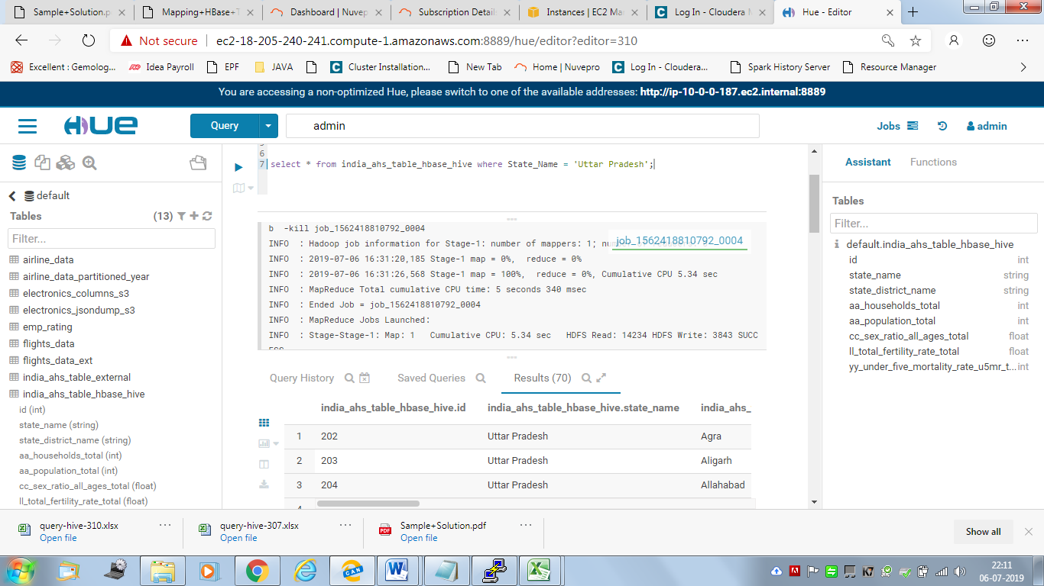

**Benchmarking:**

|  |  |  |  |
| --- | --- | --- | --- |
| Query | Default Format | ORC Format | HBASE-HIVE Table |
|  | Time Taken (Secs) | Time Taken (Secs) | Time Taken (Secs) |
| Query 1 | 23.073 | 21.048 | 26.952 |
| Query 2 | 22.23 | 19.61 | 25.888 |
| Query 3 | 16.549 | 15.099 | 17.845 |

**Query time in ORC table is less. ORC with SNAPPY Compression selected for further analysis**

**Create and insert command for the partition table for analyses 1 & 2.**

Set Hive.exec.Dynamic partition =;

Set Hive.exec.dynamic.partition.mode=nonstrict;

<Create command>

CREATE TABLE IF NOT EXISTS india_ahs_table_subset_partitioned_orc (

ID INT,

State_District_Name STRING,

AA_Households_Total INT,

AA_Population_Total INT,

CC_Sex_Ratio_All_Ages_Total FLOAT,

LL_Total_Fertility_Rate_Total FLOAT,

YY_Under_Five_Mortality_Rate_U5MR_Total_Person INT)

COMMENT 'subset schema with orc format with partitioned on State Name'

PARTITIONED BY (State_Name STRING)

stored as orc

tblproperties ("orc.compress"="SNAPPY");

<Insert command>

INSERT INTO TABLE india_ahs_table_subset_partitioned_orc PARTITION(State_Name)

SELECT ID,State_District_Name,AA_Households_Total,AA_Population_Total,

CC_Sex_Ratio_All_Ages_Total,LL_Total_Fertility_Rate_Total,

YY_Under_Five_Mortality_Rate_U5MR_Total_Person,State_Name

FROM india_ahs_table_subset_default;

***The result of each analysis along with the query and the corresponding chart generated in Hue. Keep optimizations in mind:***

**1. The child mortality rate of Uttar Pradesh**

**<Query on the table with the chosen format such as orc>**

select avg(YY_Under_Five_Mortality_Rate_U5MR_Total_Person) as Child_MortalityRate_In_UP from india_ahs_table_subset_partitioned_orc where State_Name='Uttar Pradesh';

**Output:**

**90.22857142857143**

<Screenshot of the result>

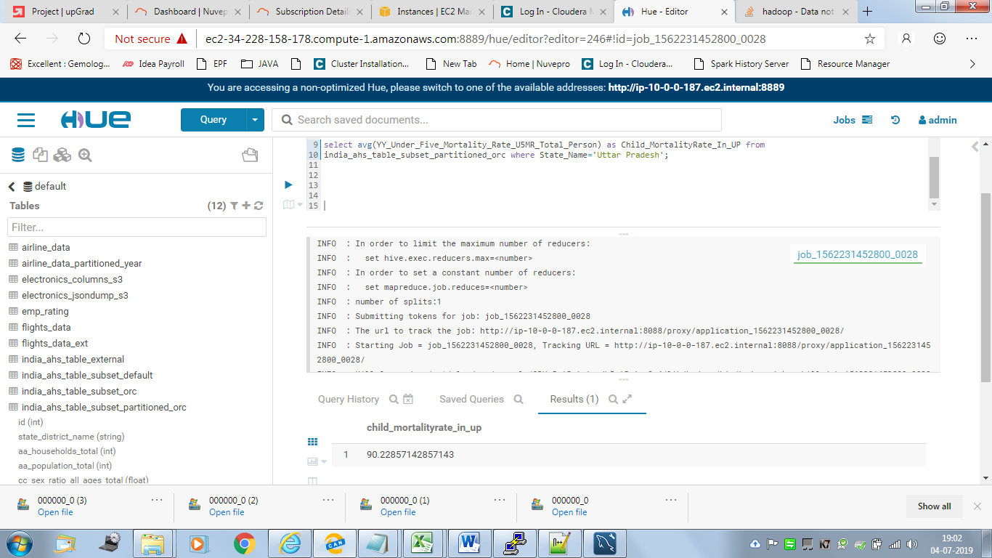

INFO : Compiling command(queryId=hive_20210110132828_cb42f9b8-0719-4ce7-8918-7de9e408f259): select avg(YY_Under_Five_Mortality_Rate_U5MR_Total_Person) as Child_MortalityRate_In_UP from india_ahs_table_subset_partitioned_orc where State_Name='Uttar Pradesh'

INFO : Semantic Analysis Completed

INFO : Returning Hive schema: Schema(fieldSchemas:[FieldSchema(name:child_mortalityrate_in_up, type:double, comment:null)], properties:null)

INFO : Completed compiling command(queryId=hive_20210110132828_cb42f9b8-0719-4ce7-8918-7de9e408f259); Time taken: 0.304 seconds

INFO : Executing command(queryId=hive_20210110132828_cb42f9b8-0719-4ce7-8918-7de9e408f259): select avg(YY_Under_Five_Mortality_Rate_U5MR_Total_Person) as Child_MortalityRate_In_UP from india_ahs_table_subset_partitioned_orc where State_Name='Uttar Pradesh'

INFO : Query ID = hive_20210110132828_cb42f9b8-0719-4ce7-8918-7de9e408f259

INFO : Total jobs = 1

INFO : Launching Job 1 out of 1

INFO : Starting task [Stage-1:MAPRED] in serial mode

INFO : Number of reduce tasks determined at compile time: 1

INFO : In order to change the average load for a reducer (in bytes):

INFO : set hive.exec.reducers.bytes.per.reducer=<number>

INFO : In order to limit the maximum number of reducers:

INFO : set hive.exec.reducers.max=<number>

INFO : In order to set a constant number of reducers:

INFO : set mapreduce.job.reduces=<number>

INFO : number of splits:1

INFO : Submitting tokens for job: job_1562231452800_0028

INFO : The url to track the job: http://ip-10-0-0-187.ec2.internal:8088/proxy/application_1562231452800_0028/

INFO : Starting Job = job_1562231452800_0028, Tracking URL = http://ip-10-0-0-187.ec2.internal:8088/proxy/application_1562231452800_0028/

INFO : Kill Command = /opt/cloudera/parcels/CDH-5.15.1-1.cdh5.15.1.p0.4/lib/hadoop/bin/hadoop job -kill job_1562231452800_0028

INFO : Hadoop job information for Stage-1: number of mappers: 1; number of reducers: 1

INFO : 2021-01-10 13:28:17,418 Stage-1 map = 0%, reduce = 0%

INFO : 2021-01-10 13:28:23,740 Stage-1 map = 100%, reduce = 0%, Cumulative CPU 3.24 sec

INFO : 2021-01-10 13:28:32,096 Stage-1 map = 100%, reduce = 100%, Cumulative CPU 7.34 sec

INFO : MapReduce Total cumulative CPU time: 7 seconds 340 msec

INFO : Ended Job = job_1562231452800_0028

INFO : MapReduce Jobs Launched:

INFO : Stage-Stage-1: Map: 1 Reduce: 1 Cumulative CPU: 7.34 sec HDFS Read: 21719 HDFS Write: 18 SUCCESS

INFO : Total MapReduce CPU Time Spent: 7 seconds 340 msec

INFO : Completed executing command(queryId=hive_20210110132828_cb42f9b8-0719-4ce7-8918-7de9e408f259); Time taken: 22.836 seconds

INFO : OK

**<Query on the Hive-Hbase integrated table>**

select avg(YY_Under_Five_Mortality_Rate_U5MR_Total_Person) as Child_MortalityRate_In_UP from india_ahs_table_hbase_hive where State_Name='Uttar Pradesh';

**Output:**

**90.22857142857143**

<Screenshot of the result>

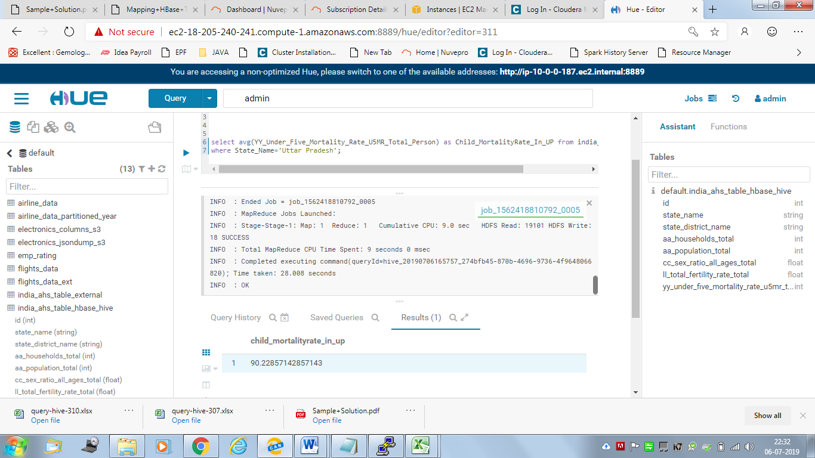

**job_1562418810792_0005**

**INFO : Compiling command(queryId=hive_20210110165757_274bfb45-870b-4696-9736-4f9648066820): select avg(YY_Under_Five_Mortality_Rate_U5MR_Total_Person) as Child_MortalityRate_In_UP from india_ahs_table_hbase_hive**

**where State_Name='Uttar Pradesh'**

**INFO : Semantic Analysis Completed**

**INFO : Returning Hive schema: Schema(fieldSchemas:[FieldSchema(name:child_mortalityrate_in_up, type:double, comment:null)], properties:null)**

**INFO : Completed compiling command(queryId=hive_20210110165757_274bfb45-870b-4696-9736-4f9648066820); Time taken: 0.115 seconds**

**INFO : Executing command(queryId=hive_20210110165757_274bfb45-870b-4696-9736-4f9648066820): select avg(YY_Under_Five_Mortality_Rate_U5MR_Total_Person) as Child_MortalityRate_In_UP from india_ahs_table_hbase_hive**

**where State_Name='Uttar Pradesh'**

**INFO : Query ID = hive_20210110165757_274bfb45-870b-4696-9736-4f9648066820**

**INFO : Total jobs = 1**

**INFO : Launching Job 1 out of 1**

**INFO : Starting task [Stage-1:MAPRED] in serial mode**

**INFO : Number of reduce tasks determined at compile time: 1**

**INFO : In order to change the average load for a reducer (in bytes):**

**INFO : set hive.exec.reducers.bytes.per.reducer=<number>**

**INFO : In order to limit the maximum number of reducers:**

**INFO : set hive.exec.reducers.max=<number>**

**INFO : In order to set a constant number of reducers:**

**INFO : set mapreduce.job.reduces=<number>**

**INFO : number of splits:1**

**INFO : Submitting tokens for job: job_1562418810792_0005**

**INFO : The url to track the job: http://ip-10-0-0-187.ec2.internal:8088/proxy/application_1562418810792_0005/**

**INFO : Starting Job = job_1562418810792_0005, Tracking URL = http://ip-10-0-0-187.ec2.internal:8088/proxy/application_1562418810792_0005/**

**INFO : Kill Command = /opt/cloudera/parcels/CDH-5.15.1-1.cdh5.15.1.p0.4/lib/hadoop/bin/hadoop job -kill job_1562418810792_0005**

**INFO : Hadoop job information for Stage-1: number of mappers: 1; number of reducers: 1**

**INFO : 2021-01-10 16:57:20,109 Stage-1 map = 0%, reduce = 0%**

**INFO : 2021-01-10 16:57:27,453 Stage-1 map = 100%, reduce = 0%, Cumulative CPU 5.25 sec**

**INFO : 2021-01-10 16:57:34,823 Stage-1 map = 100%, reduce = 100%, Cumulative CPU 9.0 sec**

**INFO : MapReduce Total cumulative CPU time: 9 seconds 0 msec**

**INFO : Ended Job = job_1562418810792_0005**

**INFO : MapReduce Jobs Launched:**

**INFO : Stage-Stage-1: Map: 1 Reduce: 1 Cumulative CPU: 9.0 sec HDFS Read: 19101 HDFS Write: 18 SUCCESS**

**INFO : Total MapReduce CPU Time Spent: 9 seconds 0 msec**

**INFO : Completed executing command(queryId=hive_20210110165757_274bfb45-870b-4696-9736-4f9648066820); Time taken: 28.008 seconds**

**INFO : OK**

**2. The fertility rate of Bihar**

**<Query on the table with the chosen format such as orc>**

select avg(LL_Total_Fertility_Rate_Total) as fertility_rate_of_Bihar from

india_ahs_table_subset_partitioned_orc where State_Name='Bihar';

Output:

3.532432427277436

<Screenshot of the result>

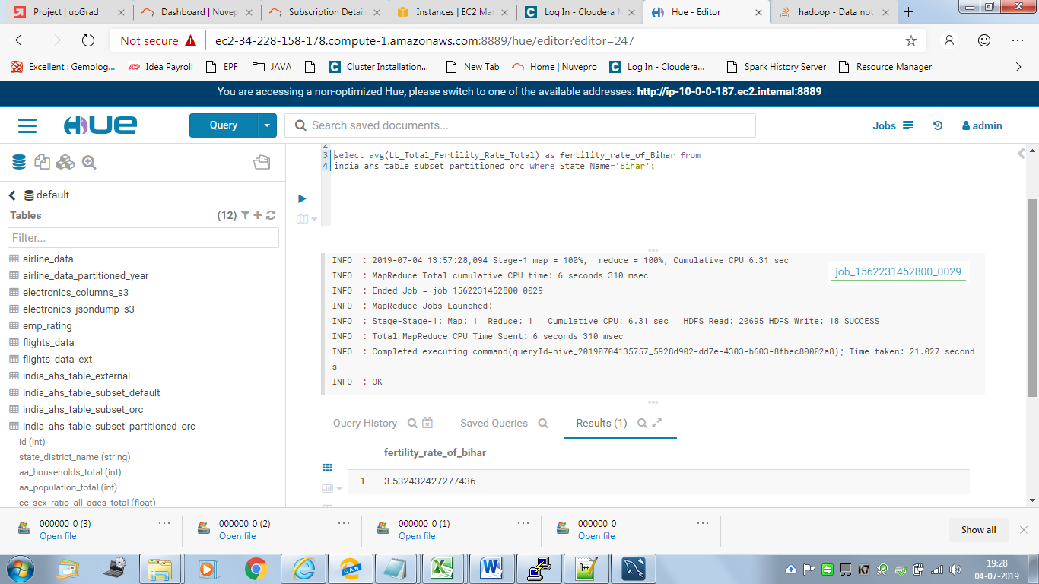

**<Query on the Hive-Hbase integrated table>**

select avg(LL_Total_Fertility_Rate_Total) as fertility_rate_of_Bihar from

india_ahs_table_hbase_hive where State_Name='Bihar';

Output :

3.532432427277436

<Screenshot of the result>

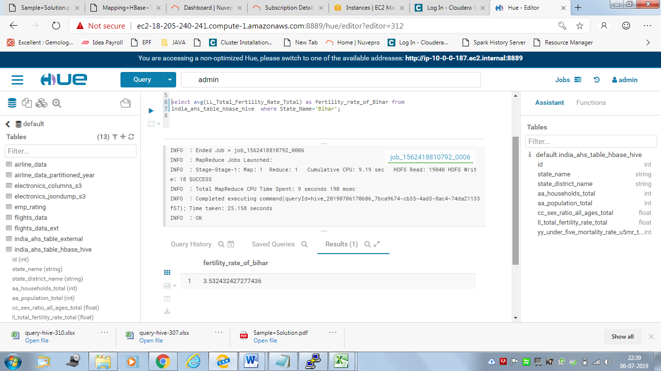

job_1562418810792_0006

INFO : Compiling command(queryId=hive_20210110170606_7bca9674-cb35-4ad3-8ac4-74da21133f57): select avg(LL_Total_Fertility_Rate_Total) as fertility_rate_of_Bihar from

india_ahs_table_hbase_hive where State_Name='Bihar'

INFO : Semantic Analysis Completed

INFO : Returning Hive schema: Schema(fieldSchemas:[FieldSchema(name:fertility_rate_of_bihar, type:double, comment:null)], properties:null)

INFO : Completed compiling command(queryId=hive_20210110170606_7bca9674-cb35-4ad3-8ac4-74da21133f57); Time taken: 0.096 seconds

INFO : Executing command(queryId=hive_20210110170606_7bca9674-cb35-4ad3-8ac4-74da21133f57): select avg(LL_Total_Fertility_Rate_Total) as fertility_rate_of_Bihar from

india_ahs_table_hbase_hive where State_Name='Bihar'

INFO : Query ID = hive_20210110170606_7bca9674-cb35-4ad3-8ac4-74da21133f57

INFO : Total jobs = 1

INFO : Launching Job 1 out of 1

INFO : Starting task [Stage-1:MAPRED] in serial mode

INFO : Number of reduce tasks determined at compile time: 1

INFO : In order to change the average load for a reducer (in bytes):

INFO : set hive.exec.reducers.bytes.per.reducer=<number>

INFO : In order to limit the maximum number of reducers:

INFO : set hive.exec.reducers.max=<number>

INFO : In order to set a constant number of reducers:

INFO : set mapreduce.job.reduces=<number>

INFO : number of splits:1

INFO : Submitting tokens for job: job_1562418810792_0006

INFO : The url to track the job: http://ip-10-0-0-187.ec2.internal:8088/proxy/application_1562418810792_0006/

INFO : Starting Job = job_1562418810792_0006, Tracking URL = http://ip-10-0-0-187.ec2.internal:8088/proxy/application_1562418810792_0006/

INFO : Kill Command = /opt/cloudera/parcels/CDH-5.15.1-1.cdh5.15.1.p0.4/lib/hadoop/bin/hadoop job -kill job_1562418810792_0006

INFO : Hadoop job information for Stage-1: number of mappers: 1; number of reducers: 1

INFO : 2021-01-10 17:07:02,951 Stage-1 map = 0%, reduce = 0%

INFO : 2021-01-10 17:07:09,325 Stage-1 map = 100%, reduce = 0%, Cumulative CPU 5.28 sec

INFO : 2021-01-10 17:07:16,686 Stage-1 map = 100%, reduce = 100%, Cumulative CPU 9.19 sec

INFO : MapReduce Total cumulative CPU time: 9 seconds 190 msec

INFO : Ended Job = job_1562418810792_0006

INFO : MapReduce Jobs Launched:

INFO : Stage-Stage-1: Map: 1 Reduce: 1 Cumulative CPU: 9.19 sec HDFS Read: 19040 HDFS Write: 18 SUCCESS

INFO : Total MapReduce CPU Time Spent: 9 seconds 190 msec

INFO : Completed executing command(queryId=hive_20210110170606_7bca9674-cb35-4ad3-8ac4-74da21133f57); Time taken: 25.158 seconds

INFO : OK

**3. State wise child mortality rate and state wise fertility rate and does high fertility correlate with high child mortality?**

**<Query on the table with the chosen format such as orc>**

State wise child mortality rate and state wise fertility rate

Select State_Name,avg(YY_Under_Five_Mortality_Rate_U5MR_Total_Person)

as StateWise_ChildMortality_Rate,

avg(LL_Total_Fertility_Rate_Total)

as StateWise_Fertility_Rate

from india_ahs_table_subset_orc

GROUP BY State_Name;

<Screenshot of the result>

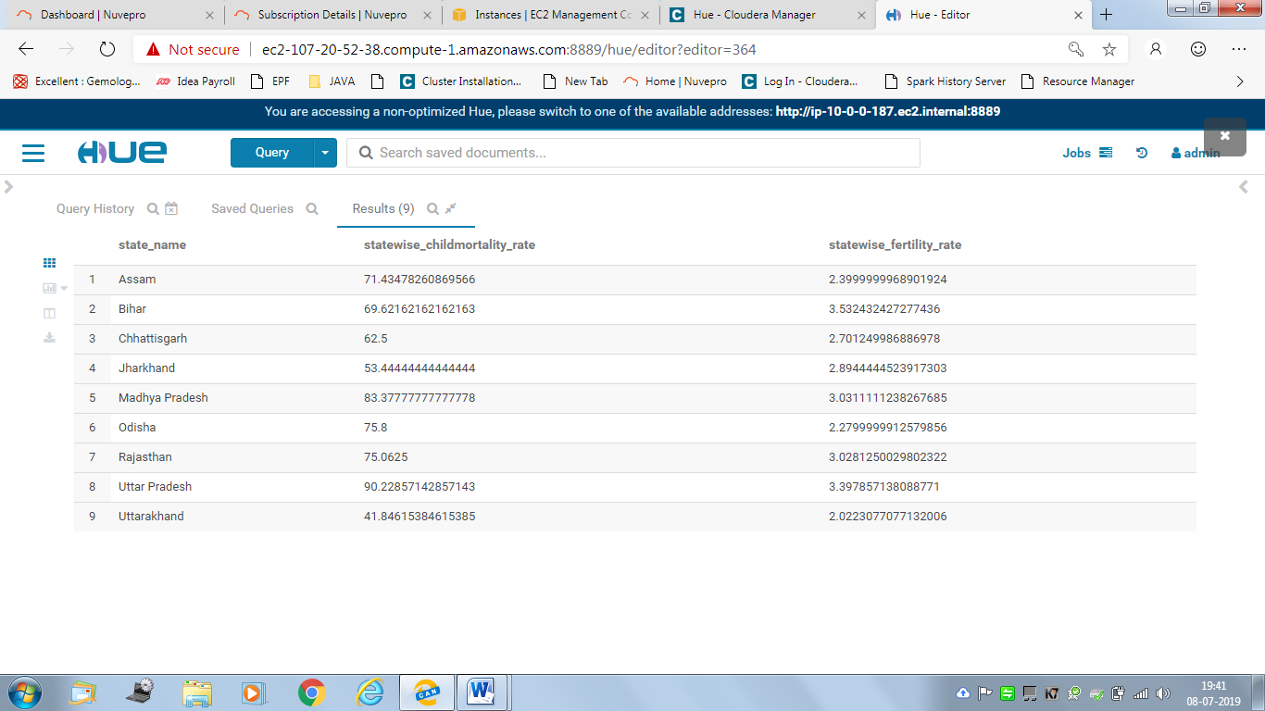

Exported to EXCEL:

|  |  |  |
| --- | --- | --- |
| state_name | statewise_childmortality_rate | statewise_fertility_rate |
| Assam | 71.43478261 | 2.399999997 |
| Bihar | 69.62162162 | 3.532432427 |
| Chhattisgarh | 62.5 | 2.701249987 |
| Jharkhand | 53.44444444 | 2.894444452 |
| Madhya Pradesh | 83.37777778 | 3.031111124 |
| Odisha | 75.8 | 2.279999991 |
| Rajasthan | 75.0625 | 3.028125003 |
| Uttar Pradesh | 90.22857143 | 3.397857138 |
| Uttarakhand | 41.84615385 | 2.022307708 |

Chart:

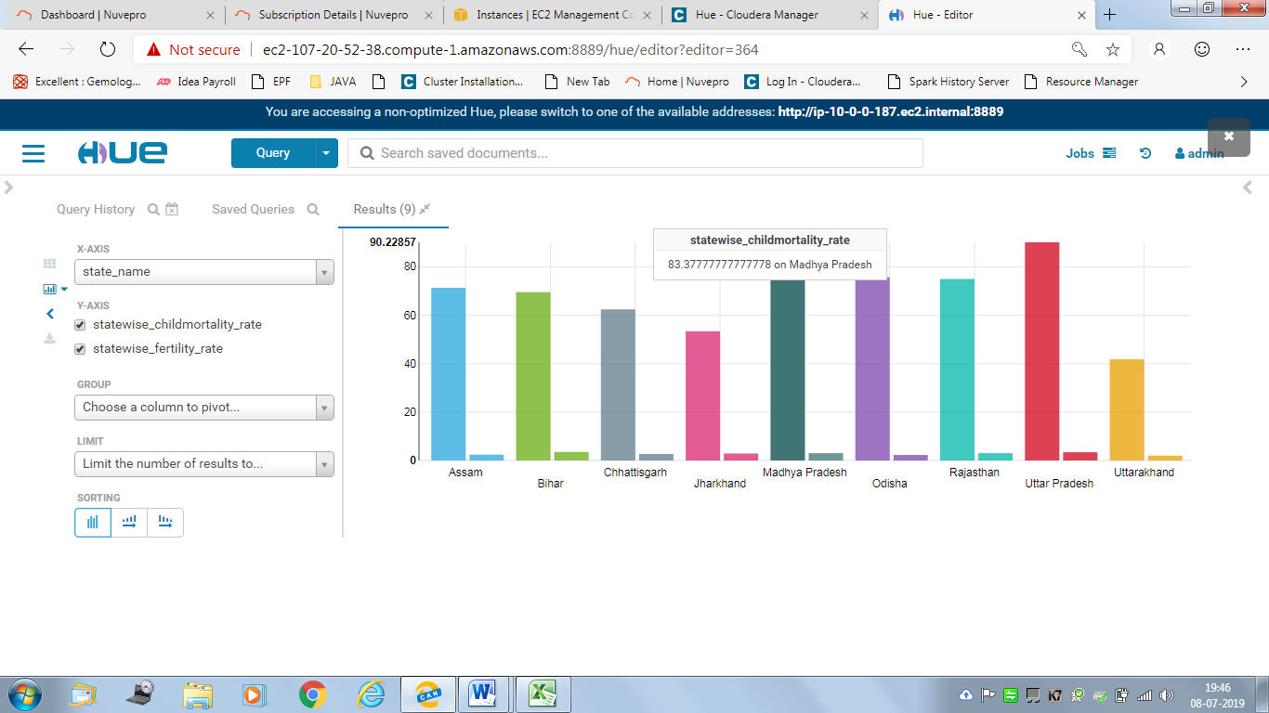

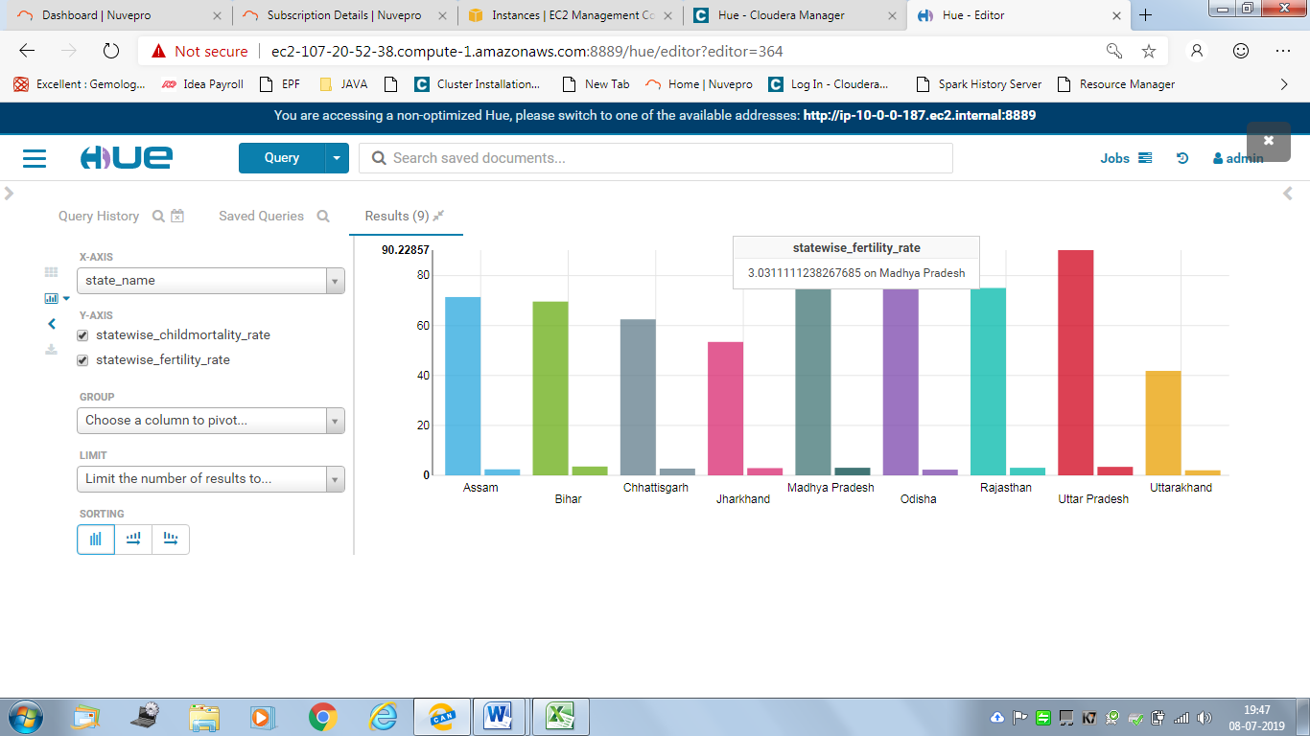

**Correlation Coefficient between Fertility Rate and Child Mortality Rate:**

**Query:**

select corr(a.StateWise_ChildMortality_Rate,a.StateWise_Fertility_Rate)

as Correlation_Coefficient_between_FertilityRate_and_ChildMortalityRate from

(Select State_Name,avg(YY_Under_Five_Mortality_Rate_U5MR_Total_Person)

as StateWise_ChildMortality_Rate,

avg(LL_Total_Fertility_Rate_Total)

as StateWise_Fertility_Rate from india_ahs_table_subset_orc GROUP BY State_Name)a;

**Screenshot:**

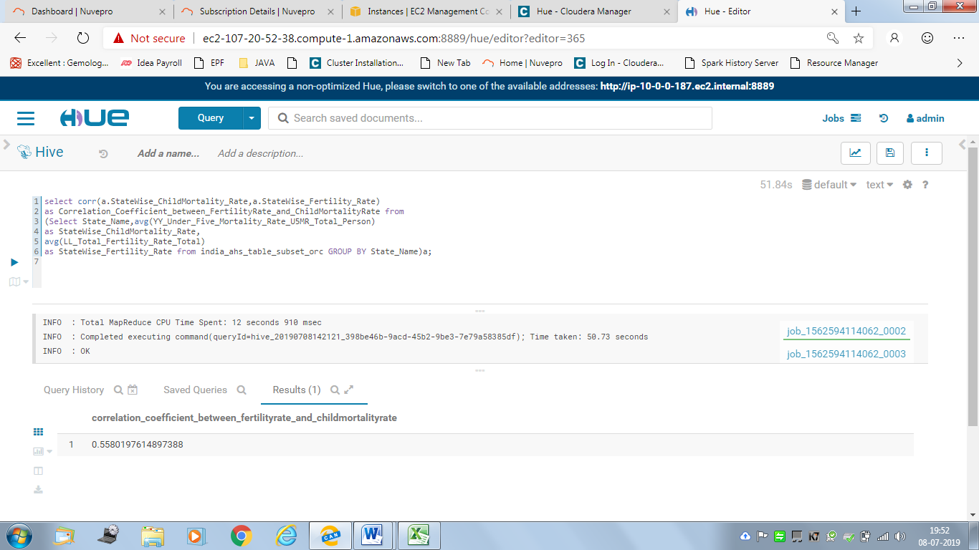

Output: 0.5580197614897388

**It is greater than 0.5 indicates STRONG (POSITIVE) i.e. at high values.**

**<Query on the Hive-Hbase integrated table>**

Select State_Name,avg(YY_Under_Five_Mortality_Rate_U5MR_Total_Person) as StateWise_ChildMortality_Rate, avg(LL_Total_Fertility_Rate_Total) as StateWise_Fertility_Rate from india_ahs_table_hbase_hive GROUP BY State_Name;

<Screenshot of the result>

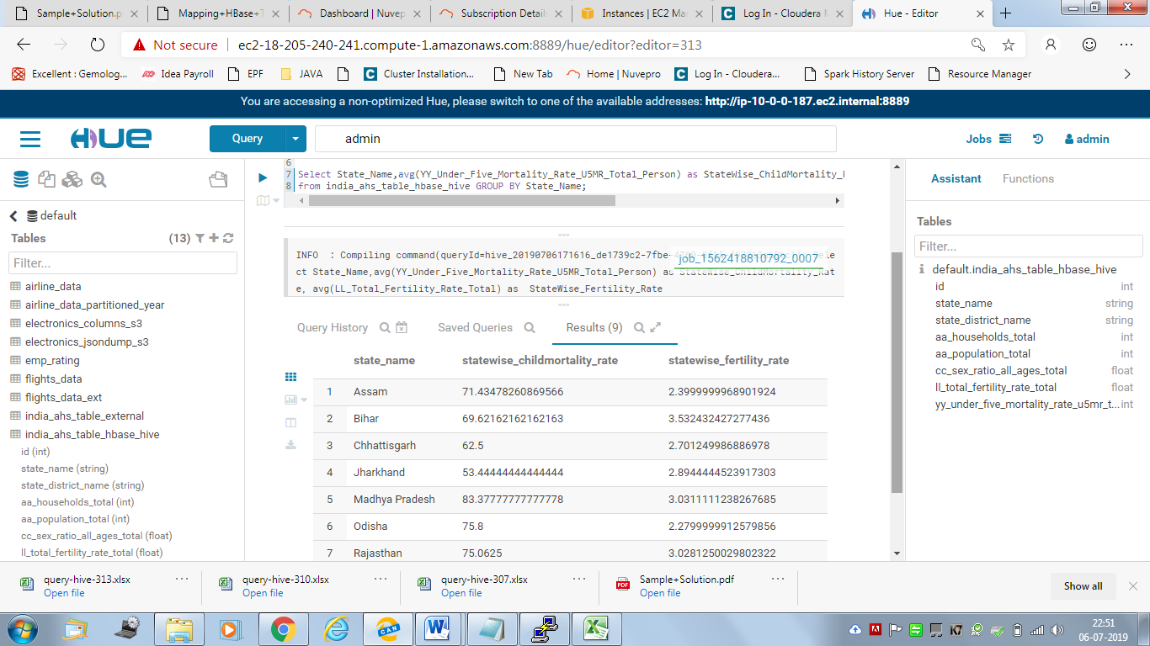

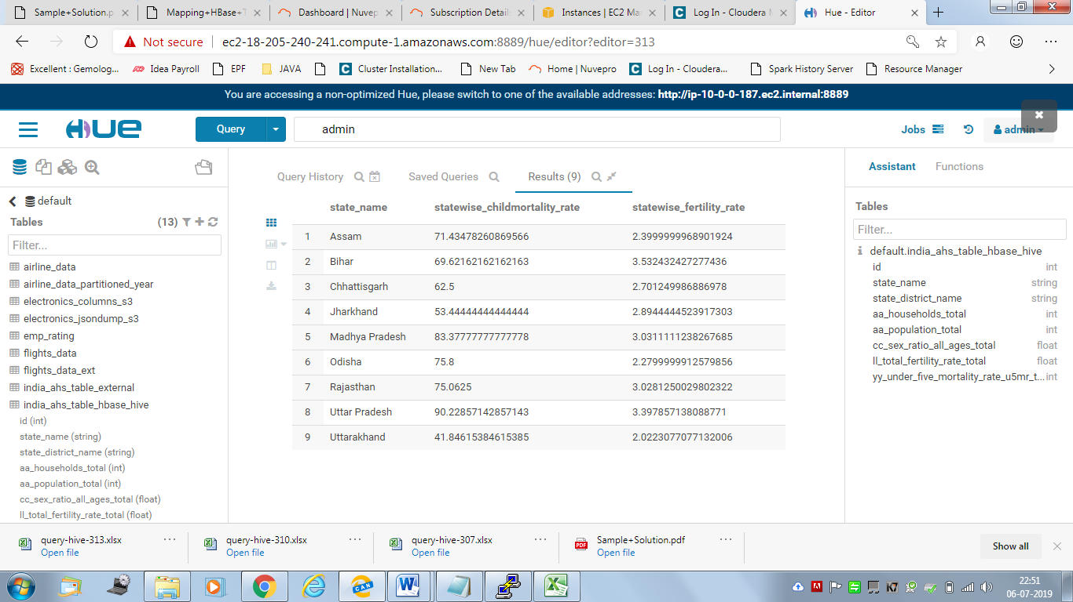

Output : Export to EXCEL

|  |  |  |
| --- | --- | --- |
| state_name | statewise_childmortality_rate | statewise_fertility_rate |
| Assam | 71.43478261 | 2.399999997 |
| Bihar | 69.62162162 | 3.532432427 |
| Chhattisgarh | 62.5 | 2.701249987 |
| Jharkhand | 53.44444444 | 2.894444452 |
| Madhya Pradesh | 83.37777778 | 3.031111124 |
| Odisha | 75.8 | 2.279999991 |
| Rajasthan | 75.0625 | 3.028125003 |
| Uttar Pradesh | 90.22857143 | 3.397857138 |
| Uttarakhand | 41.84615385 | 2.022307708 |

<Chart>

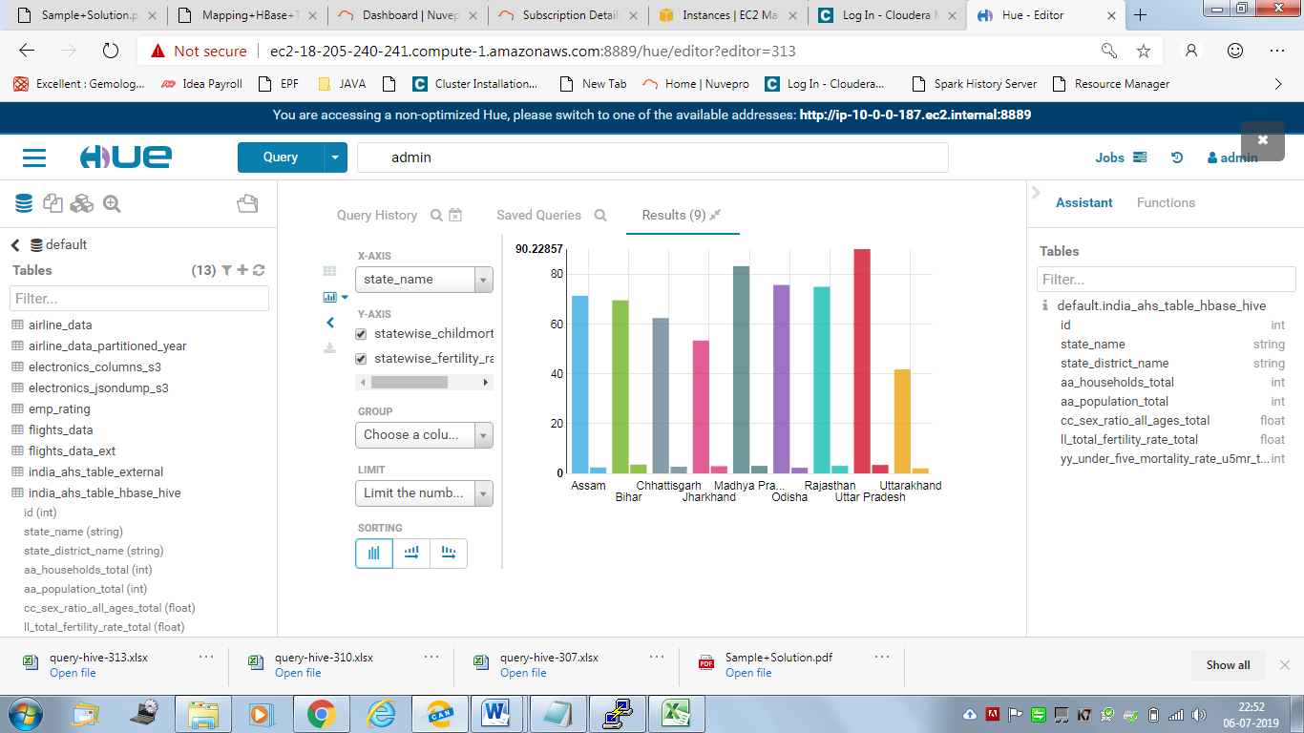

**Correlation Coefficient between Fertility Rate and Child Mortality Rate:**

select corr(a.StateWise_ChildMortality_Rate,a.StateWise_Fertility_Rate) as

Correlation_Coefficient_between_FertilityRate_and_ChildMortalityRate from

(Select State_Name,avg(YY_Under_Five_Mortality_Rate_U5MR_Total_Person) as StateWise_ChildMortality_Rate,

avg(LL_Total_Fertility_Rate_Total) as StateWise_Fertility_Rate from india_ahs_table_hbase_hive GROUP BY State_Name)a;

<Screenshot of the result>

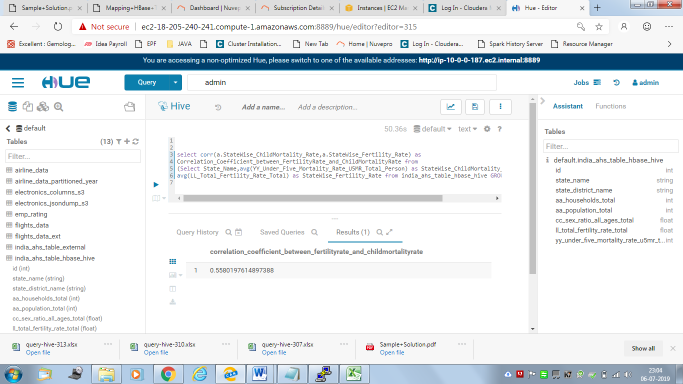

Output:

0.5580197614897388

**It is greater than 0.5 indicates STRONG (POSITIVE) i.e. at high values.**

**4. Find top 2 districts per state with the highest population per household**

**<Query on the table with the chosen format such as orc>**

select state_name, state_district_name,Population_Per_Household

as PopulationPerHousehold

from

(select state_name , state_district_name, aa_population_total/aa_households_total

as Population_Per_Household,

row_number() over (partition by state_name order by aa_population_total/aa_households_total DESC)

as state_rank from india_ahs_table_subset_orc )ranked

where state_rank<=2;

<Screenshot of the result>

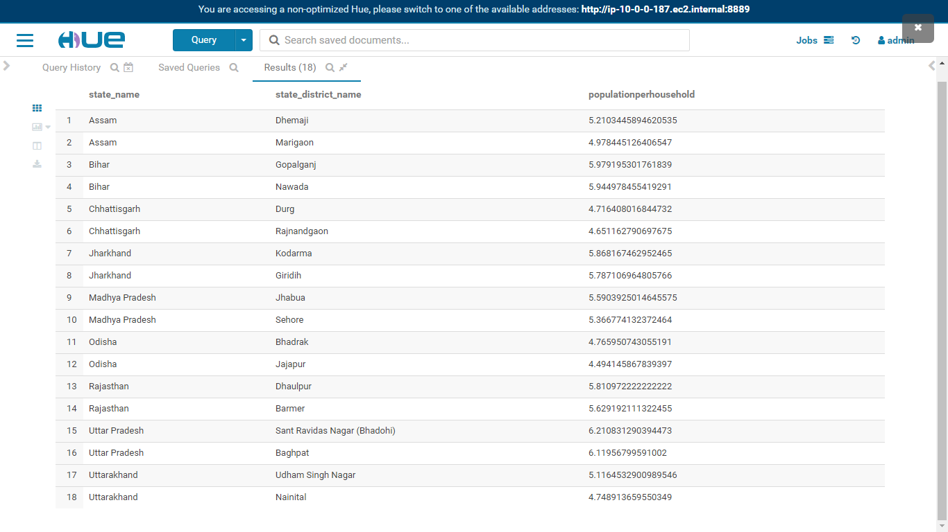

Export to EXCEL:

|  |  |  |
| --- | --- | --- |
| state_name | state_district_name | populationperhousehold |
| Assam | Dhemaji | 5.210344589 |
| Assam | Marigaon | 4.978445126 |
| Bihar | Gopalganj | 5.979195302 |
| Bihar | Nawada | 5.944978455 |
| Chhattisgarh | Durg | 4.716408017 |
| Chhattisgarh | Rajnandgaon | 4.651162791 |
| Jharkhand | Kodarma | 5.868167463 |
| Jharkhand | Giridih | 5.787106965 |
| Madhya Pradesh | Jhabua | 5.590392501 |
| Madhya Pradesh | Sehore | 5.366774132 |
| Odisha | Bhadrak | 4.765950743 |
| Odisha | Jajapur | 4.494145868 |
| Rajasthan | Dhaulpur | 5.810972222 |
| Rajasthan | Barmer | 5.629192111 |
| Uttar Pradesh | Sant Ravidas Nagar (Bhadohi) | 6.21083129 |
| Uttar Pradesh | Baghpat | 6.119567996 |
| Uttarakhand | Udham Singh Nagar | 5.11645329 |
| Uttarakhand | Nainital | 4.74891366 |

**Chart:**

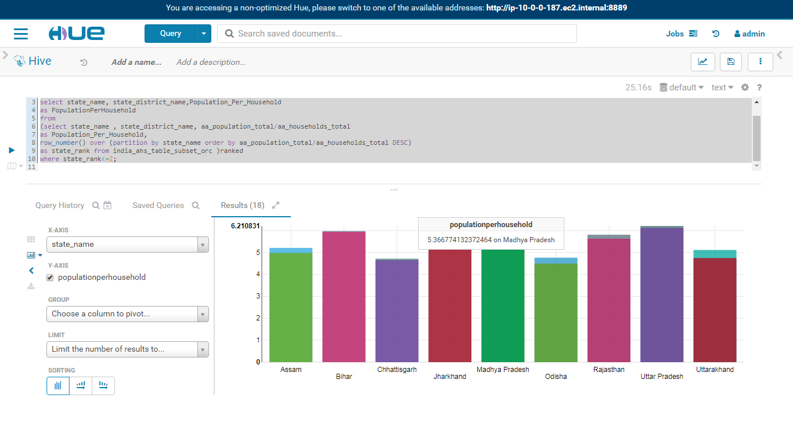

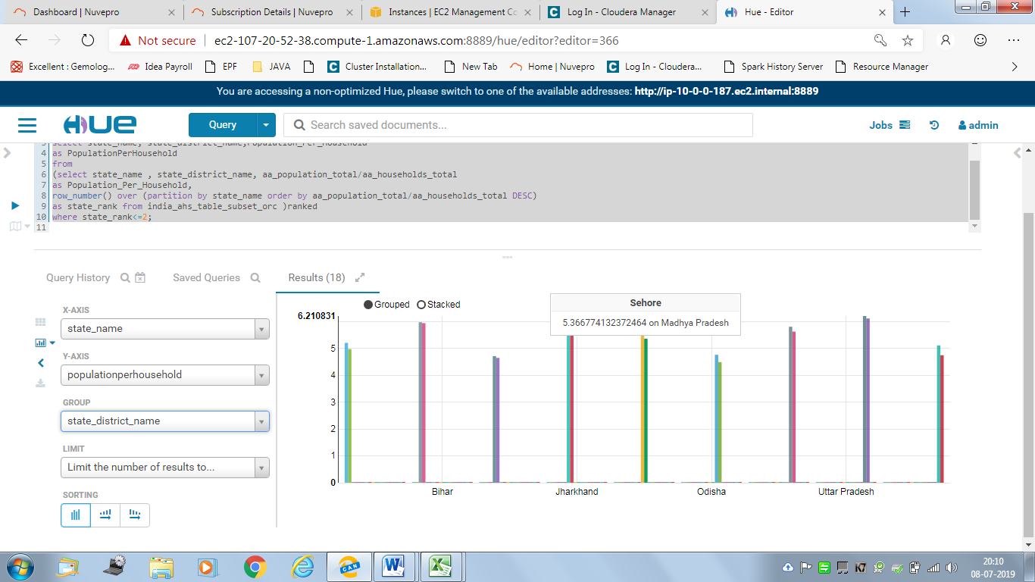

**<Query on the Hive-Hbase integrated table>**

select state_name, state_district_name,Population_Per_Household as PopulationPerHousehold

from

(select state_name , state_district_name, aa_population_total/aa_households_total

as Population_Per_Household,

row_number() over (partition by state_name order by aa_population_total/aa_households_total DESC)

as state_rank from india_ahs_table_hbase_hive)ranked

where state_rank<=2;

<Screenshot of the result>

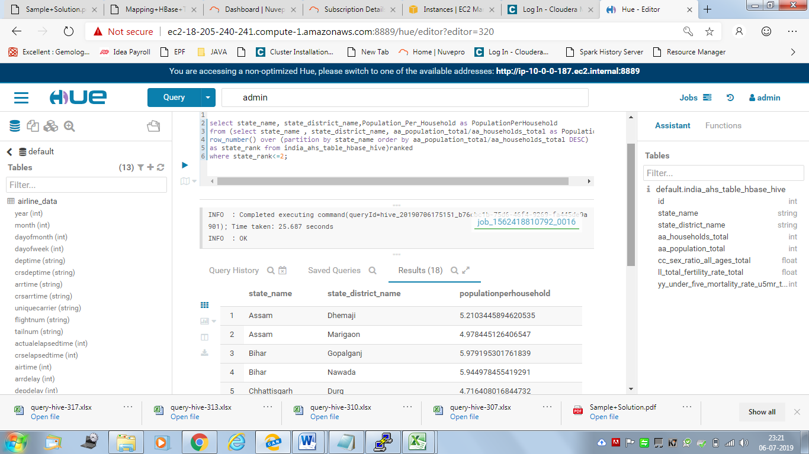

**Output: Export to EXCEL**

|  |  |  |
| --- | --- | --- |
| state_name | state_district_name | populationperhousehold |
| Assam | Dhemaji | 5.210344589 |
| Assam | Marigaon | 4.978445126 |
| Bihar | Gopalganj | 5.979195302 |
| Bihar | Nawada | 5.944978455 |
| Chhattisgarh | Durg | 4.716408017 |
| Chhattisgarh | Rajnandgaon | 4.651162791 |
| Jharkhand | Kodarma | 5.868167463 |
| Jharkhand | Giridih | 5.787106965 |
| Madhya Pradesh | Jhabua | 5.590392501 |
| Madhya Pradesh | Sehore | 5.366774132 |
| Odisha | Bhadrak | 4.765950743 |
| Odisha | Jajapur | 4.494145868 |
| Rajasthan | Dhaulpur | 5.810972222 |
| Rajasthan | Barmer | 5.629192111 |
| Uttar Pradesh | Sant Ravidas Nagar (Bhadohi) | 6.21083129 |
| Uttar Pradesh | Baghpat | 6.119567996 |
| Uttarakhand | Udham Singh Nagar | 5.11645329 |
| Uttarakhand | Nainital | 4.74891366 |

<Chart>

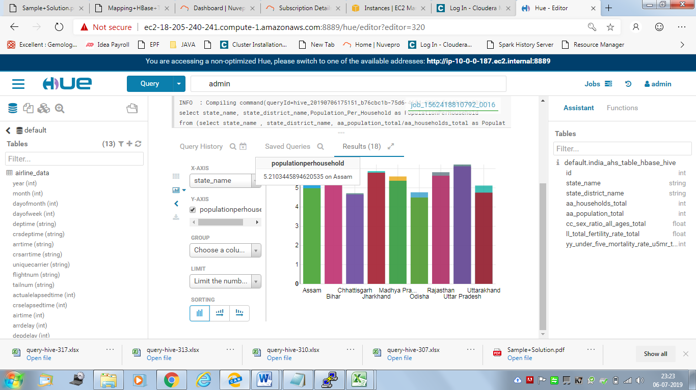

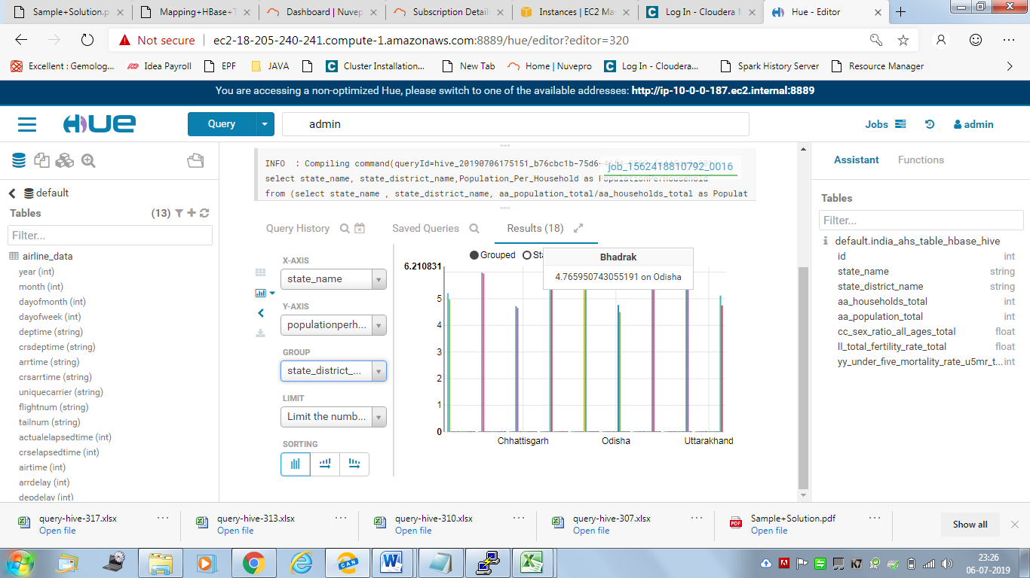

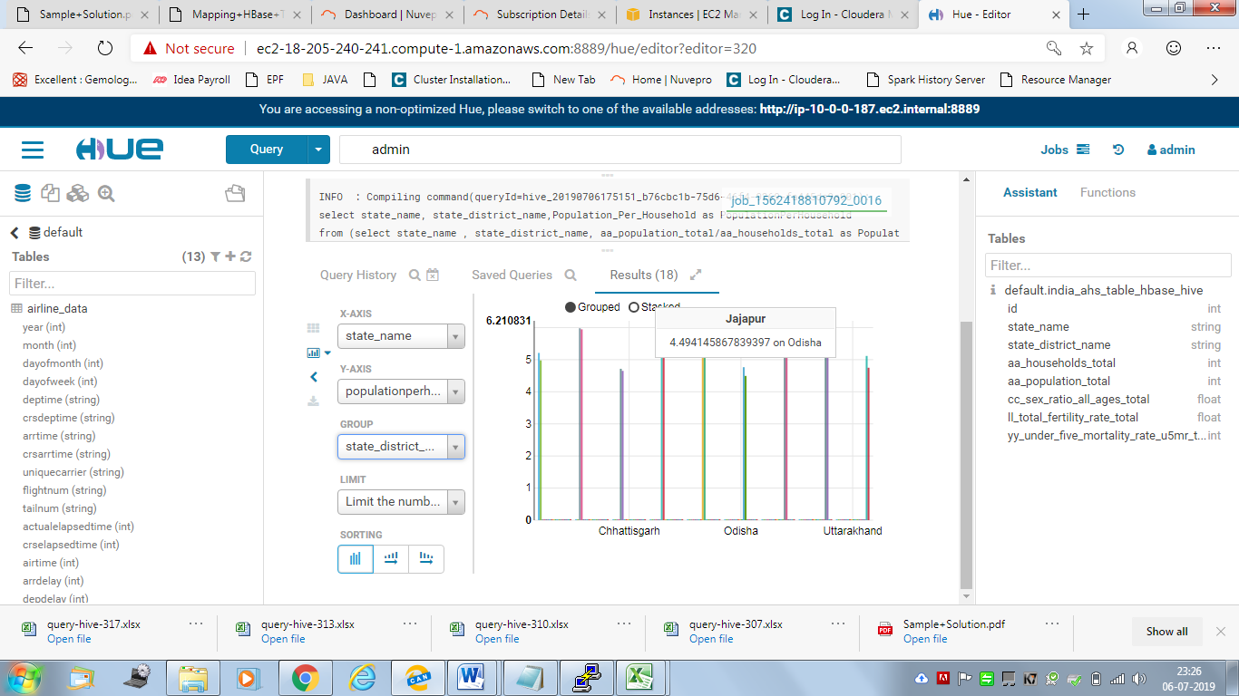

**5. Find top 2 districts per state with the lowest sex ratios**

**<Query on the table with the chosen format such as orc>**

select state_name, state_district_name, Sex_Ratio

from

(select state_name , state_district_name,cc_sex_ratio_all_ages_total as Sex_Ratio,

row_number() over (partition by state_name order by cc_sex_ratio_all_ages_total ASC)

as state_rank from india_ahs_table_subset_orc)ranked

where state_rank<=2;

**<Screenshot of the result>**

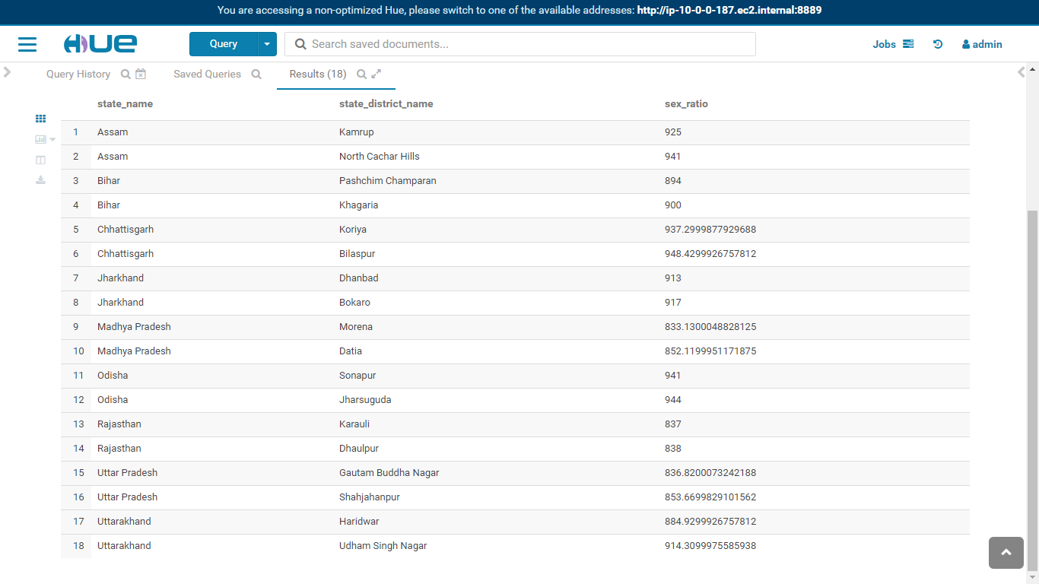

**Export to EXCEL**

|  |  |  |
| --- | --- | --- |
| state_name | state_district_name | sex_ratio |
| Assam | Kamrup | 925 |
| Assam | North Cachar Hills | 941 |
| Bihar | Pashchim Champaran | 894 |
| Bihar | Khagaria | 900 |
| Chhattisgarh | Koriya | 937.2999878 |
| Chhattisgarh | Bilaspur | 948.4299927 |
| Jharkhand | Dhanbad | 913 |
| Jharkhand | Bokaro | 917 |
| Madhya Pradesh | Morena | 833.1300049 |
| Madhya Pradesh | Datia | 852.1199951 |
| Odisha | Sonapur | 941 |
| Odisha | Jharsuguda | 944 |
| Rajasthan | Karauli | 837 |
| Rajasthan | Dhaulpur | 838 |
| Uttar Pradesh | Gautam Buddha Nagar | 836.8200073 |
| Uttar Pradesh | Shahjahanpur | 853.6699829 |
| Uttarakhand | Haridwar | 884.9299927 |
| Uttarakhand | Udham Singh Nagar | 914.3099976 |

<Chart>

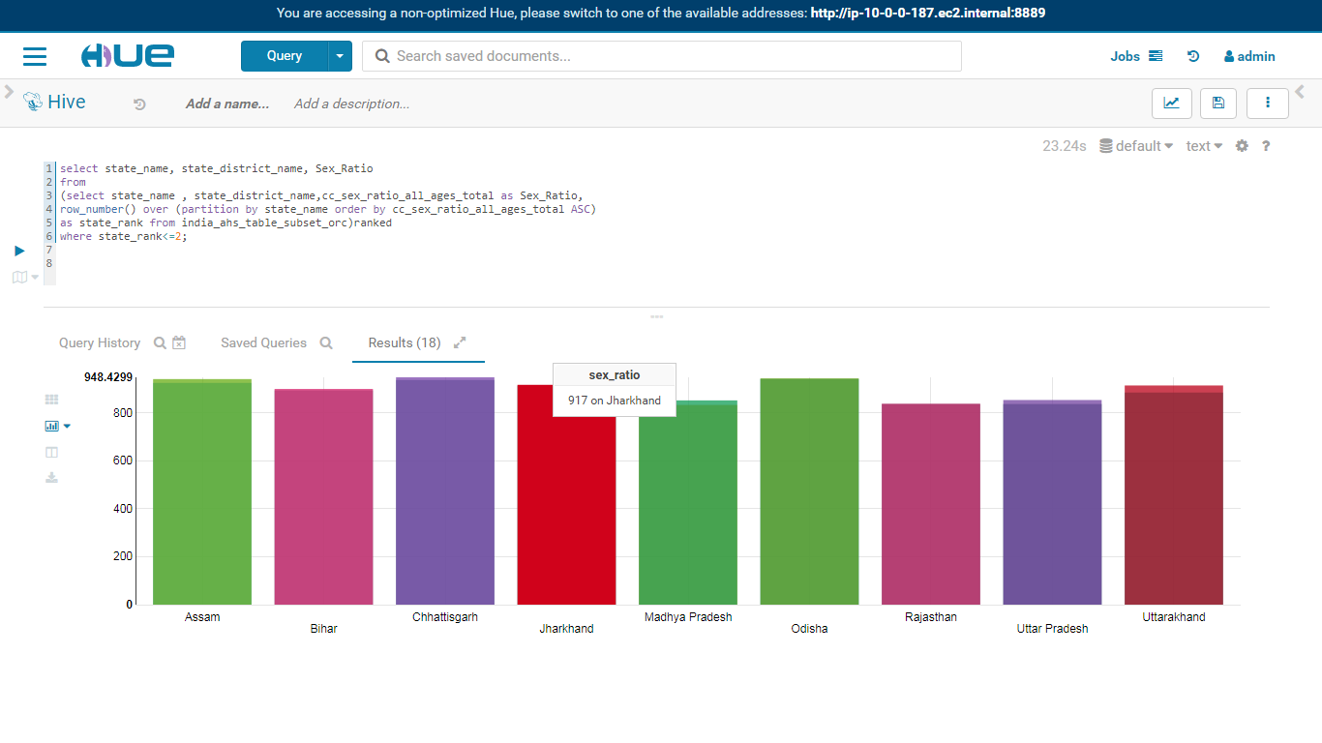

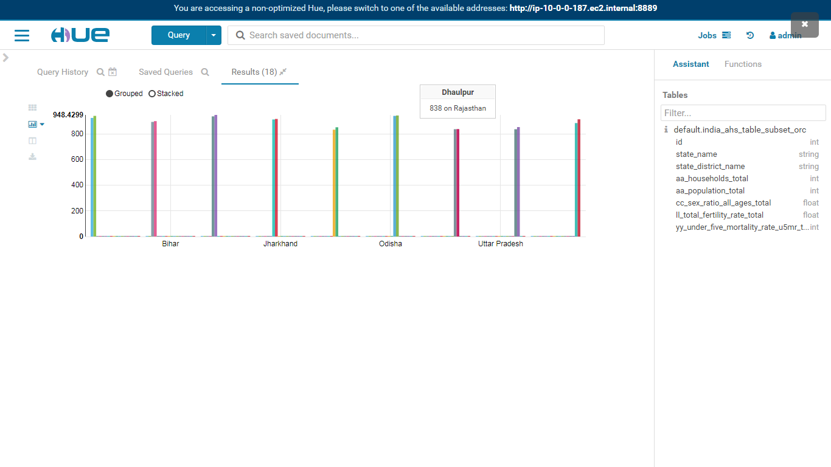**<Query on the Hive-Hbase integrated table>**

select state_name, state_district_name,Sex_Ratio

from

(select state_name , state_district_name,cc_sex_ratio_all_ages_total as Sex_Ratio,

row_number() over (partition by state_name order by cc_sex_ratio_all_ages_total ASC)

as state_rank from india_ahs_table_hbase_hive )ranked

where state_rank<=2;

<Screenshot of the result>

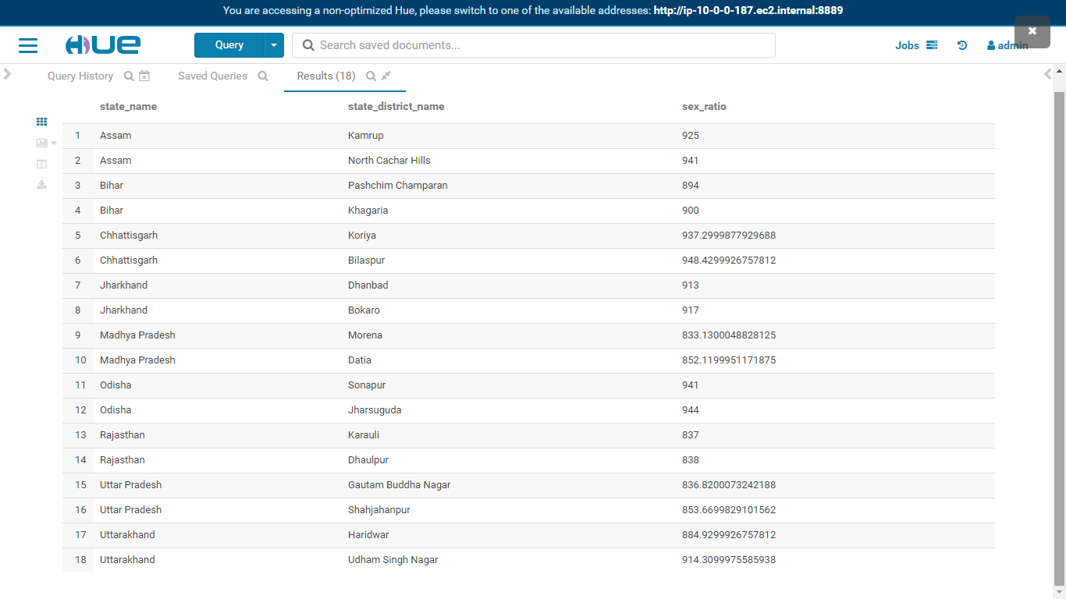

**EXPORT to EXCEL**

|  |  |  |
| --- | --- | --- |
| state_name | state_district_name | sex_ratio |
| Assam | Kamrup | 925 |
| Assam | North Cachar Hills | 941 |
| Bihar | Pashchim Champaran | 894 |
| Bihar | Khagaria | 900 |
| Chhattisgarh | Koriya | 937.2999878 |
| Chhattisgarh | Bilaspur | 948.4299927 |
| Jharkhand | Dhanbad | 913 |
| Jharkhand | Bokaro | 917 |
| Madhya Pradesh | Morena | 833.1300049 |
| Madhya Pradesh | Datia | 852.1199951 |
| Odisha | Sonapur | 941 |
| Odisha | Jharsuguda | 944 |
| Rajasthan | Karauli | 837 |
| Rajasthan | Dhaulpur | 838 |
| Uttar Pradesh | Gautam Buddha Nagar | 836.8200073 |
| Uttar Pradesh | Shahjahanpur | 853.6699829 |
| Uttarakhand | Haridwar | 884.9299927 |
| Uttarakhand | Udham Singh Nagar | 914.3099976 |

Chart:

